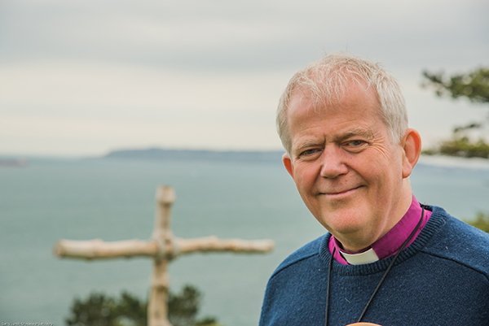

This Joyful Eastertide

What a long journey it has been to Easter! It has felt like the longest Lent ever, not 40 days but over a year since the first lockdown. In that time a lot of our worship has been online. Where we have been able to worship together in person we have got used to being socially distanced. Coming out of lockdown, still distanced and Covid-safe, worship doesn’t feel so familiar or so easy. Someone told me that they cried when they received the sacrament for the first time in months.

The Church of England has tried to do its best through the pandemic but there have been murmurings, as there were about Moses among the people of Israel in the wilderness on the journey from slavery in Egypt to the freedom of the promised land. The pandemic has been really hard work. Some of what the churches have been doing has been outstanding – worship online, community care, seeking out those most in need, schools open for the most vulnerable and the children of key workers and so on. Some of it has been less good – and you can make your own list here – but I’ll own up for myself that I have been less than perfect. Most people know their inadequacies and we also know the relief as we begin to see new life emerging.

The Easter Gospel stories include John’s epilogue of chapter 21, with 7 of the disciples gathered again by the Sea of Tiberias. 5 of them are named, and in various ways they had let Jesus down. Yet here they are back where he first called the fisherman. They are feeling perplexed but getting on with life when the risen Lord came among them. John is telling us that Jesus accepted their failures and restored them as a community of the resurrection.

However the pandemic has been for you and us, the task this Easter is to allow God to recall us and put us back together as a Christian community. It will take weeks and months and years. There’s a big job to do. If we have been attentive we will have learned lessons about what is a person, what makes a worthwhile life and how we live together in God’s creation. We don’t want it to be the same as it was before. We want it to be different. We can do better in response to the God who loves us, sustains us, renews us this joyful Eastertide.

+Nicholas Sarum

