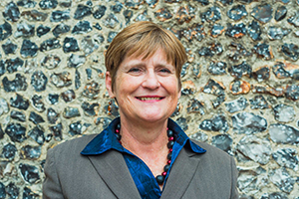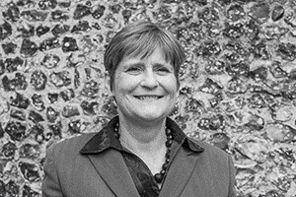

Photo: ‘2018-9 Lucinda Herklots’
Colour photos folder here
Grayscale photos folder here

The Local Church Is Best

“My passion is the local church.”
Lucinda Herklots is due to move on in November after fourteen years as Diocesan Secretary. Her journey to faith started in a little Saxon Church near her grandparents’ farm in Sussex.
“My father was an army officer, so I spent all my holidays there. Then at an Anglican convent secondary school, I was an acolyte and head of the choir, which meant a great deal to me.
“My darkest hour was at university aged 19, when I became seriously ill and needed a kidney transplant. I just said to God, ‘over to you’. He provided. That has been my guiding force ever since.
“My husband, Radu, is a priest’s son, and we used to worship and help a little at his father’s church near Portsmouth. Then after he retired, we began to get involved in Salisbury Cathedral.
“I worked for 23 years as an electronics engineer, based locally but travelling all over the world. By the early 2000s, I wanted to travel less and see more of Radu. When this job was advertised, it seemed to be perfect, and I was appointed to my surprise and delight.
“It might seem far from the grassroots, but being Diocesan Secretary is about providing the resources for mission and ministry in parishes. The church is best when it is local.
“This is seen as a pressure job, but I’ve enjoyed these years and leave with very mixed emotions. I’ve loved the people, places and culture of the Diocese.
“Whatever God has in store for me now, I’ll be around in Salisbury for it.”

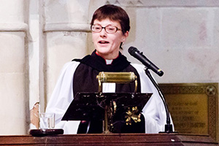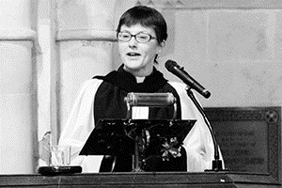

Photo: ‘2018-9 The Ven Sue Groom’
Colour photos folder here
Grayscale photos folder here

Monthly Letter
The Ven Sue Groom
Archdeacon of Wilts

It’s the time of year when we come together to give thanks to God for the safe gathering in of the harvest, and for all that he gives to us. The celebration of harvest should produce an attitude of gratitude.
The traditional hymn ‘We plow the fields and scatter’ with its chorus All good gifts around us are sent from heaven above, then thank the Lord, O thank the Lord for all his love reminds me how poor we are at giving thanks for all the good things in our lives.
We’re far more likely to be moaning and complaining about the irritating and frustrating things in our lives. I’m just as much to blame here as the next person! But why is it? Why are we more likely to moan than to give thanks? I don’t think I’m alone in this.
I was reading an issue of the Saga Magazine recently (yes, I am old enough to do so!) Grandparents were asking for advice on how to encourage their grandchildren to respond to gifts with an expression of gratitude, preferably in the form of a card or letter, but some said that even an email, or a text would do!
Elizabeth Barrett Browning wrote -
Earth’s crammed with heaven,
And every common bush afire with God,
But only he who sees takes off his shoes;
The rest sit round and pluck blackberries.
So, join in the celebration of harvest, have an attitude of gratitude. Give thanks to God for all that is good in your life, for your home, your daily food and fresh water, your family and friends. And say ‘thank you’ to everyone who provides anything for you.
See what a difference it makes to your own life and to your relationships with others when you have an attitude of gratitude.

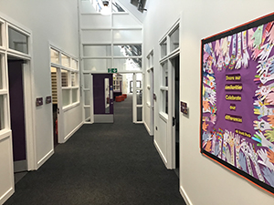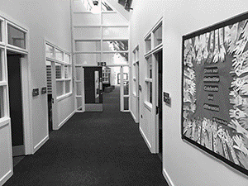

Photo: ‘2018-9 St Peter’s School’
Colour photos folder here
Grayscale photos folder here

New Church School Opens

The first new church school in the Diocese for 14 years has just been officially opened by Bishop Nicholas.
St Peter’s CE Primary Academy is on the huge new developments at the former Land Forces HQ site in Wilton.
Headteacher Oliver Martindale said, “This is every Headteacher’s dream – to build a school, ensuring the highest possible standards of teaching, learning, aspiration and behaviour.
“I will make the most of this extraordinary privilege, as part of the rich network we are establishing with the church and wider community.”
Diocese of Salisbury Academy Trust (DSAT) CEO Mark Lacey said, “Ollie and the staff have hit the ground running, and the children are even more excited!”

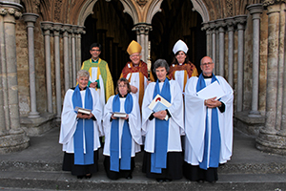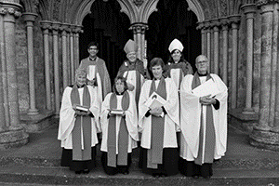

Photo: ‘2018-9 New LLMs 2018’
Colour photos folder here
Grayscale photos folder here

Four New Lay Ministers

Four new Licensed Lay Ministers (LLMs) have completed their three-year training at Sarum College and have been admitted to this office, which authorises them to preach and lead worship, among many other things.
Judy Anderson, Diocesan Associate Warden of LLMs, said, “After rigorous training alongside ordinands, they will now minister in local parishes.
“LLMs have a unique role as highly trained theologians based principally in a secular context. This gives them the opportunity to connect with people who may never come to church.
“If you think you might have a calling to a lay ministry, explore more at salisburycalling.org.”

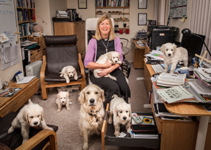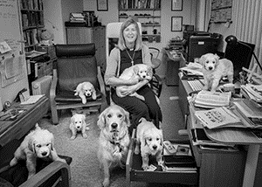

Photo: ‘2018-9 Ali Bridewell’
Colour photos folder here
Grayscale photos folder here

Called to the Countryside

“There is as much opportunity in a rural context to lead a lively, thriving church.”
After a lifetime living in towns, last year the Revd Ali Bridewell started as Priest in Charge of the new Wellsprings Benefice, centred on Devizes.
“All six villages are different from one another, making it very interesting.
“I grew up in St Francis’ Church in Salisbury, staying involved through to adulthood. I eventually led youth ministry there with my husband Stuart.
“Eventually, I became more unsettled in my MoD researcher career, and trained as a counsellor to degree level. At the same time, I found a call to ordained ministry deepening. As I started to test it, the doors opened one after another.
“I was offered a generous redundancy, which funded me to work part-time during my years training at Sarum. I worked for Bemerton Methodist Church’s outreach worker, a great experience of ecumenical working.
“I started training on my own financing, not going to selection conference until February of the first year. I am not a risk taker but had a real sense of God calling me out of my comfort zone!
“My curacy was also in Bemerton. The community centre on the estate was a great base to learn how to be a priest, but was quite pioneering - building networks and community.
“I was surprised to find myself applying to work in a country benefice, but we felt a definite call. The same skills are required as in towns. It’s about making the right connections with people. People are still committed to their local church, although they may not come often on Sunday mornings, so we must connect outside the historic patterns.
“A difference is that a rural vicar can’t be anonymous, but people have been incredibly welcoming and friendly.
“Rural ministry is a full-on job but there are great joys; growing our own vegetables, a strong community and good neighbours. It’s a great place to walk the dogs in tranquil countryside. The village pub is also a great place to build friendships and relationships!”

