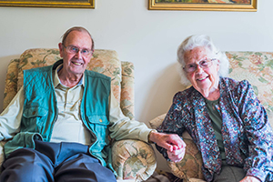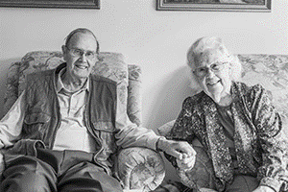

Photo: ‘2018-8 Rob and Margaret Cave’
Colour photos folder here
Grayscale photos folder here

It’s Never Too Late For Love

“God arranged to bring us together.”
Rob and Margaret Cave recently made the news as one of the oldest couples ever to marry. The Wimborne Minster worshippers tied the knot, both within a few months of their 91st birthday.
“It never occurred to us that it was anything out of the ordinary”, says Rob, “We both lost our first spouses three years ago at about the same time. We got thrown together consoling each other. Things went from there.”
“We have so much in common”, adds Margaret, “We both love opera and ballet. More personally, we both lost a son at a relatively young age.
“These days people would say, ‘Why don’t you just live together?’, but that didn’t seem right to us.
“It all happened very quickly. It came up one day as we discussed what would happen when Rob gave up driving, and within seven weeks we were married!”
“We’re both very involved in the Minster”, Rob continued, “I’m a guide two days a week and Margaret takes the weekday midday prayers sometimes.
“Visitors often say there is a distinct atmosphere in the Minster. It has been prayed in over so many centuries.”
“A lovely moment in our wedding”, says Margaret, “was the organist playing Spread A Little Happiness as we signed the register. Without meaning to, we seem to have spread a lot of happiness!”
People may know Margaret from Brief Encounter; she was the tea room assistant, part of a long acting and radio career. Local lad Rob farmed for many years before ending up as a civil servant.

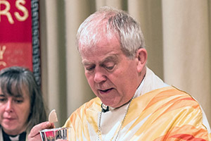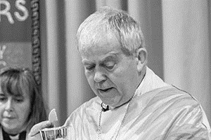

Photo: ‘2018-8 The Rt Revd Nicholas Holtam’
Colour photos folder here
Grayscale photos folder here

Monthly Letter
The Rt Revd Nicholas Holtam
Bishop of Salisbury

A thriving Christian presence in every community is one of the aims of the Church of England. It happens in a number of ways with church buildings, committed Christians, schools and community projects contributing a great deal to the good of our communities, where we live for others in the way of Jesus Christ.
A few weeks ago I took the new Archbishop of South Sudan to some of our churches – the licensing of a Team Vicar in Tisbury, a community environmental day for a Greener Bradford on Avon, Sunday morning at St Thomas’s in Salisbury, followed by the installation of the new Dean in the cathedral.
The Archbishop spoke about the priorities of his church in a country where people have been killing each other and there are millions of refugees. His was a very different context to ours, yet in South Sudan they too were seeking to create a flourishing Christian presence in every community that is good for all in the way of Jesus Christ.
In Devizes we met with other partners from the Lutheran Church in Latvia. They had a different story again. A small country, they emerged from behind the iron curtain. They confidently sit on the border with Russia partly because they are members of the EU. It is a bit more complicated for the Latvian church to find its place in the worldwide Church. They face the same challenges as the rest of us with different understandings of what it is to be human and how we live the Gospel faithfully in our different contexts – men and women, gay and straight and as people with varied political views.
To some extent, where you stand determines what you can see.
We are challenged by Christians from different contexts who see things differently. Being part of the worldwide Church we see what it means for the Church to be local everywhere.

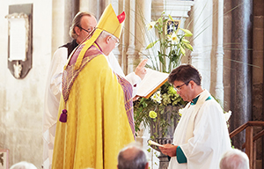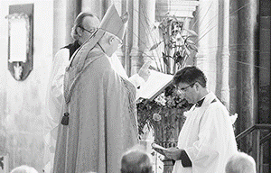

Photo: ‘2018-8 Bishop Nicholas and the New Dean- Photo by Ash Mills’
Colour photos folder here
Grayscale photos folder here
NB: If you use the photo, please credit ‘Photo (c) Ash Mills’

New Dean Installed

The Very Revd Nick Papadopulos was installed as 81st Dean of Salisbury at Choral Evensong on 9 September.
Bishop Nicholas said, “His commitment to this place as a house of prayer in service to the wider community is unwavering. His installation signals a new beginning for Cathedral and city after a difficult year. That joy and optimism extends to Heather, Barnaby and Thea, who we hope will spend many happy years within this community.”
The new Dean, who was previously Chaplain and Press Officer to David Stancliffe when he was Bishop of Salisbury, added, “This place shaped my early ministry and taught me the power of worship and the value of a shared life of prayer; shared with all who visit this extraordinary place.”

Photo: ‘2018-8 canstockphoto13292782’
Colour photos folder here
Grayscale photos folder here
NB: If you use the photo, please credit ‘Photo canstockphoto13292782’

Safeguarding IT Upgrade

A new IT system aimed at reducing the workload and improving compliance on safeguarding is making rapid progress.
The Disclosure and Barring Service Project (DBS Project) brings together in one place all data with respect to DBS certificates and safeguarding training history. It will also proactively notify Parish Safeguarding Officers when DBS checks are needed.
Adrian Smale, who is managing the development, said, “This is just the first stage of a larger initiative to reduce the burden of safeguarding record keeping on both parishes and Church House.
“We are aiming to complete the whole seven-stage project in early 2019.”

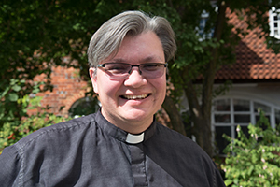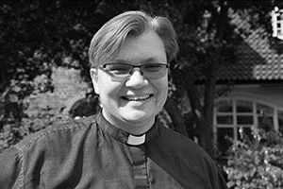

Photo: ‘2018-8 Philip Bromiley’
Colour photos folder here
Grayscale photos folder here

The Joy of Starting Young

“I wouldn’t be the priest I am today had I not been ordained young.”
Still in his mid-forties, Philip Bromiley has been in holy orders for twenty years. The Rector of the Avon River Team, living in Durrington, recently hit the headlines as he took the funeral of Novichok victim Dawn Sturgess.
“I had little time to prepare for Dawn’s funeral, just five days. Without being aware of it, I already knew her daughter, a lovely girl in one of our church schools, who chose the hymns.
“I did a lot of media, taking attention away from the family, helping them grieve in peace. God was deeply present at the funeral. I had messages from across the UK assuring me of prayer.
“I first felt the call to priesthood aged thirteen, on my bed in my pyjamas, asking God what He wanted me to do. My parents, who sent me to church but didn’t then go themselves, panicked and took me to the vicar. His wise advice was neither to rush nor put barriers in God’s way, but keep praying ‘Thy Will Done’ and be obedient.
“Along the way, God gave me plenty of opportunity to say no. There were times when I thought this wasn’t right for me, but then another door opened.
“My curacy was in a huge suburban Blackpool parish, with three funerals a week, one where you either sank or swam! I then moved to this Diocese, first church planting in a Calne housing estate, then 11 years nearby in Oldbury, before coming here last year.
“Parish ministry is so varied. It is a huge privilege to walk alongside people in their challenges and vulnerabilities.
“It is a little daunting that after twenty years, I’m not quite halfway through my ministry. I try to pace myself and keep a work-life balance.
“We need diversity in ministry in terms of age as well as everything else. I have evolved and been shaped throughout my priesthood. It is wonderful to have young people exploring vocation asking God, ‘What would you like me to do for you?’– whether it’s priesthood or something else.”

