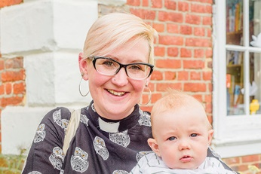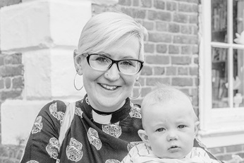

Photo: ‘2018-6 Ruth Wells’
Colour photos folder here
Grayscale photos folder here

Ministry and Motherhood

“I thought having a baby in my deacon’s year might be a problem. It has proven to be a gift, opening many doors.”
Ruth Wells is the Curate at St Mary’s in West Moors and is to be ordained priest this Petertide. Six months after she was made a deacon last year, her third child, Baby Etienne, arrived.
“When facilitating our baby-and- toddler group, I support and am supported by others in a unique way. People whose grandchildren live far away get tremendous joy from holding him at church while I lead worship. Once I led all-age worship with him in a sling, and people found it beautiful.
“Growing up in Christchurch, my family were active in an independent church. As I grew older, I moved to a Baptist church where I met my husband Nick. We did youth work in Bournemouth town centre with young people who’d never go to church but were interested in God and spirituality.
“That made me think deeply about what Church was. I left my very conservative church, spending 10 years in ‘emergent’ churches that met in homes and cafés.
“My path to priesthood started as I needed a steady job! I was appointed Deanery Youth Worker in Poole, so started worshipping in the North Poole parishes I worked in for three years.
“That awoke a call to priesthood as an Anglican. Not just ministry; I’ve a deep sense that being a deacon and a priest is about who you are, not what you do.
“Priests never stop being deacons, charged to serve others and help them flourish. That is about becoming whom God calls us to be, not fitting a mould.”

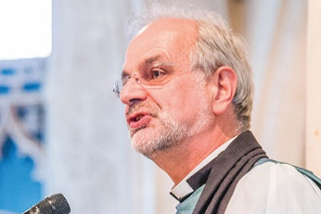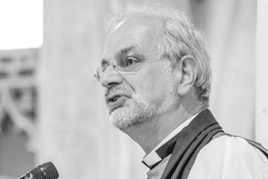

Photo: ‘2018-6 Ven Alan Jeans’
Colour photos folder here
Grayscale photos folder here

Monthly Letter
The Ven Alan Jeans
Archdeacon of Sarum

“The English are a nation of shopkeepers”. A quote from Adam Smith, the economist from 1776, or Napoleon I, dismissing our supposed unpreparedness for war against France?
The recent news of several High Street retailers closing stores is a shock to staff and customers, and many towns will lose a valuable asset. Pray for those whose livelihoods have been affected.
It raised with me the question: how do our English parish churches present as a shop window to their communities?
I’ve just enjoyed the most wonderful Sunday worship. I attended a 9 o’clock Breakfast Church, with terrific coffee and bacon rolls. The service was well attended by young people, mums, dads, and a few grandparents. Accessible worship songs and an interesting reflection on the Epistle gave us much to take away and think about.
Then a new congregation came for a Common Worship Eucharist. We sang well-chosen traditional hymns, and drew near to Christ in the Sacrament, with more coffee and conversation afterwards. This was all the more impressive as the parish is in vacancy.
Later, I attended the Wiltshire Royal British Legion and SSAFA Commemoration of the Centenary of the Armistice that ended WW1.
A full Cathedral with choir and organ, a parade of standards, Shrewton Silver Band, army and sea cadets, veterans, family and friends. A cracking sermon spoke of the failure of humanity to avoid war, and the compassion and tears of God who wept at the loss of every life.
One Sunday, three services, each a different shop window to the world. Each an invitation to come and see, to feel the welcome from a community of faith, and God’s unconditional love.
Pray for our shopkeepers, their customers, and communities. Pray too for the churches and church people who serve the community.

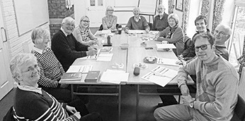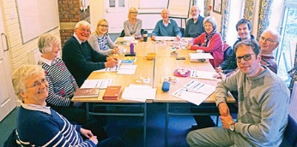

Photo: ‘2018-6 Aldhelm Certificate Group’
Colour photos folder here
Grayscale photos folder here

Learning Together

The newly revised Aldhelm Certificate is a three-term course that helps grassroots Christians journey with others and reflect on deep questions.
Canon David Durston is a tutor to one of the first groups to use the revised course, and said, “Learning together, sharing ideas, has been important.
“We are now in the middle of the second term, Faith in a Scientific World, and discussing particle physics and the Large Hadron Collider, climate change and global warming, and how our faith in God relates to these. This has pushed the boundaries of our understanding.
“The course is missional, helping Christians engage their faith with people’s issues and concerns today. Learn more at www.bit.ly/aldhelm.”

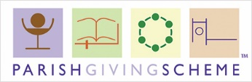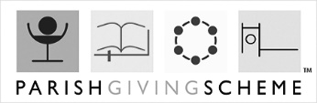

Photo: ‘2018-6 PGS logo’
Colour photos folder here
Grayscale photos folder here

Making Giving Simpler

A year after it launched, nearly a hundred parishes and 850 worshippers locally now support their church through the Parish Giving Scheme.
The new Parish Giving Scheme enables people to give to their church by Direct Debit for the first time, and allows the church to receive the Gift Aid automatically, reducing the administrative burden on both the church and the donor.
Stewardship advisor for Wiltshire John Kilbee said, “A fifth of parishes in the Diocese are already using the scheme. They report that it cuts down on work, helps them with better financial planning, and makes life easier for people than fiddly envelopes.
“Donations can also be inflation proofed and changed at any time if circumstances change. Find out more at www.bit.ly/pgscheme.”

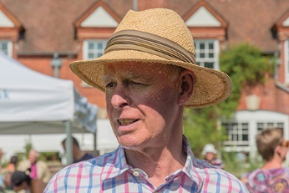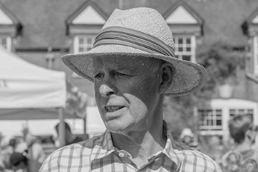

Photo: ‘2018-6 Mike Maclachlan’
Colour photos folder here
Grayscale photos folder here

Saving Lives in the Sudans

“God has shown the most amazing care and support to me while in the Sudans.”
Mike Maclachlan’s faith has been an animating force all his life.
“Aged eleven, at a Christian camp in Scotland where I grew up, I met young leaders whose way of life seemed distinct. It impressed me as altogether more profound than what I’d seen at Sunday School. One way and another God has been prodding me ever since!
“My working life was spent as an in-house corporate lawyer, especially focused on South Asia. My family had been in the Raj – my mother featured in a book The Last Children of the Raj.
“I came to Marlborough in 1974 to work for Burmah Oil, and have been involved in St Mary’s ever since. I’m currently on my second stint as churchwarden.
“I’ve been organising the Sudan Medical Link for fifteen years now. I’m not a medic, so I depend on able lieutenants. We raise over £60,000 per year, which means we can help build clinics and provide training and basic medicines.
“This means things like painkillers and rehydrating salts, common in most countries, but not in very poor South Sudan. It’s amazing which disabling illnesses can be easily cured with them.
“We train midwives, in a country where one woman in seven dies in childbirth, often leaving orphans behind. We train clinical officers who do jobs doctors would elsewhere. Our modest financial assistance helps save many lives.
“My colleagues and I regularly visit to ensure money is well spent. It isn’t always safe, especially at present, yet I always trust that God is in charge.
“I meet church leaders in Juba, the capital, before visiting projects we support around South Sudan. We only give money to organisations with whom we have a trusted relationship.
“Nothing goes to plan and you have to think on your feet. God, behind it all, honours the fact that we are out there on His work. It ‘muscles up’ your faith!”

