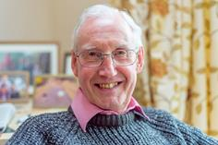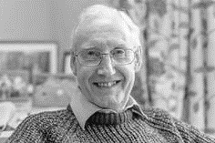

Photo: ‘2018-4 Charles Graham’
Colour photos folder here
Grayscale photos folder here

Helping Churches Be Alive

“We help maintain beautiful buildings but also fund new facilities to help churches stay as living communities.”
Charles Graham grew up in a churchgoing home and with boarding school chapel. At university he realised faith was about a living relationship with Christ, more than a set of beliefs.
“I studied modern languages and went into teaching as a vocation, informed by my faith. I spent five years at Cheltenham College, then thirty at Marlborough. I was Chapel Warden there for many years and helped run the school’s Christian Forum.
“In a boarding school it’s a seven days a week job, so it was only when I retired in 2003 that I found the time to get involved in a parish church, St. George’s, Preshute, where I have been Warden, Secretary and Treasurer
“I love the opportunities to share my faith provided by the Open the Book team at Preshute Primary and Songs of Praise in a care home every month.
“A big part of my Christian activity in retirement has been co-ordinating Ride+Stride for Wiltshire for the past eight years. This is a sponsored walking and cycling event every September.
“It raises money for Historic Churches Trusts across the country. We raised over £50,000 in Wiltshire alone last year. My job involves promoting the event to churches and counting the money after! It isn’t glamorous, but it makes a huge difference to churches.
“It is time for me to move on to other things, but if you think you could succeed me, please contact me on ctg100@hotmail.com.”

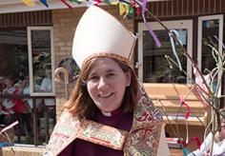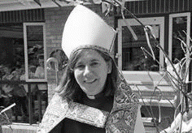

Photo: ‘2018-4 Bishop Karen’
Colour photos folder here
Grayscale photos folder here

Monthly Letter
The Rt Revd Karen Gorham
Bishop of Sherborne

One thing is for certain, Christians are never stationary! In fact as followers of ‘The Way’ we are all Pilgrim People, moving through life with Christ and being changed and challenged as we go.
As Easter gives way to Ascension and Pentecost in May, we are reminded of the change in the first disciples, as they were invited to wait for God’s power to come upon them and then gradually move out to be Christ’s witnesses, in Jerusalem, throughout Judea, in Samaria and to the end of the earth as they shared what they had experienced with others.
We are being invited during this season to pray for those who have not yet experienced the changing power of God in their lives.
It is also a great time of movement in the diocese as we seek a new Bishop of Ramsbury and say goodbye to the Archdeacon of Sherborne. Please join me too in praying that God will be preparing the right people to take up those roles. We pray also for the new Dean as he joins us in September.
With significant people leaving and arriving, the story of the diocese will change, building on what has gone before. God will lead us into new ventures.
The stories of our lives too are important and if we are going to be witnesses in Wiltshire, Dorset, and to the ends of the earth, we are called to share what God has done with others.
My pilgrimages which take place soon are aimed at helping us do just that - as we follow the stories of the saints who have gone before, and in the paths of many pilgrims of old, sharing what God has done with friend and stranger. This will not only connect us to the past, but give us confidence for the future, renewing our hope as a pilgrim people.
Wherever you are going remember God is with you, and that your story of God’s love and hope may be just what someone else needs to hear.

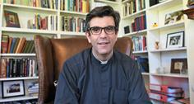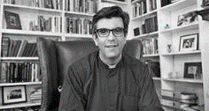

Photo: ‘2018-4 Nick Papadopulos’
Colour photos folder here
Grayscale photos folder here

New Dean Appointed

Canon Nick Papadopulos, currently Canon Treasurer at Canterbury, has been announced as the 81st Dean of Salisbury. He knows this area, having served as Senior Chaplain and Press Officer to the then Bishop from 2002 to 2007. He will be installed at Evensong on Sunday, 9 September.
Canon Nick said, “Salisbury Cathedral shaped my early ministry and taught me the immeasurable value of a shared life of prayer and the extraordinary power of worship. Returning as Dean is an awesome privilege.”
Bishop Nicholas added, ““Nick Papadopulos will be coming back to a place he loves. He has a commitment to the Cathedral as a house of prayer in service to the wider community. We look forward to welcoming him.”

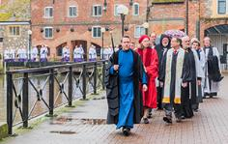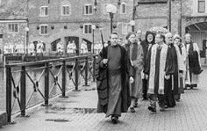

Photo: ‘2018-4 St Thomas' Procession’
Colour photos folder here
Grayscale photos folder here

Church Spy Case Response

The Church continues to respond to event in Salisbury after Russian spy Sergei Skripal’s poisoning in March.
St Thomas’s Church, just metres from the scene, has been in the front line. On Sunday 15 April, it held a service of Celebration of the Community Life of Salisbury to “symbolically reclaim the city for the common good”.
It was followed by a procession to The Maltings area where the Skripals were found. The Revd Kelvin Inglis, Rector, performed an act of cleansing.
Bishop Nicholas preached at the service, saying, “Christians assert, because of the resurrection of Christ, that goodness is stronger than evil, love is stronger than hate, light is stronger than darkness, life is stronger than death. In Eastertide we look forward to new life.”

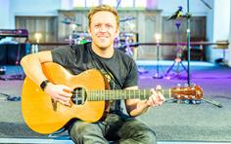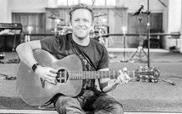

Photo: ‘2018-4 Paul Kingsley-Smith’
Colour photos folder here
Grayscale photos folder here

Join With Heaven

“Worship has been a life-giving thing.”
Paul Kingsley-Smith is Worship Pastor at St Paul’s in Salisbury and his first EP, [Join With] Heaven will be released in a few weeks’ time.
“I grew up in a musical vicarage family. Sixty years ago, my grandad recorded an EP of hymns. My mother was a professional singer, as was my father before ordination. I also went to New Wine regularly, experiencing life-changing Charismatic worship.
“Aged 14, I first felt a call from God to worship ministry and learned guitar. By 18 I was writing songs, but then I had a prodigal son experience, dropping out of both university and churchgoing.
“When my gran was dying a year later I had a profound encounter with God’s presence, which was a wake up call, and I began to take more seriously my faith, and leading worship.
“I met my wife, Laura at New Wine and we spent 3 wonderful years living in New Zealand, where I was worship pastor in a large Anglican church. We then spent a year in Canada where our second daughter was born 14 weeks early and our lives fell apart personally, spiritually, and professionally.
“We came back to England in 2009 with no money. I got a job stacking shelves at Waitrose, and struggled with church.
“By 2013, however, I knew God was calling me back to ministry. In 2014, I started working for Youth for Christ and came to St Paul’s two years later. I experienced such healing here, and this gave me a fresh burst of creativity.
“Disenchanted with the worship music scene’s commercialism, I felt no desire to record. Yet I felt God pushing me. Last year I had a vision of an album title and image. I knew I had to try to raise the money to record, and when it flowed in I knew this was a real call.
“The album title is because the worship of God goes on for ever. We don’t start it, we just join in. People can find out how to order at www.spsworship.org.”

