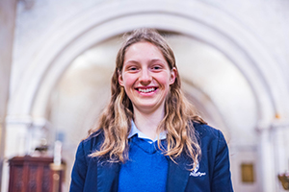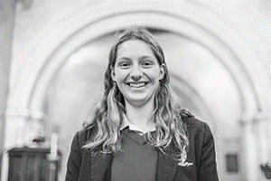

Photo: ‘2018-3 Annelies Nicholson’
Colour photos folder here
Grayscale photos folder here

Singing Internationally

“It’s amazing to be Head Chorister in the year of our first ever foreign tour!”
Annelies Nicholson has been head chorister at St John’s, Devizes, since September. The choir is noted for the large number of local school pupils, like her, who are members.
“We’ve always gone to church as a family, and I really enjoy being part of the St John’s community. Just being in a spiritual place helps me relax. It’s such a contrast with school.
“I joined the choir five years ago, while still at primary school, as I wanted to learn music and to sing in a friendly group. It has been a great experience.
“Being part of the choir has allowed me to make new friends outside school and develop teamwork and leadership. I love looking after the young members, teaching them to read music, and seeing their musical ability develop over time.
“My favourite pieces of choral music are Fauré’s Cantique de Jean Racine and Rachmaninoff’s Ave Maria.
“We’ve toured around England a lot, singing in Cathedrals like Coventry, a magical place with the ancient ruins and new cathedral. I’ll never forget singing in St Paul’s in London, an amazing building and acoustics.
“In August, we’re going to Latvia on tour, and we’re fundraising like mad, from a sponsored swim to a big fundraising concert on 20th April.
“I am so excited about visiting a whole new region of the world for the first time. This also helps the links between the Diocese and the Latvian Church.”

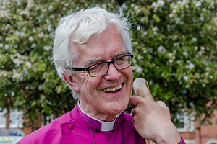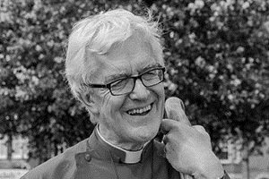
Photo: ‘2018-3 Bishop Ed’
Colour photos folder here
Grayscale photos folder here

Monthly Letter
The Rt Revd Dr Edward Condry
Bishop of Ramsbury

I spent the weekend as a White Van Bishop. We have started moving to our new home. I am retiring in April. We have moved boxes of books and large pot plants, as well as much of the other detritus you collect over the years, with trips to the charity shops too.
A pause in the middle of this, however, to say a Great Big Thank You to everyone in the Diocese of Salisbury. I have very much enjoyed my time here as the Bishop of Ramsbury. I have been very fortunate to be here. I have been blessed with excellent colleagues.
I have particularly enjoyed being a small part of parish life. I have loved coming to churches on Sunday for parish communions, family services, harvest festivals, Remembrance Sundays and carol services. I have enjoyed flower festivals, fund raising events, thanksgiving for restoration appeals, as well as blessing new kitchens.
I have found so much commitment and energy in the parishes of this diocese. There are doom mongers who say that the Church of England’s parish system is on its last legs. They should come here and see otherwise.
There are people faithfully coming to church as people have done for centuries, as well as experimenting with new ways of worshipping. There really is a “mixed economy” of church worship and practice.
The parish congregations are heavily involved in the local communities, as well as raising funds for South Sudan, Christian Aid, the Children’s Society, Macmillan Cancer and much much more.
With 260 churches in the Ramsbury Area alone, I have missed regular congregational involvement, and look forward to that in our new home.
I leave with much thankfulness to God, as well as a strong belief that T S Eliot was right: “Old men ought to be explorers”. Amen.

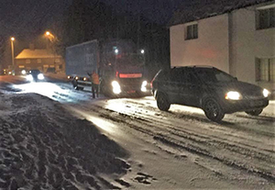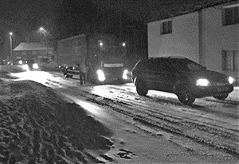

Photo: ‘2018-3 Collingbourne Ducis Snow’
Colour photos folder here
Grayscale photos folder here

Snow Laughing Matter

A vicar is “immensely proud” of her parishioners who stepped up to help motorists stranded on the main Salisbury to Swindon road when the ‘Beast from the East’ hit.
The Revd Jo Reid, Team Vicar in the Savernake Benefice, looked for ways to help motorists stranded in heavy snow in Collingbourne Ducis, where she lives.
“We decided to open the church as a place where people could at least wait in the warm and get a hot drink, and also directed people to local pubs and B and Bs. Some were trying to travel as far as Southampton and South Wales, impossible in the conditions.
“I rang round parishioners late in the evening, knowing it was a big ask, for those who still needed a bed to sleep in and people responded generously.”

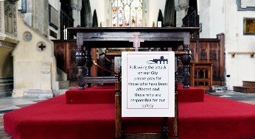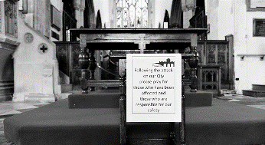

Photo: ‘2018-3 St Thomas' Altar’
Colour photos folder here
Grayscale photos folder here

Salisbury Church Responds

St Thomas’s Church in Salisbury has been responding to demands for spiritual and practical support. It is just metres from the bench where former Russian spy Sergei Skripal and his daughter Yulia were found poisoned.
The Revd Kelvin Inglis, Rector, said “We are open from 8am to 5pm every day for prayer and reflection. We know many people are upset by this attack on our city, and we have set up a prayer station where they can go and spend time with their emotions, and with God in a place of peace.
“This attack is a violation of the peace and prosperity of the city, and we shall respond on 15 April with a service that will reclaim the city for the common good. This will include an open air ceremony where Sergei and Yulia Skripal were found.”

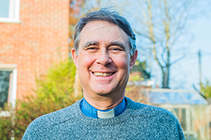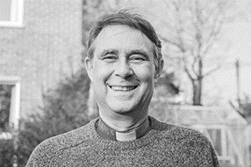

Photo: ‘2018-3 Simon Weeden’
Colour photos folder here
Grayscale photos folder here

Freeing Folk for Mission

“Bringing people to Jesus is what I love!”
The Revd Simon Weeden’s childhood involved the ritual of school chapel, but he began to seriously explore faith as a young civil servant in Whitehall.
“My wife has always been a Christian and I started going to church with her. In 1984, Luis Palau came to do a mission and his preaching struck me.
“I didn’t want to be swept along by a crowd, so took time to consider his message, and finally decided to follow Christ during a tube journey to work.
“In 1988, I went to train for ordination at Wycliffe Hall in Oxford. Since then, I’ve worked in rural parishes around the South – even while Mission Enabler for Milton Keynes Borough.
“We always said that once our sons were at university, we’d move back to smaller communities, and so we came to the Whitton Benefice eight years ago. This is six village churches in four parishes with 6,000 people in total, near Marlborough. Ramsbury, with its Saxon church heritage, is one of the largest.
“It took me four years to realise a big issue was finding 75 people to fill all legally required posts. In 2014, we began a journey of reducing this burden to free people for ministry and mission.
“A churchwarden from each church joined a working party to explore options, including clustering, but decided the best solution is a single PCC with local church committees (LCCs).
“The LCCs do a lot of the day-to-day running of churches, but the legalities and focus are with the PCC, leading to shared skills and economies of scale for things like insurance and safeguarding.
“Since we changed on 1 January 2017, we had extra capacity for events like a prayer week with 250 children and 70 adults, a Living Nativity, a programme for older people and more Open the Book.
“Part of a church leader’s job is to help people find their God-given gifts, rather than fitting them into boxes!”

