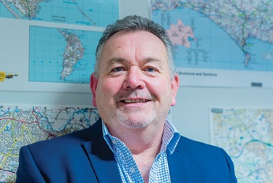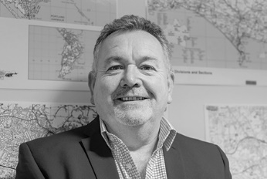

Photo: ‘2018-2 Martyn Underhill’
Colour photos folder here
Grayscale photos folder here

Faith in Policing

“You can’t be a church member without commitment to protect the vulnerable.”
Martyn Underhill has been Police and Crime Commissioner (PCC) for Dorset since the post was created in 2012. An independent, he started attending St Clement’s, Parkstone, after moving to Poole from Sussex, supposedly to retire.
“My career as a police officer was often draining and high profile. I’m probably best known as the detective who led the investigation into the disappearance of 8-year-old Sarah Payne in 2000.
“When the PCCs were created, I saw no place for party politics in operational policing and decided to run.
“I love my job! I’m responsible for setting the budget and policy for the police and holding the Chief Constable to account; for bringing the fragmented elements of the criminal justice system together; and commissioning services to fill in the gaps in provision, for example for victims’ services. As police numbers fall, the gaps are growing.
“I was brought up in the church but lost God as a London cop in the 1980s, partly due to the things I saw in my job. I came back to church in 2010 through St Clement’s. I liked it so much, my wife Debs and I booked our wedding there!
“I like a sermon that challenges me to think about life, sins and community.”
“Debs suffered from a brain haemorrhage in 2016. She was given the last rites, but recovered, although with life-changing consequences. Our vicar, Jonathan Foster, has been sacrificial in his care and prayer for us.”

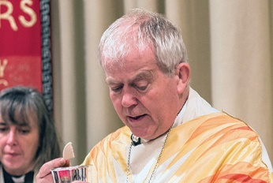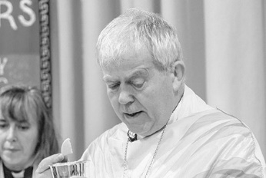

Photo: ‘2018-2 The Rt Revd Nicholas Holtam’
Colour photos folder here
Grayscale photos folder here

Monthly Letter
The Rt Revd Nicholas Holtam
Bishop of Salisbury

In Lent Christians focus on what matters – prayer, food and on what and whom we set our hearts. We are invited to pray, fast, and love others as well as ourselves. We are encouraged to give to charity because giving is good for us as well as for people in need.
Lent is time for a simple life which is why people give things up. For some of us it is amazing what we do not need! Lent is time set aside for self-examination to help us be Easter people who live in response to the resurrection of Jesus Christ.
You can teach people to pray. There is quite a lot in the Gospels where Jesus teaches his disciples, including the Lord’s prayer: keep it simple, be direct, ask for what you want, be open to God and one another. St Paul gave lots of good advice about prayer: be thankful, pray continually, live in the Lord. There is a wealth of material to learn from others, the saints down the ages.
I have just been given the newly published prayer book of Evelyn Underhill, one of the great Anglican writers on prayer and spirituality in the 20th Century. It is her collection of other people’s prayers together with those she wrote. We could all do that for ourselves. We learn to pray by doing it, acquiring the habit of prayer.
People keep Lent in lots of ways. Praying Together is at the heart of our keeping Lent as a Diocese. For a few minutes each day we will pray by reading a short passage of scripture, a reflection, prayer and action. When Easter comes we are at one with God, one another and all creation.
In the risen Christ truth, goodness, love, justice and mercy meet one another and us. Easter is like God bringing us home. Lent is preparing for the journey.
You can find out how to join in with Praying Together by ordering a booklet, downloading an app, or getting a daily e-mail at www.bit.ly/prayingtogether.

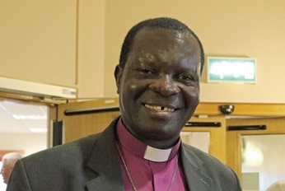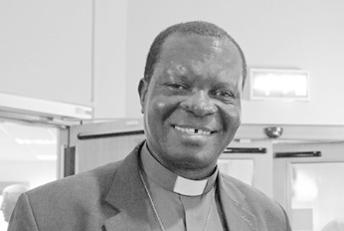

Photo: ‘2018-2 Archbishop Justin Badi Arama’
Colour photos folder here
Grayscale photos folder here

New South Sudan Primate

Bishop Nicholas has congratulated and asked for prayers for the Rt Revd Justin Badi the new Primate of South Sudan.
Currently Bishop of Maridi, Justin was chosen in late January by a college of bishops, clergy and lay people.
Bishop Nicholas said, “A new chapter in the life of the Episcopal Church of South Sudan has opened. We in this Diocese send Justin our congratulations and pray for the forty-five-year relationship between Salisbury and South Sudan, to which there is such strong commitment and which has so much more potential.
“We pray that God will bless Bishop Justin as he takes on this role. May he bring peace and unity, and strengthen the bonds of affection with the wider Anglican Communion.”

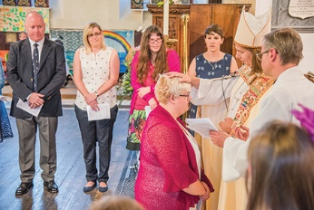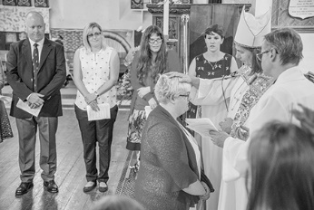

Photo: ‘2018-2 The Bishop of Sherborne confirms Hannah Goddard’
Colour photos folder here
Grayscale photos folder here

Confirmations Up By 15%

The number of confirmations held in the Diocese increased by 15% during 2017, with those of young people growing most rapidly of all.
The total increased from 552 in 2016 to 634 last year, with those aged 18 or under growing by 20%. This follows decades of steady decline, locally and across the country.
Bishop Nicholas said, “Being confirmed is a great way for people to say they are following in the way of Jesus Christ, that they are his disciples.
Hannah Goddard, who was confirmed at St Mary’s, Gillingham last year said, “I feel blessed and closer to God than I had expected. The story of the loving father goes, no matter what happens or what we do, God will always love us.”

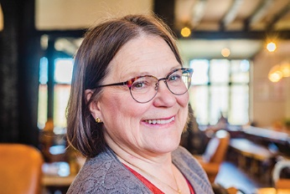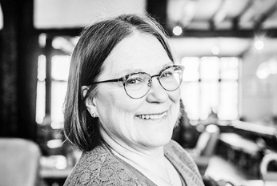

Photo: ‘2018-2 Debbie McIsaac’
Colour photos folder here
Grayscale photos folder here

Learning to Grow Churches

“Lay and ordained people working together should be our model.”
Debbie McIsaac is the Deanery Lay Chair of Alderbury and part of a two-woman team taking part in a national course on rural church growth supported by the Diocese. She came to a lively faith relatively late in life.
“I grew up in Canada on the fringe of church, and later moved to London to work as a City lawyer and then the Law Society’s monitor of training contracts.
“In the early 2000s, a fellow member of the parent-teacher association at my daughter’s school worshipped at a large Central London church. I finally gave in to her invitations to attend an Alpha supper. I came to faith in an undeniable way at the Holy Spirit weekend.
“It is great when churches get new Christians involved in ministry quickly. Within months I was speaking at their leadership conference.
“In 2004, we bought a house in Pitton and I started attending St Peter’s.
“I’m committed to rural church growth, so I wanted to be part of the Diocese’s Leading Your Church into Growth programme. I signed up with the Revd Jane Dunlop, our Assistant Rural Dean, to take part in the Germinate course.
“We travel to the Midlands together every few months for the residentials. This is a big commitment, but gives us time together to reflect. Other participants come from different denominations, which is very healthy.
“The first residential was my most significant learning experience of the past fifteen years. Rural issues are embedded in the course, not bolted on. Participants work in multi-parish benefices, sharing the same challenges.
“I’d recommend it to anyone helping lead a rural congregation. There are also other types of training available to suit different churches and teams.”
Learn more about the Diocese’s plans to help clergy and people in rural churches lead growth at www.bit.ly/ruralhope.

