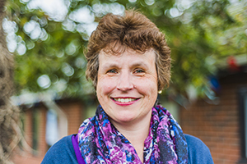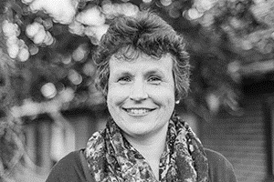

Photo: ‘2017-9 Margaret Bossom’
Colour photos folder here
Grayscale photos folder here

Building A Bigger Church

“If you think you’re being called to manage a building project, pray lots!”
Margaret Bossom coordinates a major building project at Christ Church, Creekmoor on the outskirts of Poole.
“Creekmoor is a modern estate with about 6,000 people. It’s a very ordinary place. There is some poverty and nobody is very well-off. Loneliness and isolation can be real problems.
“Christ Church was built in the 1980s, but as the community has grown, it needs to also. We have a heart for worship and community service, but we don’t have the space to carry out all the activities we’re being called to do.
“Our worship space doubles as a hall, meaning we can only host one activity at a time. Our planned extra support for the community means we need to extend the church, and add an upstairs room. We’ve raised nearly £700,000 and have about £200,000 to go.
“I grew up locally, in Bournemouth, in a Christian home. I went to church, but it’s hard to say if I knew God. When I moved to Creekmoor, I had a powerful encounter with the Holy Spirit. I had always been musical, and found myself involved in the worship team here.
“In 1999, I felt God calling me to give up my then job in management in Barclay’s IT department. Soon, I had a chance to take voluntary redundancy.
“My Mum had a stroke, so I had time to care for her, but also to become church steward and then administrator.
“My heart is still happiest when I help lead worship. That keeps it all real!”

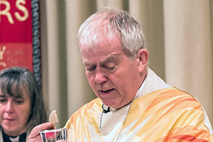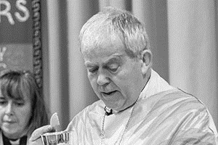

Photo: ‘2017-9 The Rt Revd Nicholas Holtam’
Colour photos folder here
Grayscale photos folder here

Monthly Letter
The Rt Revd Nicholas Holtam
Bishop of Salisbury

31 October is Reformation Day. It isn’t widely kept in the Church of England, but is very important to Lutherans.
This year’s is a special commemoration. Five hundred years ago, on 31 October 1517, Martin Luther, then a monk, posted his Ninety-Five Theses at the Castle Church in Wittenberg.
If there was a ‘start’ to the Reformation, this was it. Luther challenged corruption, translated the scriptures into the everyday German of the people, and wrote hymns and music that got congregations singing theology, and which through that shaped belief and actions.
It drove changes to church and society that rapidly spread across Europe and are now reflected worldwide.
One of the things I love about Luther, besides having married into his now distant and far flung family, is the way his table talk has been recorded: convivial conversations with people about serious issues.
He wasn’t an easy person and became even more difficult as he got older. My wife says almost the only person able to challenge him was his wife Katharina.
Luther’s strength was in following his conscience. He may never have said “Here I stand I can do no other”, but that represents his thought accurately and is not just a bloody-minded obstinacy.
It is the strong principle of a conscience properly formed by careful thought and conversation, and by his careful and prayerful reading of scripture, in which he found what others had not yet seen.
What was at first deeply unpopular has become common orthodoxy as each of us encounters God in Jesus Christ.
This is how change happens. The German philosopher Schopenhauer said, “All truth passes through three stages. First, it is ridiculed. Second, it is violently opposed. Third, it is accepted as being self-evident.”
Reformation Day this year might help us to think and pray about that.

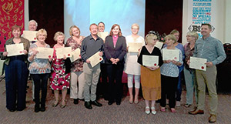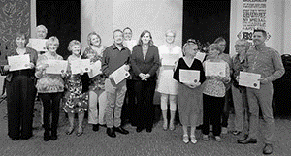

Photo: ‘2017-9 Aldhelm Relaunch’
Colour photos folder here
Grayscale photos folder here

Christian Learning for All

A Diocesan course for lay Christians to reflect on and learn about fundamental questions has been relaunched.
The Aldhelm Certificate: Faith in God’s World is for people with little theological education, but a passion for learning about their faith. It was re-launched at St Barnabas Church, Bearwood, where participants of the most recent course received their certificates.
Bishop Karen, who presented the certificates, said, “This is an opportunity for people to grow in faith and knowledge with others locally.”
Matt Smith, a local plumber who received a certificate, added, “The course enabled me to consider issues at a deeper level, which for me has brought about a greater acceptance and understanding of other worldviews.”

[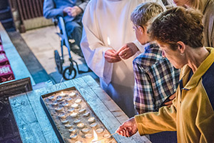 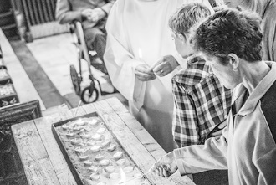

Photo: ‘2017-9 Pray for Each Other’
Colour photos folder here
Grayscale photos folder here

Pray for Each Other

The Bishop of Sherborne has asked churchpeople to pray for one another using the Diocesan Cycle of Prayer.
The Rt Revd Karen Gorham said the prayer cycle was available in a variety of formats to suit different people.
“The Diocese’s vision is Renewing Hope: Pray, Serve, Grow”, said Bishop Karen, “Scripture urges us to pray for one another (Ephesians 6:18).
“The Diocese’s cycle of prayer means every parish and church school is prayed for regularly, as are our brothers and sisters in Sudan and South Sudan.
“The cycle is available on an app or by daily e-mail, or there is a version to print out and keep at home or church. Find out more on the Diocesan website at www.bit.ly/cycleofprayer.”

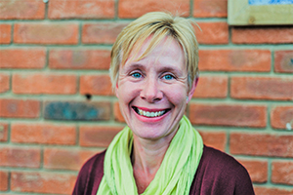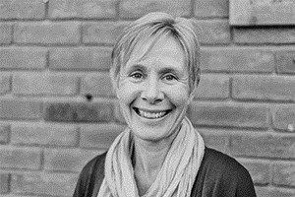

Photo: ‘2017-9 Sharon Boyle’
Colour photos folder here
Grayscale photos folder here

Called to the Countryside

“I feel excited to be training specifically for rural ministry.”
Sharon Boyle started training for ordination in September. She’s breaking new ground as one of the first people on a new Rural Training Pathway at Sarum College, which is supported by the Diocese.
“I was brought up in a churchgoing family in Bournemouth, and was confirmed at All Saints’, Southbourne. Aged 14, however, I went off the rails in many ways and dropped out!
“By 1994, I was a paediatric nurse in Southampton. I kept seeing adverts recruiting people to work with children with HIV in Romania. I eventually put my name forward. As the post was with a Christian charity, I went to church before I went – the first time in years!
“My roommate in Romania, Sally, still a close friend, introduced me to Bible studies, and there was worship at the hospice. Most of all, the children brought me back to God. They were so sick, yet full of faith and trust in Jesus.
“After I met my husband, we settled in Dorset in 1999. We first worshipped at St John’s, Wimborne, then moved to St Michael’s, Colehill, as it’s our parish church. Also, the liturgical tradition there was like coming home for me.
“Since 2010, I’ve been working for Pramacare, a Christian charity which provides home care to elderly people. Our clients are mostly isolated and vulnerable, not least in rural areas.
“I work as a trainer now, and love enabling people to do things they’ve never done. Especially in rural ministry, a priest must be an enabler of lay people.
“When I started discerning a call to ordination, that need for community in the countryside switched me on to the idea of rural ministry. With state social care being cut, the Church has a particular role. Another big task for the Church is bringing the generations together in a divided society.”

