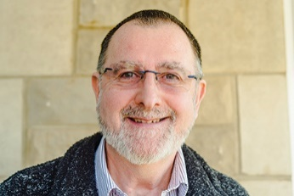
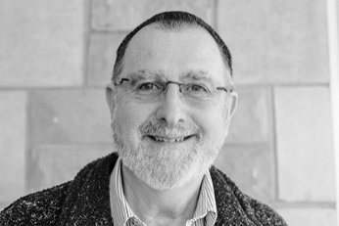
Photo: ‘2017-3 Peter Martin’
Colour photos folder here
Grayscale photos folder here

Welcoming People Warmly

“I believe churches must have a warm welcome - in both senses of the phrase!”
Peter Martin recently led the renewal of the heating system at his church, St James’ in Trowbridge. For him this was a calling, not just a job.
“I grew up in a small but busy church and gave my life to the Lord at nineteen at a Christian house party.
“My wife, Jackie, and I were looking for an Anglican Church and came to St James’. I loved how friendly it was. The idea of the family of Christ is important to me and I could see that here.
“Unfortunately, the underperforming heating system meant the temperature could be a lot colder than the welcome!
“I’m an environmental scientist and worked in sustainable energy before retiring, so our rector, the Revd Rob Thomas, suggested I help sort things out.
“We found it was important to go to church heating specialists. Local general heating companies didn’t always give the right advice.
“We found that we could afford a major improvement but not a full new system. People often think it’s all about the boiler, but in our case, a bigger issue was that we were under-radiatored – apparently that’s common in churches.
“I always felt a call to serve the Church but not as a minister. I do have a spiritual role running Bible studies,but my practical and project management skills are just as much part of God’s call to me and, I hope, just as valuable to the Church.”

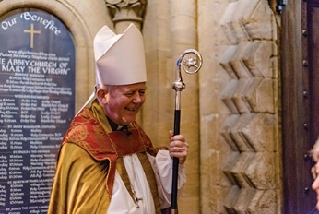
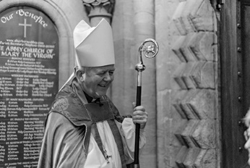
Photo: ‘2017-3 Bishop Nicholas’
Colour photos folder here
Grayscale photos folder here

Monthly Letter
The Rt Revd Nicholas Holtam
Bishop of Salisbury

This Lent we are Praying Together as a Diocese. Each day, we read a short Scripture passage, followed by a reflection, prayer and action. I hope it is going well for you. If you haven’t got a booklet – we gave out 25,000 – you can get the daily material from the website.
It is a simple Lenten feast. The first weeks’ themes have been temptation, conflict and suffering. We must all face what it is to be human. Praying helps direct our lives to God. It is the Pray part of Renewing Hope – Pray, Serve, Grow.
I hadn’t expected Pray, Serve, Grow to be so integrated. The Salisbury-Sudan link began in 1973 when the bishop hoped informed prayer would lead to informed giving. It did, and then on to partnerships across the diocese with Sudan and South Sudan. We have received immeasurably more than we have given. Our Sudanese neighbours in God’s world have shown us how to live with faith and hope under the pressures of conflict and poverty.
Praying Together and the Diocesan Lent Appeal go hand in hand. After the hope of independence in 2011, through temptation and conflict South Sudan has fallen back into violence. The economy has collapsed and malnutrition has taken a firm hold.
The suffering is great, with 3.4 million displaced from their homes, at least 100,000 facing starvation and a further million on the brink of famine. We cannot do nothing. I am appealing for urgent help for our brothers and sisters.
So far, more than £16,000 has been raised and I think we can raise £50,000. UNICEF estimates that could feed around 2,500 children for a month.
You can donate online via JustGiving at www.bit.ly/ssudanappeal.
You can give by text message. Send “SSUD17 £10” to 70070 to give £10.
You can make a cheque payable to Salisbury DBF SSA. Send to South Sudan Appeal, Church House, Crane Street, Salisbury, SP1 2QB.

Photo: ‘2017-3 Eco Church Logo’
Colour photos folder here
Grayscale photos folder here

Caring for God’s World

Diocesan Synod has agreed a new environmental policy, committing it to working towards an Eco Diocese award.
Eco Diocese is a national award scheme. It encourages dioceses to take Christian environmental teaching seriously, and change practice from buildings and land management to investment.
Bishop Nicholas said, “As the Church of England’s lead on the environment, I am encouraged that this diocese has set out for this award after a unanimous Synod vote. We are the sixth Diocese to commit to this programme. Perhaps we might be the first to achieve an award?”
To become an Eco Diocese, many parishes need to engage with the Eco Church programme by preaching and practising care for God’s creation. Learn more at www.ecochurch.arocha.org.

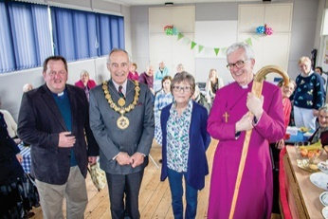
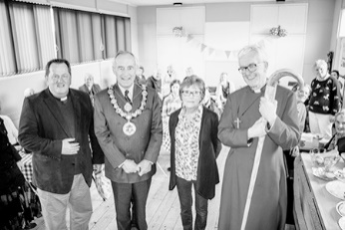
Photo: ‘2017-3 CrossBar’
Colour photos folder here
Grayscale photos folder here

Serving Our Neighbours

A church-run community café is seeking to connect neighbours on a Salisbury estate.
St Mark’s runs CrossBar every Thursday in Bishopdown Farm, providing a place for local people to grab quality coffee and cake, connect with one another, and, if they wish to, keep in touch with the Church and access spiritual support.
Ed Condry, Bishop of Ramsbury, came to the launch, saying, “This is a classic example of church outreach: warmth, friendliness, welcome and shelter.”
The Revd Jim Findlay, Vicar of St Mark’s, added, “We ran a well-attended carol service in December and our future plans include live music events.
“It is important that the Church gets out and meets people where they are – both geographically and spiritually.”

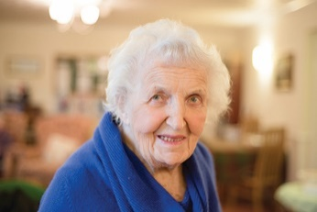
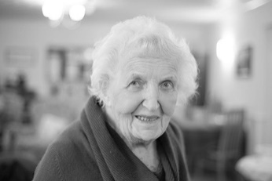
Photo: ‘2017-3 Wyn Smith’
Colour photos folder here
Grayscale photos folder here

A Platinum Faith

“MU can still offer young women a lot, especially through international links.”
Born in 1921, Wyn Smith has been a Mothers’ Union member for 70 years.
“My parents weren’t churchgoers, but there was an Elim Sunday school on our road in Portsmouth. I wanted to be saved at the revival meetings but was too shy to come to the front! When I was 11, we moved house and I started to go to St Cuthbert’s, where I was confirmed.
“I went to work at sixteen, and also started going to Red Cross meetings. I wanted to be ‘saved’ by the firemen at practices! So I was called up as a full time first aider when war came.
“After two years, my parents moved to Chideock in Dorset. I didn’t want to go but soon I got to like it. The people were so much friendlier than in the city.
“I got a job as a shorthand typist, and was the first woman ever to work at Bridport Council. Waiting for the bus to work one day, a man called Harold gave me a lift, and soon we were married.
“In 1946, a neighbour persuaded me to come to a Mothers’ Union young wives’ group. I had to be vetted by the Rector’s wife and two others. It was very scary.
“We were both very active in local life. Harold was a councillor for many years and mayor twice. I held offices in local organisations from school governors to the swimming club, as well as MU.
“Harold was a reader for 15 years, and then at 55 started training for full-time ministry. He spent ten years in charge of five churches in the Bride Valley, and sadly died seven months after he retired.
“I now go to church with my daughter Janis Moore, who followed her father into the priesthood.
“I continued to be active in voluntary work when I retired as a PA. I still do my own cooking, and I’m Treasurer of St Swithun’s Vestry Extension.
“MU membership has declined in this country, but we do a lot to support MU in countries where it is a vital voice for empowering younger women.”

