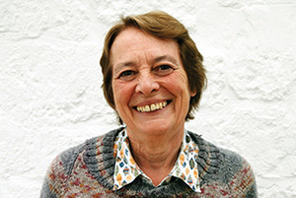

Faith and Fiction

“Fiction develops empathy, which is central to what God wants us to do.”
Gillian Cross is a children’s author and churchwarden at St Mary the Virgin in Compton Abbas. She is best known for the Demon Headmaster books, also made into a BBC children’s TV programme.
“I started writing as a young Mum after helping set up a Children’s Book Group. After five years, I was close to giving up when I got two acceptances in one week.
“Setting out to push a message doesn’t work, but fiction can be topical. Last year I won a prize for After Tomorrow. It’s about two British boys who flee to France as refugees after a banking collapse leads to social breakdown.
“My parents went to two different C of E churches! My father was organist at a Central London Anglo-Catholic shrine church, while we children worshipped locally in Harrow with my mother. As with many, a serious teenage Christianity slid away at university.
“I came back to faith through friends and housegroups at the village church where we lived 20 years ago. That renewed faith was about giving my emotions to God, not just my intellect.
“We moved to Dorset in 2009 – my husband Martin is from the area. I’m in my third year as warden. Two of us volunteered, after a period when we had none. It’s a vital role in making a church run smoothly, especially in a team ministry with eight churches.
“In this tiny parish of 200 people, church is still a vital gathering place, especially at times like Harvest.”

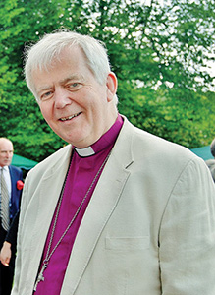

Bishop’s Letter
The Right Revd Nicholas Holtam
Bishop of Salisbury

The present refugee crisis feels like one of the biggest challenges of our lifetime. There are long-term political issues about the need for stability in the Middle East. Peace and justice go hand in hand. Our commitment to the rest of Europe is also challenged and the UN’s finance and organisation are being strained.
These are political problems but politics is informed by belief and values. The first meeting of the General Assembly was in Methodist Central Hall, Westminster, in January 1946. The following week the UN Security Council met for the first time across the road in the C of E’s Church House. Christians at the time were deeply committed to post-War reconciliation. The world had to learn how to work and live together. We still do.
I recently preached at Helen Dawes’ institution as Team Rector in Shaftesbury. The reading was Matthew 20.24-34 in which Jesus asked two blind men sitting on the roadside outside Jericho, “What do you want me to do for you?” They asked, “Lord, let our eyes be opened” which is exactly what Jesus did. It’s what we all want – sight and insight – but be careful what you pray for.
The photograph of a 3 year old washed up on a beach opened our eyes and hearts. It has changed us and there is no going back, thank God. Churches are among the first to organise in preparation for our welcoming refugees as part of an urgent collective humanitarian response. There is information on the Diocesan web site and it will continue to be updated. We need to act carefully, thoughtfully and well.
It is the universal ‘Golden Rule’ expressed by Jesus as, “Do to others as you would have them do to you.” (Luke 6:31). It is the way to renew hope for ourselves as well as for the refugees. Pray, serve and we will grow as people with larger hearts and greater love.

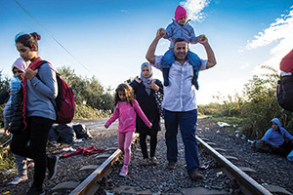

Churches Respond to Crisis

Local churches are responding to the refugee crisis, sometimes as a direct response to worship and prayer.
Worshippers at St James’, Ludgershall, responded after the Sunday Eucharist readings included Jesus healing the daughter of a foreign woman, opening the ears of a deaf man, and St James declaring “faith without works is dead”.
They decided to pray, donate clothes to Calais, money to the Red Cross, and lobby their MP and County Councillor.
St Mary’s, Longfleet is sending three vans of food and toiletries to Calais. St James’, Alderholt has collected clothing for refugees in Dohuk, Iraqi Kurdistan.
Local politicians have praised churches for their response to the crisis, including Salisbury MP John Glen.

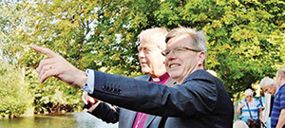

Loving All God’s Creation

Canford Magna Parish Church and Canford School came together to open a beautiful stretch of river to mobility-impaired people for the first time.
The Kingfisher Riverside Project built an accessible viewing platform next to the school’s boathouse on the River Stour. RSPB is co-ordinating volunteers to welcome visitors with guided walks and wildlife talks, while the Parish will provide teas to visiting groups.
Bishop Nicholas said, “This project enables the diversity of God’s creation to be enjoyed by the wonderful diversity God has created in humanity.”
Local Team Rector, Canon Chris Tebbutt, said the project would “boost inclusion, wellbeing, our environment and, at its best, our spirituality.”

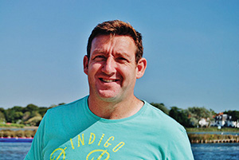

A Faith Lost and Found

“I lost my faith in the face of death and got it back again in the face of death.”
Matt King is the principal percussionist with the Bournemouth Symphony Orchestra and a Professor at the Royal Marines School of Music. He is on the teaching team at St Mary’s Longfleet in Poole. Brought up in a Salvation Army home, his faith journey is one of death and resurrection.
“I was training as a Royal Marine when the IRA bombed our School of Music in 1989”, says Matt, “Eleven people died, many of them teenagers. Like many others who were first to the scene, I was only a teenager too. I witnessed terrible things that day, and was so angry I lost faith in a God who let them happen.
“I studied Law at Cambridge after my Short Service Commission, where the atmosphere made me an intellectually convinced atheist. But when my Dad suffered a brain tumour, his confidence in what lay next challenged me.
“On his deathbed he told me, his baby boy, to stop hiding behind cleverness and allow my Earthly and heavenly fathers to love me back to the Kingdom.
“I then went to music college in London, where I met my wife, Clare, and got this job in 2000. It’s a privilege to inspire people through music. To me, Bach said it all. His music is as close to perfection as it gets. Yet, at the end of each piece he wrote SDG, or ‘to God alone the glory’.
“Church is about being salt and light to the world, not just feeling good. That’s why I’m so passionate about teaching.
“We need to be Bible-based, with all that implies in terms of loving every person God has made, especially the vulnerable and marginalised. We also need to remember a faith centred on the Cross is about fallibility more than success.
“I’m just returning to work after 6 months off with a shoulder injury. I realised God was making me worry less about ambition than being present for my little sons, Sam (3) and George (5).”

