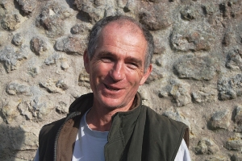

A Practical Christianity

“Climbing off a roof to go and lead a Eucharist in chapel feels natural here.”
The Revd Jonathan Herbert is based at Hilfield Friary, although he’s not in friars’ vows and is married to Suzi. Ordained in 1988, he worked on council estates in the Midlands before coming to Dorset’s Pilsdon in 1996 to try living in community. That’s where he discovered he is a natural handyman.
“At Pilsdon, we helped men rebuild their lives after crisis or addiction, and a work routine helped. Many were skilled craftsmen or builders and I learned a lot from them. Working alongside people helps in sharing lives.
“Once, someone had to learn to wield a chainsaw to chop wood so I gave it a go!
“After 13 years in Pilsdon, 5 of them as Warden, it was time for something new. I came to Hilfield for a bit of space to work out what was next and I’m still here six years later. I’ve learned more skills putting in our eco-friendly biomass heating system, like how to dig trenches with a mini-digger.
“I’ve long admired the old Worker Priest Movement”, says Jonathan, “I really value that sort of ministry of journeying with people in secular life. When the Archdeacon of Sherborne asked me to be the Diocese’s Chaplain to Gypsies and Travellers, I realised it was exactly that sort of ministry.
“I started that post in June, and do that when I’m not fixing the roof or the boiler at the Friary. It’s a privilege to work with a rich and fascinating culture that is now under such pressure.”

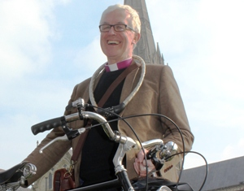

Bishop’s Letter
The Right Revd Dr Edward Condry
Bishop of Ramsbury

We say that conscience pricks. Well, I certainly feel very uneasy when I see the plight of those stranded in Calais.
Let’s not call them “asylum seekers” or “illegal immigrants” as that just dehumanises them. These are real people with real human stories.
The majority of them in Calais have escaped from war torn Syria, and have endured great hardships in their journeys as far as the Channel.
Of course I feel uneasy when I see TV footage of young men in hoodies lit by street lamps. I can too easily imagine that they threaten my way of life.
Nevertheless, we have a long history of hospitality in this country. My own ancestors include Huguenot escapees from religious persecution in France, and Irish men and women forced to leave their country at the time of the potato famine. They found their home here.
I am not suggesting that we allow everyone and anyone to come here.
However, Jesus asked us always to greet most especially those who are not like us. Those who unsettle our consciences. It is these people who are our neighbours. These people who we should not pass by. Our “neighbours” are not simply those who live next door.
These people who are human beings made, as St Paul said, in the image of the invisible God Himself.
They deserve our compassion.
We are debating whether immigration is a threat to British values in Marlborough Town Hall at 7.00pm on 30 September. Come along.
So if we are not going to let everyone in, then surely we should at least treat all people with respect and care. Razor wire and riot police are not part of giving Christian hospitality to strangers.

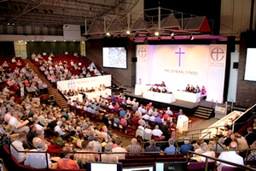

Filled With New Wine

Several hundred people from across the Diocese attended the New Wine Christian festival in Somerset.
New Wine is best known for its big stage charismatic worship, but that’s only part of what it does. It also offers lots of training opportunities, bible studies and more reflective worship.
The Revd Charlie Boyle led a group of 20 from All Saints’ Church in Branksome Park. “It was our first time and we really enjoyed it”, said Charlie, “especially our three sons. The teaching is really good for children and adults alike and there are lots of fun activities.”
“I was impressed by how inclusive it was”, added his wife Sarah, “particularly of people with disabilities.”
Learn more at www.new-wine.org.

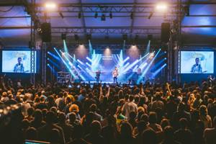

General Synod Needs You!

The General Synod is the national assembly of the Church of England, commonly referred to as the ‘Church’s Parliament’. It makes church law, sets the national church budget, regulates public worship, and debates matters of public interest.
The Church needs a General Synod which reflects its diversity. Voices of people of all ages, backgrounds and traditions. Young people, people with disabilities and ethnic minorities especially need to be better represented.
Christopher Fielden, a worshipper at St Mary, Broughton Gifford, is standing down from Synod after 5 years. He encourages others to go forward. “If you want to get changes made, you must be there to help it happen”, he said. Learn more at www.bit.ly/SarumSynod.

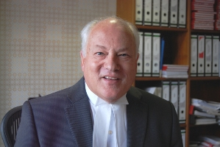

Faith in Justice

“My faith gives me peace and solace, helping me recover after a tough trial.”
His Honour Judge Keith Cutler CBE is the senior, or Resident, Judge at Salisbury and Winchester. He is an active member of St Nicholas, Porton, and was churchwarden for nine years.
“I grew up in the Church”, says Keith, “singing in choirs from the age of 7, something I still love. I met my wife, Judith, when we both sang at the church I attended while at Bristol University.
“I’ve always been what you might call middle of the road C of E. Besides supporting my Christian faith, I’ve made many friends through Church.
“Despite being proudly ‘state school and red brick’, I secured a tenancy in chambers in the Temple and started my career as a barrister in London working on crime, divorce and civil law.
“My chambers had strong West Country links, so we kept moving further out of London for a better quality of life. We ended up in Wiltshire by 1990, and I became a judge in 1996.
“One thing I’m proud of is appointing the first ever Court Chaplain in Salisbury. We’re now on to our third, and each has made a real difference.
“As well as St Nicholas’ Church, I feel a great spiritual bond with the Cathedral. I was a Lay Canon and am now on the Cathedral Council. Both our children attended the Cathedral School.
“Judges have varying beliefs, but we all must be moral people. I find being a Christian helps me to do my job well.
“I have a statutory duty to be impartial, and give defendants a fair trial. It’s important always to see people as innocent unless they are proved guilty.
“Sometimes I have to send people to prison for a long time, perhaps even life. I have to balance the impact of their deeds on victims against the need to rehabilitate and reform them. My faith helps me see there is good in people that can be redeemed.”

