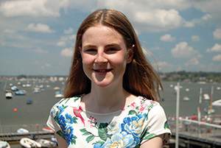

Business and Service

“I have a lot to thank the Church for and it means a lot to give something back.”
15 year old Leila Willingham’s first Church memories are the toddler group at Holy Angels, Lilliput. She is now an altar server there, and has trained her brother up too. Leila has just finished GCSEs at St Edward’s in Poole and has a developing flair for business.
“I joined a team for the Enterprise and Skills Challenge for Dorset in 2013-14. This gives school pupils a chance to try out running a business. I had a great time, so decided to have another go in my GCSE year as Managing Director.
“Our team of seven had a company called MODE, which stands for ‘motivation and determination’. We made a small profit, which we shared, and between us won several prizes from the judges. I won the Young Entrepreneur of the Year award.
“My Mum runs her own PR agency, and I grew up helping in little ways, like texting for her when she was driving! That has inspired me to consider a business career, maybe also in PR.
“I went to a Catholic Primary School, where my friends made their First Holy Communion at seven. I had to wait as an Anglican and felt I was missing out!
“I signed up for Confirmation Classes as soon as I could, aged 11, and had the privilege of being confirmed at the same time as my Mum.
“I don’t know if I could have achieved what I have without my faith, or the education the Church opened up to me.”

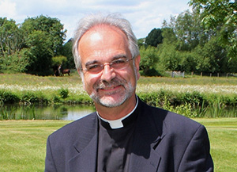

Monthly Letter
The Ven Alan Jeans
Archdeacon of Sarum

“Here I am Lord, Is it I Lord? I have heard you calling in the night...” One of the popular hymns of our generation, and a question that connects the young Samuel, Jesus and his first disciples, and each one of us today.
Bishop Nicholas’ three questions to each of us as we Renew Hope, and respond to the challenge of realising new vocations: What do you pray for? Whom do you serve? How will you grow? These also link with our sense of connectedness to God, our rootedness as followers of Jesus, and our understanding of our Spirit-given gifts in this Trinity season.
Our answers to those questions will spring out of our understanding of who we are, our humanity, and our willingness to become tangled in the divinity gifted to us in baptism.
That Christ-light, which shines out from our Christian lifestyle will surely show how God can use us – plain, ordinary people like us – and through his grace, transform us into his likeness, and then through us, transform the people and places around us. Vocation is an exciting and often unpredictable journey.
Vocation starts with Bishop Nicholas’ three questions. Vocation is something that each of us is being called to explore, in our homes, our workplaces, in our congregations, schools and communities.
As a lay minister, ordained minister, or Christian living in the world, God needs you. The Church needs you. Your city, town, village or hamlet needs you.
There are so many stories of Renewing Hope being shared across our Diocese. There are new opportunities to take hold of, and it’s wonderful to hear of how people are grasping them. Together we can achieve so much as we sing, “I will go Lord, if You lead me. I will hold Your people in my heart.”

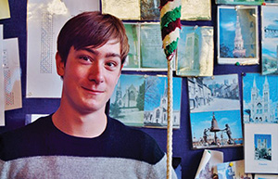

Ringing For A Change

When Thomas Powell needed to try a new activity for his Duke of Edinburgh Award, he did something a little different from the norm: bell ringing.
The 14 year old pupil at St John’s in Marlborough has been ringing weekly for the past few months with the towers at Collingbourne Kingston and Collingbourne Ducis.
“Most people learn an instrument, but ringing is great for exercise and teamwork”, said Thomas, who is exploring Christian faith, “I’ll keep it up even after I qualify for my Award.”
Mike Holt, his ringing teacher added, “It’s harder to recruit these days with so much exam pressure on young people. But ringing is fun and opens doors to a great social life, at home and abroad.”

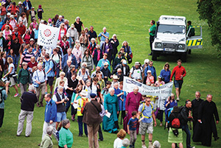

Hundreds Hail Magna Carta

700 people from across the Diocese joined a pilgrimage from Old Sarum to the Cathedral to celebrate 800 years since the sealing of Magna Carta.
Bishop Nicholas said, “Magna Carta placed everyone under the rule of law – even the king. Magna Carta is rooted in the Scriptures. Human rights defenders on every continent continue to appeal to it, and it challenges governments when they act outside the rule of law.
“We had a lovely happy day as a Diocesan family, with 700 people enjoying a mild day and at least some sunshine for picnicking and pilgrimage.
“It really was a fun day for all, and it was good to be part of a crowd of over a thousand in the Cathedral Close for the largest of many Liber-teas taking place.”

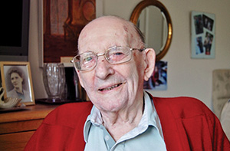

A Preaching Life

“My favourite text to preach on is one I say to myself when life is topsy-turvy, ‘Be still and know that I am God’.”
Just shy of his 99th birthday, Desmond Whiting must be one of the most experienced preachers around: he was licensed as a Reader even before the Second World War!
“My father was a clergyman”, says Desmond, “and he inspired me and trained me up as a Reader so I was commissioned in my early twenties.”
Desmond’s war service was with the RAF, which led to a career as a civilian air traffic controller. He retired to Ferndown from London ‘around four decades ago’, and was active in St Mary’s until a stroke in 2011 meant he had to move into a nursing home in West Moors.
Looking back on his life, he says, “I’ve never known a time when I wasn’t a Christian. I’ve always loved Church life, and the great community and friendships that go with it.
“I enjoy preaching, and the other great thing about being a Reader is the way it brings you into contact with such a variety of people. The ministry of Readers can be very different and the call is personal to each individual.
“The Church has changed over the decades, but God is always the same. We have women priests and bishops now, which wasn’t thought of then. When I was young, there was very much a set service, which I like, whereas now it has become more revivalist with drums and music bands.”
Now a great-grandfather, Desmond beams when asked about his present Ministry. “Every Sunday at 11, ten or so of us gather in the lounge of the nursing home for prayers, readings and hymns.
“I read a passage of Scripture and say a few words on it. So, I’m still preaching and still consider myself a Reader!”

