A Home For Future Families

Mary Kempe’s career as a librarian and researcher saw her spend decades in Uganda and Kenya – but she never doubted where home was.
“My father was a vicar, so I moved a lot as a a child,” said the parishioner of St Osmund’s in Osmington, “But we took on this house in the mid ‘30s, and my family has been in the area for 300 years.”
Much has changed in this South Dorset village of thatched cottages over eight decades. Shops and the school have closed. What was once a community of farm labourers has become gentrified.
“The proportion of second homes and holiday lets has doubled in the past decade, to about 25%,” said Mary, “While these generate work, house prices are beyond local families. The village can be very quiet out of season.”
“As the last of my family in the area, I wanted to give something back, so I’m leaving my house to a housing association. I want an ordinary family to be able to live in this beautiful village and help give life back to it.”
While others might cash in, Mary’s Christian faith means she sees social justice and community as essential. “There is a lot of homelessness on the South Coast. While it has complex causes, shortage of housing is a major contributor.”
Stewardship is another core value for this passionate environmentalist. “We have a duty to look after the beautiful world God has created,” she says firmly.

Bishop’s Letter
The Right Revd Dr Edward Condry
Bishop of Ramsbury

A fully-grown Common Hippopotamus can weigh as much as 4 tonnes and grow to 4 metres in length and a height of 1.4 meters (measured up to its shoulder). It doesn’t matter whether the hippo is standing on its head, wallowing in mud, or swimming under water: the measurements will always be the same.
A church is different. A church is not a hippo. So why do we persist in measuring it in just one way, like a hippo?
We are obsessed with average attendance on a Sunday morning. As a result we are likely to be depressed.
Your church is not a hippo. There are so many other ways of measuring a church which give a different picture.
A much more optimistic picture.
There are hundreds of children in Messy Church. There are 42,000 children in church schools in this diocese. Numerous churches are experimenting with meeting in different places and styles.
There are thousands of people involved in prayer groups and study groups.
The churches of our diocese are probably better kept now than they have been for centuries. Members of churches are involved in numerous community events, projects and organisations, from village hall committees to the Trussell Trust and Street Pastors.
The parish church provides a place for joy as well as grief. Remembrance Sunday will see churches and services packed. Many of our village churches welcome half to two-thirds of the population to worship in any year.
So let’s find realistic and optimistic ways of measuring the church.
How would you measure your church differently?

Through The Pain Barrier!

Parishioners of St Denys the Minster at Warminster developed an innovative and painful way of raising funds – a public all-male leg wax!
Gutsy Phil Meadows, Richard Golay and Paul Sheridan agreed to have their legs waxed by professional beautician Kay Sims.
As the waxing took place at the Three Horseshoes Mall, shoppers’ donations added to sponsorship already secured. Over £800 was raised to pay the Minster’s ‘parish share’.
Parish share funds a wide range of activities, including: clergy salaries and housing costs, training for future clergy, support for church schools, work with young people, and our share in the cost of the Church of England nationally.

Sacred Space at Work

A generation ago, the work day was 9 to 5 with a good hour for lunch. Now it runs from 8 to 6.30 with lunch at the desk in the company of a warm PC.
Job stress risks us losing ourselves, damaging our well-being. work:space works with major employers in Poole, like Barclay’s and the Borough Council, to give people space at work just to be.
Pioneer Minister for Central Poole, Paul Bradbury, said, “work:space offers a time of quiet during the working day at busy workplaces. It draws on ancient Christian traditions of meditation and contemplative prayer. It is open to people of any faith or none.”
Learn more at
www.workspace-poole.org.uk

Sharing The Warmth

For some, the annual winter fuel payment for older people is a bonus allowing a short break or nice meal. For others, it makes the difference between being able to heat their home or not.
The Surviving Winter programme allows people who can afford it to donate their winter fuel payment to someone struggling to stay warm.
Andrew Marx, a parishioner of All Saints in Enford, donated his winter fuel allowance last year.
“This was a simple, practical, way to help my neighbour”, says Andrew, “My wife volunteers with Age UK, so I’m aware of how poverty hits many older people.
“Sometimes, the cost of restricting a benefit to those in need can be more than providing it to everyone. That’s true with the winter fuel payment, but I think those of us who don’t need it have a duty to help those who really do.”
Surviving Winter began 3 years ago due to increasing winter deaths of elderly people in fuel poverty. Led by the UK Community Foundation, it raises a six figure sum in Dorset and Wiltshire.
Applicants receive a full benefits check, guidance on insulation and a heating system assessment. The programme is so effective that few applicants come back for a grant the following year.
Last winter, Mr and Mrs F from Salisbury received a grant of £300. Mr F wrote, “Both of us are registered disabled and virtually house bound. Until now we have sat in the house with the temperature around 15C. Thanks to this grant we will be able to keep warm.”
To donate to Surviving Winter: in Wiltshire text “WARM21” to 70070 or call 01380 729 284; in Dorset call 01202 292255 or visit www.dorsetcommunityfoundation.org
To apply for a grant from Surviving Winter please contact your local Citizens’ Advice Bureau.

Image bank

Low resolution photos used in this issue are below in uncut form.
Either left-click each one, paste into PowerPoint and right-click to ‘Save Picture As,’ or go to the Editors’ page - www.salisbury.anglican.org/whos-who/communications/grapevine/ed - for high resolution 300dpi versions in colour CMYK 300 or black-and-white grayscale (with high-contrast versions for risographs).

Front cover: Inside pages:
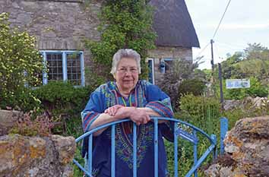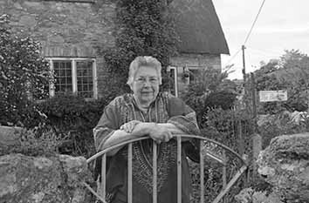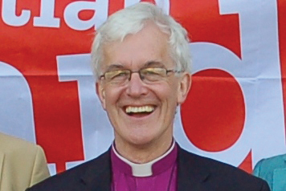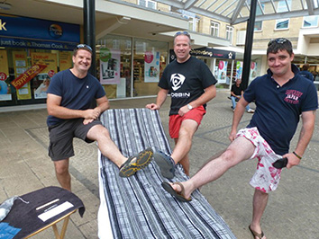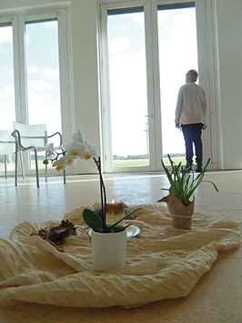

Back cover:


