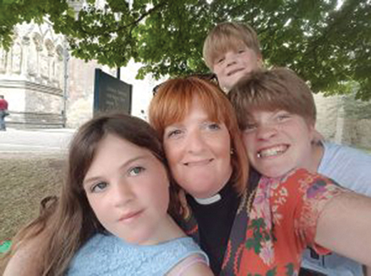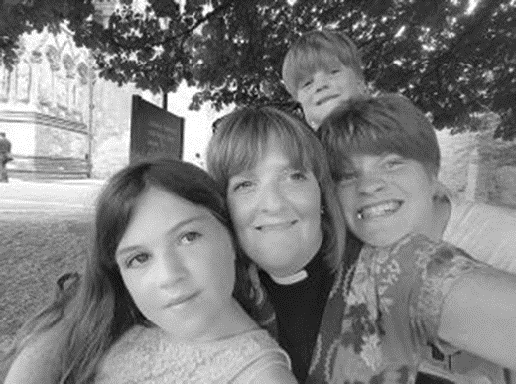
‘2019 MayJun Lorraine Dobbins’

Colour photos folder here
Grayscale photos folder here

Go For It!

The Revd Lorraine Dobbins is the Vicar of St Francis, Littlemore, Weymouth. Their Vision Statement says “We aim to relate to people meaningfully in the community”. How does that work in practice?
“This is my 15th year and what drew me here was the church ‘family’. They said they really wanted to engage with the local community. It’s been a real journey and now 80 per cent of what we do is focused on God’s call to us to minister to and bless those around us.
“So, the focus isn’t just the in house stuff and even Sundays themselves have become about how we can grow as disciples and be equipped to serve Jesus out in the community during the week.
“There is a strong sense of community here. Littlemore is an area of quite high deprivation. The new road from Dorchester cut half the community off and we are still adjusting to that.
“A few years ago we had a time of seeking God and our vision and how we could reach out to the community and what we wanted was our building to be a hub, but our vision was to meet the needs of the community, not necessarily to get them into the church for worship and that brought about a big change.
“The church now has a large soft play area in the main worship space, a community café and washing machines that provide a community laundry service.
“When we opened the café, we wanted it to be a community, not church, café. We wanted Starbucks on a shoestring! The first stage was in our hallway, because the worship space with its heavy chairs couldn’t be used. Then through church giving we purchased stackable chairs, so the café is now in the main worship area and, with the soft play during the week, the whole building is that hub we wanted.
“There have been sacrifices made by the congregation – the soft play area isn’t pretty to look at and it takes up a lot of space and it can’t be taken down just for worship. But it was a domino effect and some of the church family who had wobbled originally were gathered around the soft play area when it arrived, praying for its use.
“So people were happy to make that sacrifice knowing that the church would be used by the wider community.
“We are not a big church, in one of the most deprived areas of the Diocese, so we punch above our weight. The vision was bigger than we thought we could deliver, so I encourage people.
“You don’t have to be big.
“We found that when we stepped into the vision God had for us, the money came in. At the beginning we had grants of thousands of pounds for the soft play area but couldn’t pay our share, but we found as we stepped into the vision God had planned for us, the money came. We stepped out together in faith. The church family is with us.
“So I’d encourage other churches to go for it!”
Hear more about the vision at St Francis in our podcast with Lorraine at http://bit.ly/on-the-vine.

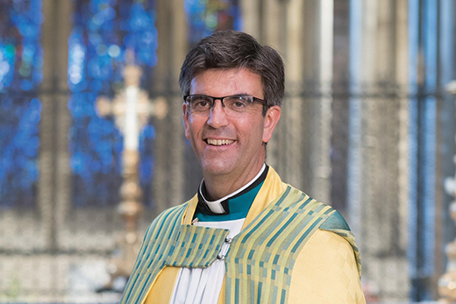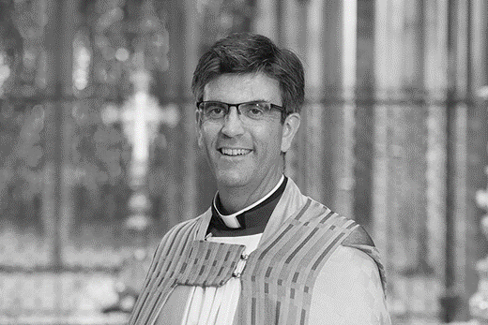
‘2019 MayJun The Dean of Salisbury - photo by Ash Mills’

Colour photos folder here
Grayscale photos folder here

From…
The Very Revd Nicholas Papadopulos,
Dean of Salisbury

“Come, Holy Spirit.” With these words the Archbishops of Canterbury and York conclude a recent letter to the clergy. They asked us all to pray these words in the days between Ascension and Pentecost. The Archbishops recall how the disciples gathered after Jesus’s Ascension and devoted themselves to prayer, awaiting the outpouring of the Spirit that he had promised. In particular, they asked us to pray that that same Spirit might work in the lives of five friends “…who have not responded with their ‘Yes’ to God’s call”.
But these days of prayer, and the global movement now associated with them, have a different three-word strapline, taken from another prayer. “Thy Kingdom Come”.
“Teach us to pray” say the disciples. “When you pray, say…” responds Jesus, introducing some of the most well-known words in Scripture.
“Thy Kingdom Come” is (of course) the first half of the second petition of the Lord’s Prayer. If we can get beyond its familiarity, it’s a breath-taking prayer. It’s that God’s perfect rule – God’s justice, righteousness, God’s good purposes – should be realised.
Here. Now. In a messy and imperfect world that is riven with cynicism, poverty, and despair.
It’s an amazing thing to pray. And isn’t it a rather bigger prayer than a prayer for five friends?
Now, I love that we’ll all be praying together. I look forward to welcoming many of you to the Cathedral for a joyous Beacon event. And I will pray for five friends, because if prayer is like charity then it starts at home. But…if prayer is like charity, then it cannot end at home. So I will also pray that five virtues of the Kingdom might be poured out not just upon my five but upon all. Forgiveness. Humility. Thankfulness. Justice. Peace. Whenever they are lived and by whoever they are lived, they serve to bring the Kingdom of God closer.
Thy Kingdom Come! Alleluia!
Amen

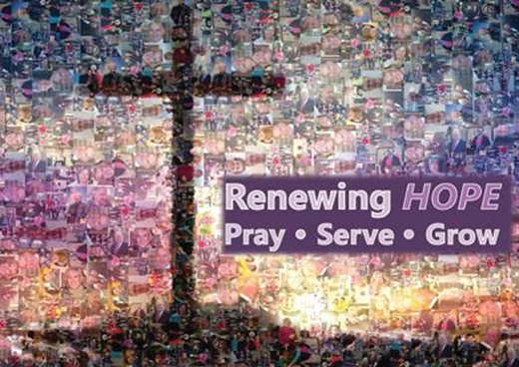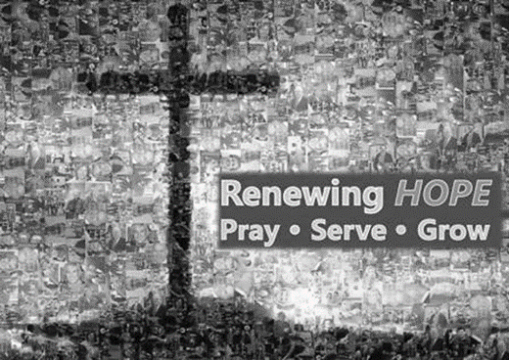
‘2019 MayJun Renewing Hope Prayer Card’

Colour photos folder here
Grayscale photos folder here

Reviewing Hope

Bishop John Gladwin, former Bishop of Chelmsford, visited our Diocese in March to conduct an interim review into our Diocesan Vision and Programme Renewing Hope - Pray Serve Grow.
He has now submitted his report and our Diocesan Secretary, David Pain, reflects on its conclusions.
‘A thriving Christian presence in every community’ is an inspiring vision- what does it mean in practice for you?
Our calling as disciples of Jesus is different in each local context, rural and urban, as we deepen our understanding of God and of ourselves.
The great diversity of the Diocese of Salisbury is one of our many strengths. As we look to the future, what might we need to pay attention to so that we thrive in a changing society?
In March Bishop John Gladwin spent a week with us. +John’s task was to help us take stock of ‘Renewing Hope - Pray, Serve, Grow’, the framework we use as we seek to respond to God’s calling in each community where we serve.
His report challenges us to think more about how culture is changing and how our ministry is going to have be lighter and more flexible. He challenges us to ‘go local’, to ‘travel light’ and to work collaboratively. The report includes six core values and a dozen recommendations. You can download it from the diocesan website.
In the autumn of this year we will start to set out a three year balanced budget for the diocese. This will reflect the priorities we need to attend to as we plan for our future and respond to +John’s report. It will be great to hear your voice in this conversation. At the front of the report I set out how you can give feedback. I look forward to hearing from you!
You can read Bishop John’s Report at http://bit.ly/reviewinghope.
The deadline for feedback is 5 July.

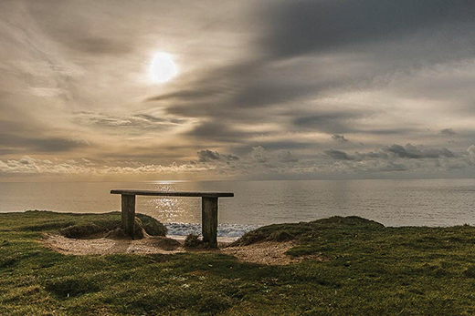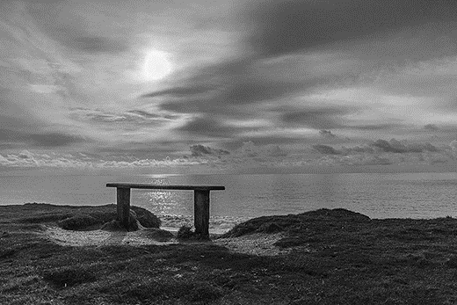
‘2019 MayJun Photo by Margaret Preuss-Higham’

Colour photos folder here
Grayscale photos folder here

Wanted: Photographers Who Love Our Countryside!

We’ve launched a competition to find 12 pictures that reflect Rural Hope, to create our own 2020 Calendar.
We’d like you to submit photos of your rural churches and your communities along with their characters and wildlife through the seasons.
Send your jpegs (black and white or colour) via the WeTransfer website to sarah.keen@salisbury.anglican.org.
The closing date for all entries is September 30.
For more details, go to http://bit.ly/doscalendar.

