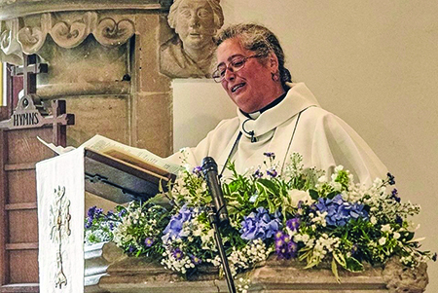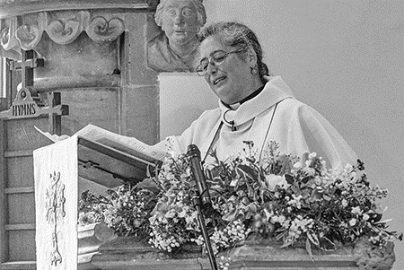
‘2019 MarApr Rachma Abbott’
Colour photos folder here
Grayscale photos folder here

Liberated by Lay Ministry

Serving on the northwest frontier of the Diocese with two sets of parishes about to join together, the Revd Rachma Abbott has come from inner city London, via its suburbs, to rural Wiltshire to be the Priest in Charge of the Woodhill Benefice (Broad Town, Clyffe Pypard, Hilmarton and Tockenham and newly joined Lyneham with Bradenstoke).
She serves a mixture of rural parishes large and small, a MOD base, a Fijian community, farmers, and even some Naval personnel. So how is it different to London?
“I think rural ministry is exciting, although it is sometimes very demanding, partly because it is a more complex task. I started in the catholic tradition, but in a rural setting you are always called to be diverse, in cities people can walk to another church with different services, they can’t here. You need to be a Jack of all trades. But the blessing is you get other people who have real giftings.
“There is always a team, I had a very good predecessor who did a fantastic job of starting to enable lay people. So when I came, I inherited some very good Lay Worship Leaders and Lay Pastoral Assistants. With that enabling gift that my predecessor brought, people have developed, discovered ministry and skills, and are now beginning to fly.
“One LLM [Licensed Lay Minister], as well as taking a service in Hilmarton, is now taking one in Lyneham, so that is another bridge for a community which has yet to develop its own lay ministry, but is seeing how different ministry can be, and that it doesn’t have to be ordained.
“I could not do all that on my own. But actually it is done better by other people than by me. It is a liberation.
“All the baptised are called into the kingdom that is God’s people.”

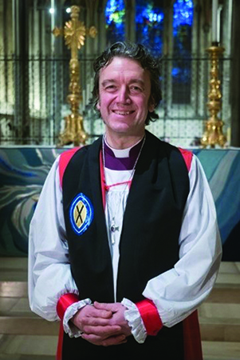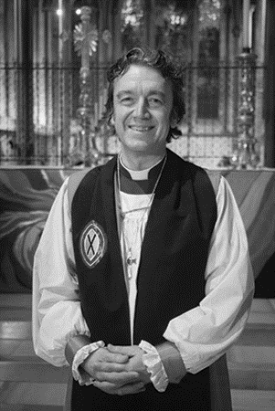
‘2019 MarApr Bishop Andrew’

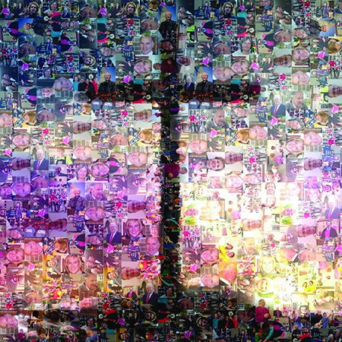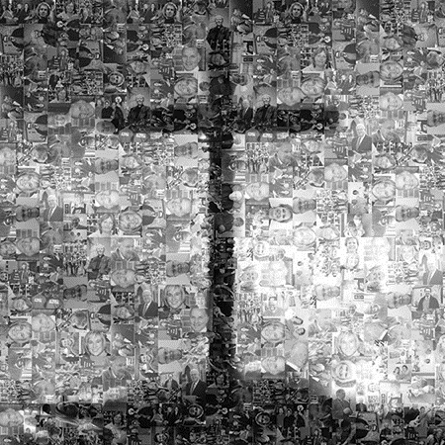
‘2019 MarApr Renewing Hope Cross Square’
Colour photos folder here
Grayscale photos folder here

Monthly Letter
The Rt Revd Dr Andrew Rumsey
Bishop of Ramsbury

The cross before us in Passiontide is so familiar we can forget how strange an emblem it makes. As the symbol of faith in an invisible God, it is utterly and undeniably physical - not ‘spiritual’ at all, whatever we might mean by that.
For a faith whose kingdom is not of this world, how earthly and human is the cross; our own brutal idea, sawn and sledgehammered into the ground. Striking, too, that the mark of a faith so often spoken of as a private matter should be so unavoidably public and political. Crowds abound in the Passion story, with Christ at the centre; a blatant spectacle.
Because it is in these ways the opposite of what we might expect, the cross pitches our faith in reality. And just as it is true to the things we can see, the cross is equally true to all we cannot, but which is just as real; things like the fear of failure, or our longing for justice.
For many, the cross becomes their personal signpost, standing for direction when they are lost and life in the midst of death. Which is surely the most shocking thing about the badge of our faith; that something so bleak and hopeless could, after all, be reckoned as so wondrous.
+Andrew

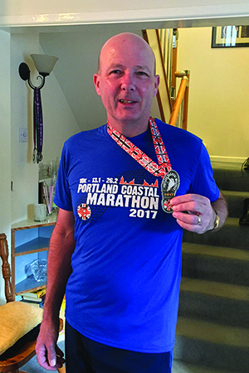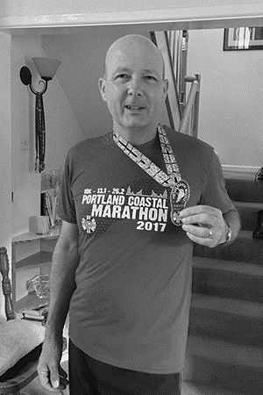
‘2019 MarApr Neil Biles’

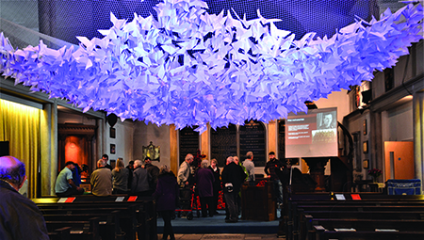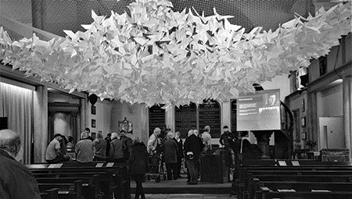
‘2019 MarApr Neil Biles 2’

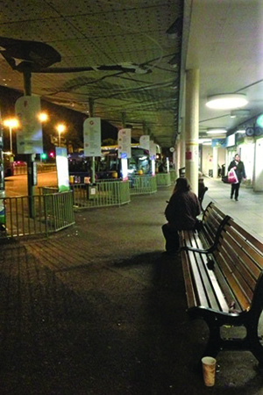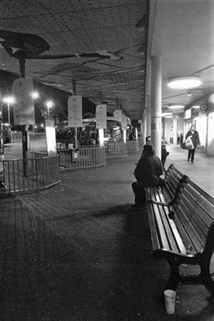
‘2019 MarApr Poole Bus Station- Street Pastors’
Colour photos folder here
Grayscale photos folder here

A Tale of Two Town Pastors

Neil Biles has just picked up a Community Award for his work as Weymouth’s Community Chaplain and he is delighted, especially as he is following in some pretty big footsteps.
“My faith, my beliefs and my role as community chaplain are based on the journey of Jesus, who came to serve people.”
Neil’s job description is just as big an ask. It tasks him with bringing Good News to Weymouth Town Centre by serving the local community through the opening of St Mary’s Church Centre as a beacon of light in the town for all to enter.
“St Mary’s District covers the retail hub of the town, but there are also several flats and bedsits including new blocks of private flats. We have a mix of young adults and the elderly as well as those who work here. More ward residents claim disability benefit and there is higher unemployment than in the rest of the borough.
“The nature of the area means there is a floating population of seasonal employees and a large influx of holidaymakers. Despite a boost from the Olympics in 2012, the town centre now has many empty shops.”
Neil was Operational Director for Church Army until 6 years ago, when he felt the call.
“I felt that God had called me back to Weymouth, God then provided the money, through a trust, to fund me, to allow me to work for him full time.”
Neil’s Chaplaincy role sees him dividing his time between St Marys and St Ebenezer’s Evangelical Church in the town.
“My focus is across a lot of projects and across the week, I flow from one thing to another and those things include a Monday Brunch Club that feeds 30-odd, Tuesday Prayers that light the town centre church up like a disco, a Wednesday Coffee, and a Thursday Lunch.
Then there is the ‘Christians In Work Breakfast’ that sees Neil using his catering skills again, cooking an early town centre breakfast that allows local Christians to eat, pray and talk together before work.
“We see about 50/50 attendance between church and non.”
Neil has many hats - he is Benefice, PCC and Deanery Lay Chair - and he says this allows him to garner help from lots of different places.
“The local congregation have great enthusiasm and a big heart for the future. This enthusiasm relates also to the Diocese vision for our communities by ‘Renewing our Hope – Praying and Serving with the outcome of Growth.’
But the key to his work?
“Double listening. Listen to God and listen to the context, but then add a third; what are your gifts and talents and how can you use them?”
“My ethos is hospitality, I offer the welcome ‘Come to the table, come to eat, come to have fellowship, and by the way, you can meet Jesus if you want to.’
Down the road in Poole, John and Anne Ainsworth spend every Saturday afternoon looking for trouble in the town centre. Not because they want to join in, but because they want to help.
John and Anne are part of the Poole Street Pastors team. Their Saturday afternoon ministry involves wearing hi-vis jackets and caps, and offering a calming approachable presence at key ‘trouble spots’ such as the Bus Station and High Street. Anne says,
“We do this at the request of the Police, because there is a great need for positive support especially among the youth, the homeless and elderly.
“Sometimes we find someone in pain who needs a listening ear and we offer prayer.
“Other times we do practical deeds such as giving gloves in cold weather, phone for a taxi when someone is ill, we have picked up a motorbike rider after a fall and stayed with him till he had recovered.
“It’s an opportunity to open conversations about God. One gentleman asked us to have a word with ‘The Guvnor’ - God - to sort out the mess in our Government!”

