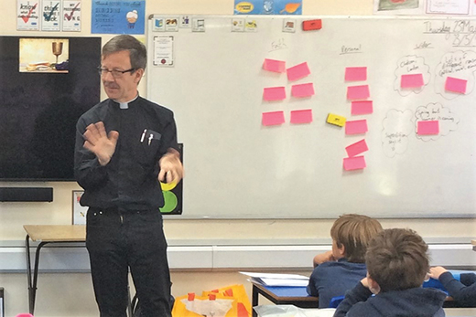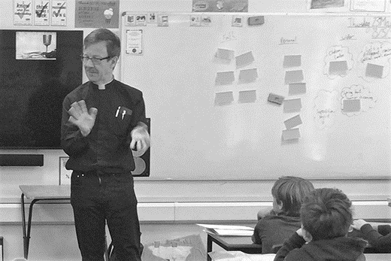
‘2019 JunJul Richard Curtis classroom’

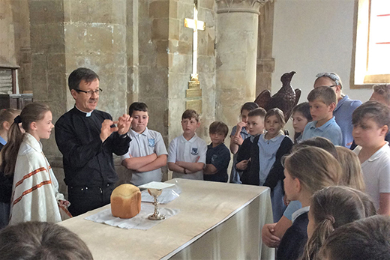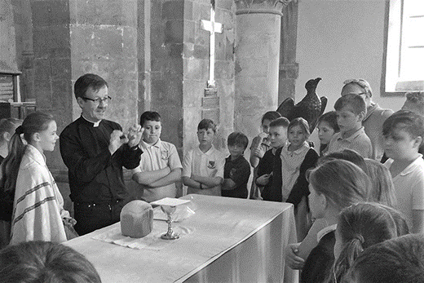
‘2019 JunJul Richard Curtis church’

Colour photos folder here
Grayscale photos folder here

Breaking Bread in Schools

The Revd Richard Curtis, our very own ‘Running Rector’ is Team Rector of the Cannings and Redhorn Team in the Vale of Pewsey. As well as 8 “traditional” village churches, Richard also has 4 schools...
“I often to say to people, ‘How much effort would it take to get 100 children into church on a Sunday?’ Because I can just go to school and there are 100 children there who are very open, engaging and want to know more about faith and it is a wonderful opportunity.
“I find it really exciting to do it, it is great to have that engagement and what I also find encouraging is that you really do see faith in so many children.
“One of the things I have to keep reminding myself is that Sunday is not the same as it was when I was their age growing up. Two thirds of my class went to Sunday school because it was something to do. Nowadays Sundays are so busy for families that, while I have children who would love to come to church on a Sunday, with the complexity of their weekend it is really difficult for them. So, for a lot of children actually school is their church. And you see it in adults too. I see a lot of adults who work in church schools and that community is their church.
“I think in the last 10 years we have had a better focus on schools as church. That’s good, because it is a really important part of our ministry.
“I like to do a number of complete days in school. I do them about Communion, and that’s great because the children have the opportunity to ask the sort of questions they would like to ask the Vicar. We have some really good sessions and often I have had to go back for another half day just to catch up with their questions!
“I actually start by getting my bread maker out and making a loaf of bread. We go through the Eucharistic prayer and talk about what that is about, and in the end when the bread is ready we share the loaf of bread. They are always insistent that we make the largest loaf possible and we have fun sharing this.
“The children write any questions they want to ask on post-it notes - I’ve always got a lot.
“What’s interesting is the deep questions they ask. Often I say to them that these are the sort of questions we are going to be thinking about for the whole of the rest of our lives and as you go through secondary education, as you go through the rest of your life, you will continue to come back to these big questions, about the world, the universe and everything. And it is great to keep asking ourselves these questions too.
“I think it is a great way to think about theology, our relationship with God, and one of the things I want to get over to children is that actually we are all on a learning journey learning about a lot of stuff. Obviously I am keen that they learn about God, but I think it is very good to encourage them to do that in the context of everything else they are doing in school.”
Hear more about Richard’s bread making and the Cannings and Redhorn Team in this month’s podcast at
http://bit.ly/on-the-vine

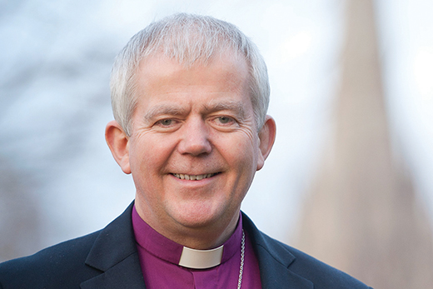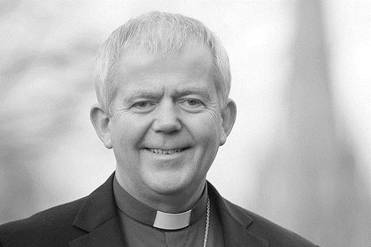
‘2019 JunJul Bishop of Salisbury’

Colour photos folder here
Grayscale photos folder here

From…
The Rt Revd Nicholas Holtam
Bishop of Salisbury

Lessons from life...
I cycle. Balance is essential. Getting blown off course is easy, as Chris Froome knows all too well! The first bike for a little child is often what is called a balance bike.
An intelligent and creative friend was bi-polar, what we used to call manic-depression. He was unstable and couldn’t make consistent progress. He could not hold down a job. He lacked balance.
To some people, a single issue political party looks attractive because we know it will do what it says. To others, it will do it at all costs. Campaigners are important in the social mix but they lack the necessary political balance needed for good judgement and a happy society in which we all flourish.
That’s one of the differences between being a good campaigner who is determined about a single issue and a great political leader who has a proper responsibility for all. We are watching this in a political process that has created division and anxiety and exposed us as an unhappy country because of a single issue.
In the Diocese of Salisbury we are in the process of a 5 year review of Renewing Hope – Pray, Serve, Grow. The assessment cannot be by measurement of a single issue. The questions we asked at the outset were: For what do you pray? Whom do you serve? How will you grow?
A healthy Church has balance and a varied ecology in which we all can thrive. To measure ourselves we have been using not a single issue but a ‘balanced scorecard’. Our God given diversity means we are a mixture of theological traditions, different social groups, of varied abilities. It is a strength that gives balance and helps us find that unity which is in Christ. It is a lesson from life and for life in all its fullness.
+Nicholas Sarum

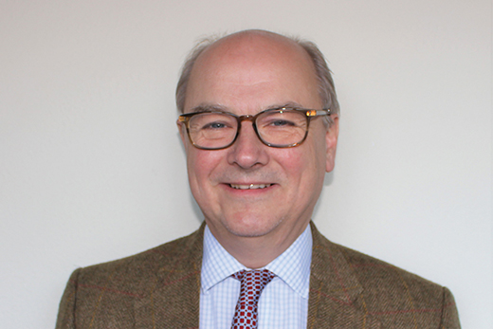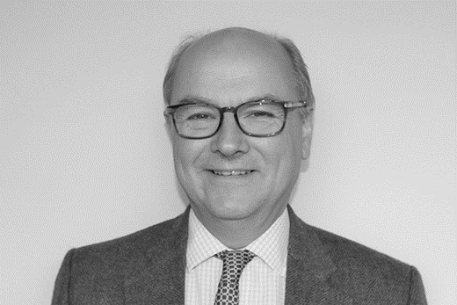
‘2019 JunJul Nigel Salisbury’

Colour photos folder here
Grayscale photos folder here

A Financial View

Our Diocesan Finance Team has been busy ‘crunching the numbers’ and this week our Synod members approved our 2018 Accounts and were presented with the budget for 2020.
Unfortunately the 2018 accounts reflect a difficult year - we are spending £454k more than we receive in income.
This arises partly because, despite an excellent record of Share payment, we never quite receive payment in full. And while Share is only one of the many financial calls on our parishes, it is a vitally important one as it funds our clergy’s stipends, housing, training and support.
However, we also know that for some parishes with declining or small congregations the pressures of Share payment are falling on smaller and smaller numbers of contributors each year. So, partly in recognition of these strains upon our parishes, we have begun a series of Reviews that will allow us to set out a financial plan for the years 2021 - 23. This will address the deficit and pave the way for a realistic and sustainable approach to funding ministry for the future.
In the meantime our 2020 budget is a transitional one. We have tried to keep the Share increase as low as we can, whilst broadly maintaining the status quo in terms of clergy and staff numbers, and while we look at what savings and additional sources of income we might have going forward. So with Synod’s agreement, the increase in Share for 2020 is just under 1.5% for 2020. That’s 1% less than the past 3 years’ increase.
Taking into account the further decline in numbers, seen in the Count just completed, this is a 2.86% per capita increase, but we know the Share paid by individual parishes will vary significantly especially with a continuing decline in Sunday attendance - around which the Fairer Share concept is based. And that’s why we are taking an in-depth look at the Fairer Share system, to see whether any improvements can be made.
I can re-assure you that we are taking every step we can to minimise increases to Share, and I remain extremely grateful for the continued support of parishes throughout the Diocese whose contributions towards Share enable us to maintain a thriving Christian presence in every community.

