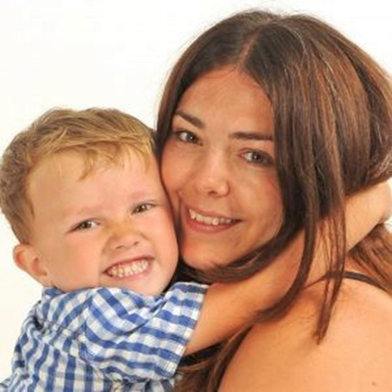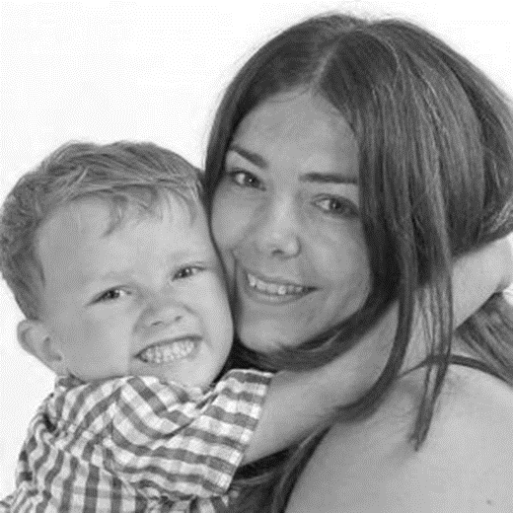

‘2019 JulAug Ruth Peers’

Colour photos folder here
Grayscale photos folder here

Transforming Lives

Ruth Peers is the Community Advocate Worker at St Francis, Littlemoor, Dorset. She took on the role after she was asked to pray about it by her Vicar...
“I was a missionary in Russia for years, so I’m used to getting my hands dirty. I missed doing that and I thought it was an ideal opportunity to do that here in Littlemoor.
“No day is the same, I’m based at the café at the church, it is a really good point of contact, and I’m building up relationships. I take part in ‘Open the Book’. I help people with benefits, food vouchers and whatever it is they need and I plan for ‘Make Lunch’ in the school holidays.
“Then with ‘Transforming Lives for Good’, we are doing early intervention. Just helping children who are struggling in the system. Basically you are working in a volunteer role with one child for one hour a week, sitting with them, sometimes playing games with them, getting to know them. Then doing some work on emotional literacy and just trying to raise their self-confidence so they can also reach their potential like the other children in the class.
“We went on a really good training day and it was really encouraging, it was done in a way to help us know we would be able to do that, because we are doing it in God’s strength. It was all about praying together and getting a prayer partner together with you.
“It is quite funny because I was losing hope on finding a church that I would fit into. But one of the reasons I was drawn to this church was because I could see they were outward looking. So just little bit by little bit, I got more involved!”
Hear Ruth’s full podcast at http://bit.ly/on-the-vine

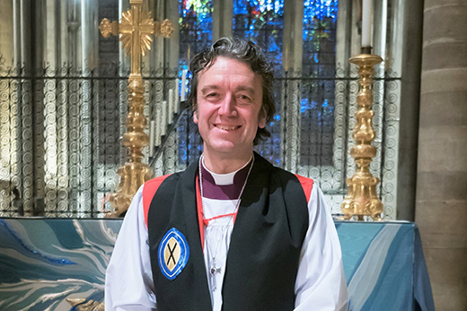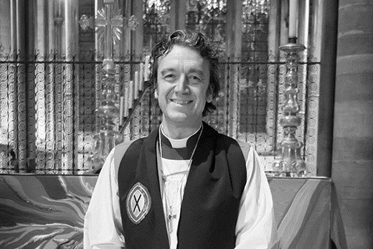

‘2019 JulAug Bishop Andrew at Salisbury Cathedral’

Colour photos folder here
Grayscale photos folder here

From…
The Rt Revd Dr Andrew Rumsey
Bishop of Ramsbury

It’s that time of year when schoolchildren everywhere begin to receive their end of term reports and the results of tests.
Reports and exams are such a constant part of childhood: until the age of 21, my progress was constantly tested and assessed. I knew precisely how good I was at certain subjects: where I really needed to try harder, where I fell completely short - and precisely where I stood in comparison to my friends.
As an adult it is far harder to know how we are progressing: in our professional lives, in our relationships, and indeed in our Christian faith. Hearing and reading God’s word in the Bible is perhaps the main way in which we consider how our lives measure up to Christian standards – it should perhaps give us that same blend of reassurance and discomfort!
The prophet Amos, speaking to a nation that remained politically and spiritually smug whilst oppressing the poor and ignoring the needy, portrays God with a plumb line in his hand, about to test whether they are true to his ways.
‘Flee away, you seer!’ is the response of the religious leadership, who – like us – find it almost impossible to hear accurate criticism.
What makes it possible is the grace of God in Christ, who both shows us how we ought to live, but crucially also bears the cost of our failure to do so - saving us from our sins and for a life of good works.
Whatever tests of life we are facing, and whatever the report, for or against us, may this grace encourage and empower us in God’s service.
+Andrew July 2019

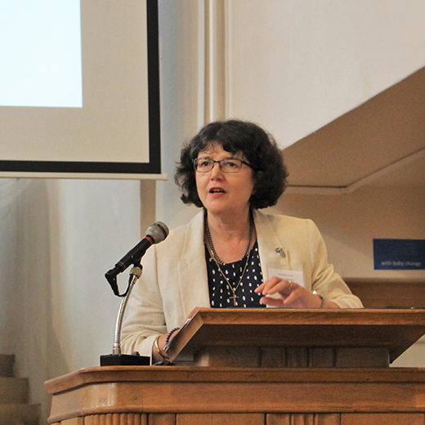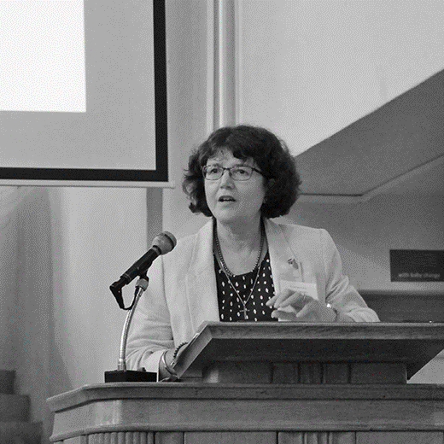

‘2019 JulAug Rosemary Cook’

Colour photos folder here
Grayscale photos folder here

Fairer Share
Rosemary Cook
Fairer Share Task Group

A review into Fairer Share is underway, led by Rosemary Cook. Lay Chair of Pewsey Deanery and of the Diocesan Finance Committee, Rosemary is also on Bishop’s Council.
“The idea of a Review had originally come from comments at a meeting for Lay Chairs and Rural Deans. They had concerns about a lack of consistency. What was revealed was a myriad of different approaches, especially with ‘fresh expressions’, and that was concerning.
“There was a deep seated desire for clarity and consistency and so we set up a Task Group made up of some of the Rural Deans and Lay Chairs.
“But then Bishop John Gladwin’s Review of Renewing Hope widened the scope and so our remit grew.
“Bishop John emphasised that the ‘counting members in order to determine what we are asking parishes for in support of the Diocese’ is often seen as a tax. And growing numbers can mean a larger bill. So the question does need to be asked - ‘Is our current system fair?’
“So we now have a wider remit to look at all aspects of Share mechanism, but, I think I need to stress this, we are not looking at the actual amount parishes are paying.
“However, it is worth saying that, compared to other Dioceses, we do have a very high percentage of payment - 97% of Share request for 2018 was paid - that might indicate that the scheme is working.
“But our feedback suggests there is room for improvement. So very careful consideration is needed before we propose changes.
“The Fairer Share Task Group is currently preparing a draft report for the Finance Committee and Bishop’s Council, but there is much work still to do, particularly modelling the financial impacts of various proposals under consideration.
“If our draft proposals receive support, the Task Group will work with Focus Groups to gauge reactions and refine the proposals in the light of their comments.
“Participants in the Focus Groups will include many of those who have already fed views into the Task group. But we will be seeking to include a mixture of people reflecting the variety of worshipping styles, parish sizes, geographical locations and rural/ non-rural communities to be found in the Diocese of Salisbury.
“So if you would like to propose someone to take part in one of the focus groups, that would be great – just let us know.”
Any new system would only come into force after September 2021.

‘2019 JulAug Time for Change’

Colour photos folder here
Grayscale photos folder here

All Change

Grapevine is changing.
From September this monthly magazine is merging with our e-Bulletin to provide weekly news and stories of Renewing Hope from around the Diocese.
Grapevine’s new weekly e-format will also host the Bishop’s Monthly Letter at the start of each month.
And we will be continuing to publish our podcasts, videos and longer articles at http://bit.ly/on-the-vine.
As a subscriber you will receive our new weekly Grapevine in your inbox each week, but if you don’t want it -just click the unsubscribe link..
For those of you who print out the magazine or use it in your local publications - there is more information on how to download stories and the Bishop’s Letter at http://bit.ly/on-the-vine.
All our stories and the Monthly Letter will also be posted on our Facebook page and you are welcome to share these or copy them directly to your pages too.
Thank you for supporting our Grapevine magazine, we hope you will continue your support when it returns in its new weekly format from September.

