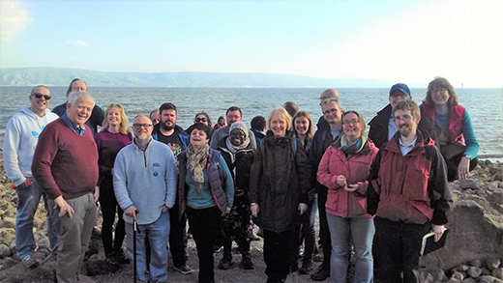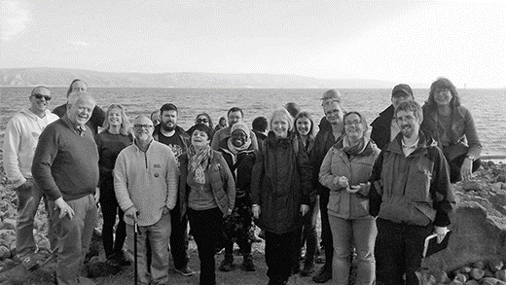
Photo: ‘2019 JanFeb- The group in Galilee’

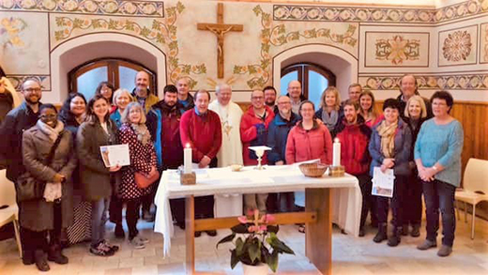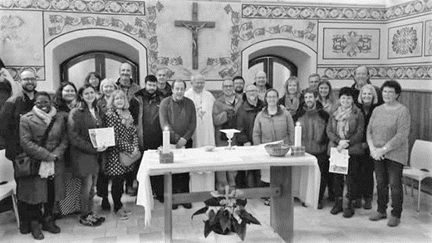
Photo: ‘2019 JanFeb- Bishop Nicholas with group’

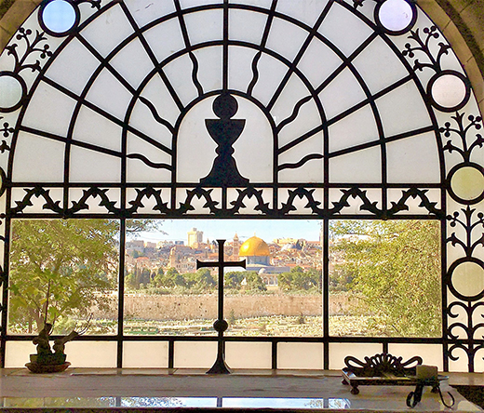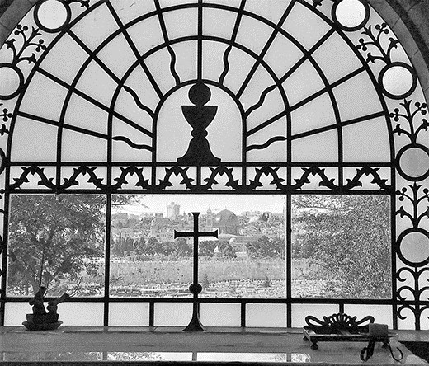
Photo: ‘2019 JanFeb- Window to Jerusalem’

Colour photos folder here
Grayscale photos folder here

Following in His footsteps

This January, 15 of our Curates joined Bishop Nicholas, his Chaplain Tony Monds, and our Chaplain to the Deaf and Hard of Hearing, Neil Robinson on a special Pilgrimage to the Holy Land.
Among the group, who literally walked in the footsteps of our Lord, were Andy Muckle from Gillingham and Milton-on-Stour, and Jane Palmer from Trowbridge St James and Keevil.
“The whole journey was held within the context of worship and prayer,” Andy said.
“We prayed daily, not only for our pilgrimage, but for those we had left behind, the peace of this troubled region and the wider world.
“In that way there was an interconnectedness between our journey through this complex and beautiful Holy Land and the wider context of our lives.
“At many of the places we visited, the Bishop explored the Biblical story and placed it within the narrative of our modern world and those connections and observations are something that will stay with me for a long time.
“One moment of the trip does stand out - we were taking a boat across the Sea of Galilee.
“To be in the place where Jesus walked on water and calmed the storm was a deeply spiritual experience.
“The impact the pilgrimage has had on me (and my wife, Becky) has been immense, and I think it will take time for the full implications of the journey to sink in.
“No doubt as I reflect on the many emotions and experiences, there will be new insights and memories that will emerge and will resurface again in sermons!”
“It was amazing being able to spend some time in the footsteps of Jesus in the Holy Land,” said fellow Curate Jane Palmer.
“As we paused in each holy space, we heard the parts of the Gospel associated with the place we were in which brought scripture to life. I will now have a much more realistic understanding of the geography of the places we read about in the Bible”.
“Experiencing the different cultures and faiths in the Holy Land and in particular the complexity of Jerusalem and the divided territories of the Palestinians and the Israelis was extraordinary.
“One of my favourite moments was visiting the site on the Jordan where Jesus was baptised and we renewed our own baptism vows. Another was sailing across the Galilee and singing hymns using British sign language, joining in with Neil in his own language, praising God.
In the place where the Gospel was being brought to all people it felt really special joining in with the deaf community, experiencing that there is nothing that can separate us from the love of God. And personally, I renewed my own sense of vocation to sharing the good news of Jesus with all those on the margins of life.
“The most exciting thing for me though is that I’m coming home and able to say “I visited the tomb of Jesus and it is empty! Jesus is risen!” I can’t wait to tell people it’s true! The whole time I was there I kept hearing Jesus’ words from John 20 v29 -
“Because you have seen Me, you have believed; blessed are those who have not seen and yet have believed.””
Read more @ http://bit.ly/fihf

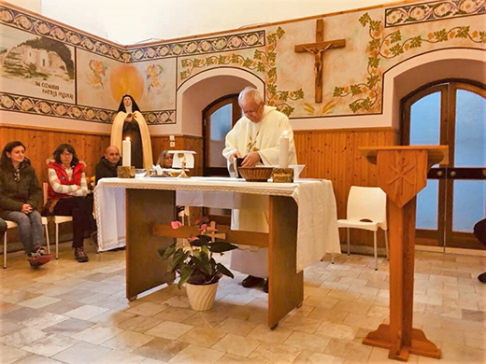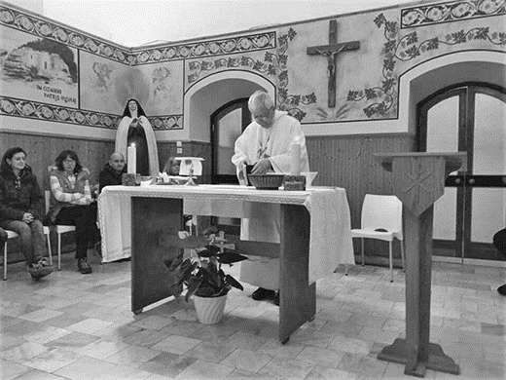
Photo: ‘2019 JanFeb- Bishop Nicholas presiding’

Colour photos folder here
Grayscale photos folder here

Monthly Letter
The Rt Revd Nicholas Holtam
Bishop of Salisbury

Christmas came twice for the curates who went on pilgrimage to the Holy Land.
We arrived in Bethlehem on 6th January, Epiphany for us but for Orthodox Christians it was Christmas Eve. We went through a check point in the security wall between Israel and Palestine by Banksy’s ‘Walled Off Hotel’. “O little town of Bethlehem how still we see thee lie.”
In the Church of the Nativity there was a big service, the equivalent of Midnight Mass I suppose, broadcast on TV. In the shepherd’s fields we remembered the angels singing ‘Glory to God and Peace on earth’. In Manger Square, along Star Street from our hotel, there was a huge Christmas tree and a mosque with the Islamic call to prayer.
We stood on the Mount of Olives experiencing the famous view of Jerusalem looking towards the gold Dome of Rock. It is a holy place for Muslims, Christians and Jews. Now only Muslims are allowed on what was the Temple Mount. Christians walk the Via Dolorosa, the way of the cross. Jews pray at the Western Wall, part of the second Temple destroyed in AD 70. We read Psalm 122 - ‘O pray for the peace of Jerusalem’ and we did. In its peace lies the world’s peace.
In the north of Galilee we went to Caesarea Philippi. We were near the Lebanese and Syrian borders. The site had been called Banyas where there had been a temple to the god Pan who created confusion – panic – among the people. Peter declared Jesus is the messiah. Jesus said his followers are on the way of the cross. Who is Jesus and who are we?
We met pilgrims from around the world. In Cana, where Jesus at a wedding turned water into wine, we heard the prayers of Nigerian Christians that their country will become again a happy country. That is now my prayer for Brexit Britain.
Early in 2019, following in the way of Jesus, we pray for the peace of the world.
+Nicholas Sarum

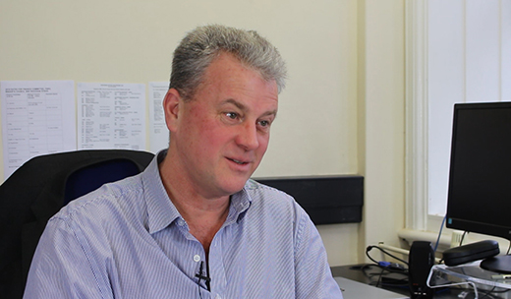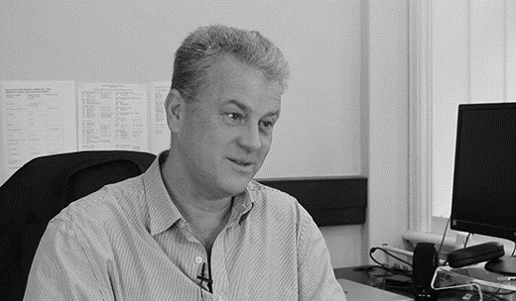
Photo: ‘2019 JanFeb- David Pain interview’

Colour photos folder here
Grayscale photos folder here

First impressions
Meet our Diocesan Secretary, David Pain

“I’ve been here nearly two weeks - it feels so much longer and I have been made so welcome, but it is early days and I still have a lot to learn.
“I am really excited about the work of the Diocese, which I have come to know through my parents, who have lived here over the last 30 years.
“Before coming here I worked for Christian Aid for 20 years, I was head of their Africa Programme, and now you may think Africa is a long way from Dorset and Wiltshire, but what I learnt there was how to work in and lead a dispersed organisation and how to make decisions together in a way that was true to the local context.
“Also how to do things well together when we needed to.
“I think that also applies here, where each parish is different, opportunities vary, but there are some things we need to decide on together and work together on.
“And one of the great things about the Diocese is its really big vision of what it means to be ‘church’ and a recognition that can be very varied in different parts of our area.
“Having a sense of being part of something bigger I think is really important because, having that sense of identity and belonging in a local place is really precious, but also knowing that we can pray, serve and grow together and support each other.
“And I’m really excited that even on first impressions this is a Diocese that is looking to the future - we have an extraordinary inheritance, our buildings and a story that literally goes back over a thousand years. We have strong ambitions of where we want to go as we pray-serve-grow, but also the challenge to make sure that what we want to do and the resources we have actually match each other.
“So we have to do some work on that.
“But as I start my role, it is all about learning more about the Diocese and I am really looking forward to getting to know people in the length and breadth of our Diocese.”

