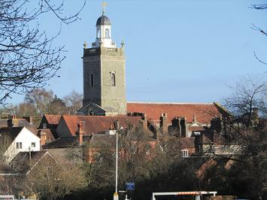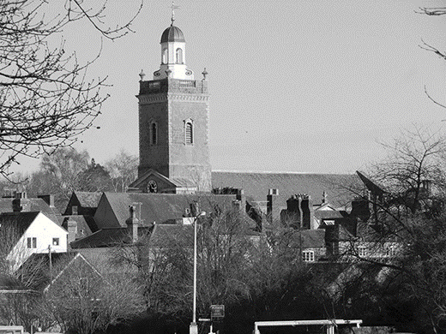
‘2019 FebMar Blandford Church’
Colour photos folder here
Grayscale photos folder here

Growing With Love

Blandford Forum church hit the headlines with a Heritage Lottery grant of £1.4 million towards restoration. But as Rector Jonathan Triffitt explains, the restoration is part of a much bigger project.
“When the Cupola was restored, someone wrote in the local press, this symbolised the restoration of the town. You cannot separate out the Church from its community here, we are absolutely linked, part of the fabric. The whole town was built at the same time, so we have never been separated.
“In January we launched “The Big Church Project”, extending our vision for the renewal of this building in 3 ways. Obviously to restore the building to the glory of God, but the second area is reimagining the space. It is filled with Georgian box pews, a glorious but inflexible working space. We want to think more creatively, how can we use this beautiful space to gather and serve community? But also, how do we tell and retell the story of the Gospel? And the third area is re-engaging with the wider community through things like our community kitchen, so it is great spending money on restoration, but it can’t just be for our benefit.
“Already the impact is extraordinary, the relationships and the doors that are opening bringing us into contact with people who in all honesty would not walk through our door.
“So we are growing in an awareness of what God is calling us to be and I think that will lead to numerical growth, but are we growing in terms of the community in Blandford? Absolutely, and pray God that that continues.
“Our job is to love this place back to life - the building, the people the community, the town - all back to life.”
Hear the whole interview:
http://bit.ly/on-the-vine

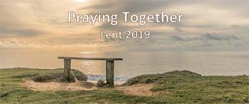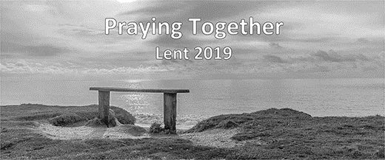
‘2019 FebMar Praying Together 2019 [1000 px wide]’
Colour photos folder here
Grayscale photos folder here

Monthly Letter
The Rt Revd Karen Gorham
Bishop of Sherborne

Our “Praying Together’ Lent booklet will give us all a chance again to pray together as a Diocese.
Using reflections and prayers compiled by individuals (who will be known and unknown to us) we shall be united in common prayer and reflection as we make our way through Luke’s Gospel.
Praying Together will hopefully though do much more than that. It will enable us to pray together as small groups in our churches, as prayer partners, with those in hospital and nursing home, and as families around the breakfast or dinner table.
It can also draw us into having more faith filled conversations. What reflection spoke most to you this week? What new thing did you discover from the readings? What action challenged you most? These are all questions which can deepen our faith understanding and move us on in our journey as disciples.
Praying Together may arrive as a personal gift, but the living Word of God has the power to transform us, our churches and our communities. So take the opportunity to open it up, join in the conversation and grow deeper as we together make our way through Lent. Pause, pray and participate.
If you are on Twitter let’s use #prayingtogether to share how we are getting on.
Our Praying Together Lent resource of daily readings, reflections, prayers and actions is a gift from our Bishops and is available for individual or group use again this year from your Church or incumbent.
+Karen

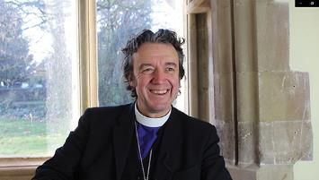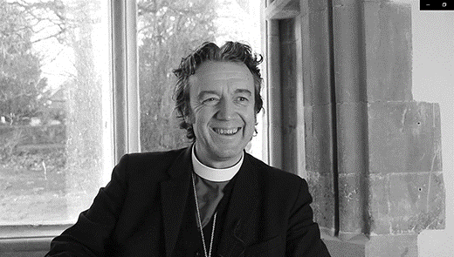
2019 FebMar Bp Andrew interview pic
Colour photos folder here
Grayscale photos folder here

Learning The Dialect
Meet the new Bishop of Ramsbury

“It was a remarkable trio of events that began my ministry here and for me, that moment when all the Bishops put their hands on me, I felt was like a time machine. I was carried back through the centuries to St Peter. That was amazing.
“It was a profound and joyful weekend, I loved the serene Evensong at the Cathedral and then, at Ramsbury Holy Cross on Sunday morning, an ordinary Parish church where I feel at home, it was lovely to just be in pastoral contact with people.
“People are definitely a priority for me, because first and foremost the Church is a community of people. We have this amazing local geographical responsibility for places, but people make places and people are the body of Christ and my first calling as Bishop is pastoral care of this bit of Christ’s own flock. Pastoral care is in my bones and it is what I am here to do really.
“Place is really important to me because place is about people and they ground real life, they are the context for all that we do. And I think they shape us and we shape them. More than sometimes we realise, places influence the shape of a community, the way the church relates to the rest of society, everything takes places somewhere, everything has a where and a when. Therefore Ramsbury area with this remarkable poetic, deeply spiritual landscape is fascinating to me alongside the communities that are constantly changing, overlaid on that and living with it.
“As Bishop you can only be in one area at a time, so you have to immerse yourself completely in the particular bit you are in, so a lot of that is about listening to the people in a place and learning the language.
You know, at Pentecost the Christian Church received this remarkable ability to discern and speak not only in the broad language but the local dialect and I have to learn the local dialect and to do that you don’t speak first, you listen to it and you pick it up and you respond.”
Watch the whole of this interview: http://bit.ly/on-the-vine

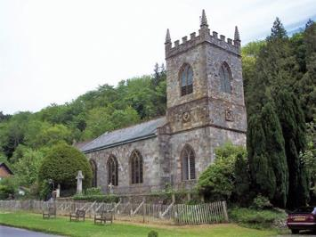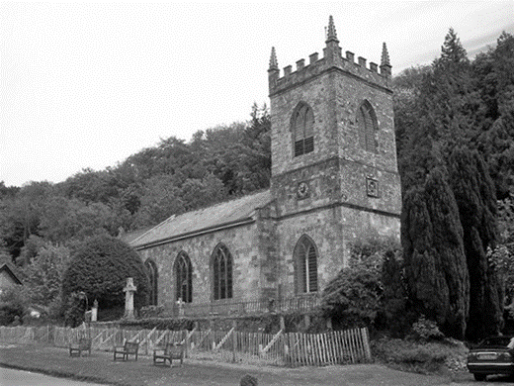
‘2019 FebMar St James Milton Abbas [credit Trish Steel, geograph.org.uk 444483]’
Colour photos folder here
Grayscale photos folder here

The Real Story Of A Village

The Dorset village of Milton Abbas was the star of the BBC4 ‘Pubs, Ponds and Power, the Story of the Village.’
The presenter, TV archaeologist Ben Robinson, said it “perfectly captures our romantic notion of what the idyllic English village should look like”. But he also revealed that “behind it lurks a history of one man’s wealth and power.”
With help from local historians we learned how, in the 18th Century, the local landowner relocated the village, because it ruined the view from his house.
But to the great disappointment of the parish church and its congregation, the programme didn’t include them.
The Rector of St James Milton Abbas, Alan Ryan says they missed a treat:
“People have told me that St James’ is the glue that holds the village together, the one thing that everyone has in common.
“St James is not a monument to the past, but a building where people gather to worship God, to be inspired and to inspire others to do great things. These are the people who are inspired by Jesus Christ to serve others.
“The buzz on Shoebox packing day, when people come from all parts of the village to pack and despatch 150 shoeboxes to areas of high deprivation is a sight to be seen.
“And - where do we find the village activists? Well, more than often, in some way, associated with St James’.
“We know the roof of our building leaks, it is cold and damp, heating it is impossible. But it is still used for concerts, council meetings, exhibitions, and many other activities. There is a crazy children’s corner, where parents and carers bring small children to meet.
“St James’ didn’t get much of a mention on the programme, if at all, but actually St James’ parish church is where much of what happens in the modern village begins.”

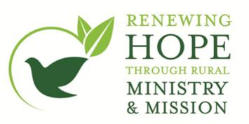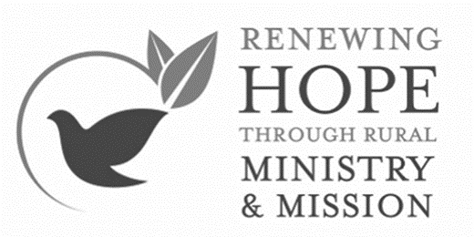
2019 FebMar Rural Hope logo
Colour photos folder here
Grayscale photos folder here

This special edition of Grapevine includes Spring news from our Rural Hope Team.
If you would like any further details about Rural Hope, contact your Rural Field Officer. See http://bit.ly/ruralhope

2019 FebMar THRIVE logo
Colour photos folder here
Grayscale photos folder here

THRIVE-ing

As part of the Rural Hope project the Diocese is investing in the CPAS ‘THRIVE’ learning programme. As the Rural Field Officer [RFO] for Dorset, Richard Hancock spent a day with six rural multi-parish benefices undertaking THRIVE in the Bristol Diocese. They were half-way through a two-year learning journey, and all reported that it had been a positive and productive experience for them and their churches.
“It’s important not to see this as a course where you simply turn up and are given a load of information on how to develop your churches. Rather this is a shared learning experience between churches and benefices over a two-year period. Yes, there is good solid input from the CPAS leaders, but it is not prescriptive.
“As anyone knows who ministers in rural parishes, one size does not fit all. Like a good tweed suit, it has to be made to measure!
“The real creative process happens in the sharing of ideas between the benefices participating, sharing what has worked and not worked in their particular context. This coupled with the input from the CPAS leaders enables each church and or benefice to tailor its own programme for mission, outreach and growth.”
“So how does it work? Firstly, Benefices find six participants for the two-year learning journey. These should be a mix of ordained and lay. Six benefice groups then combine to form a THRIVE Learning Community. Over the two-year programme, the Community will meet together four times looking at the following areas: Journey, Leadership, Discipleship and Mission.
In between these six-monthly meetings, benefices and churches look at a particular piece of work or project to undertake.
Participating benefices can then ask for support from their RFO. This gives some extra capacity and support to clergy, bringing a fresh pair of eyes and additional expertise to a project. The really good news is that this is all FREE, and the diocese will cover transport costs of getting to the THRIVE training hub meetings and lunch.
THRIVE training launches in Dorset this March and in Wiltshire on 14 June, with further training opportunities in 2020.
If your benefice is interested in becoming part of the THRIVE learning community, then please speak to your Archdeacon or your area RFO.
See http://bit.ly/ruralhope

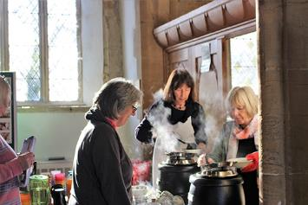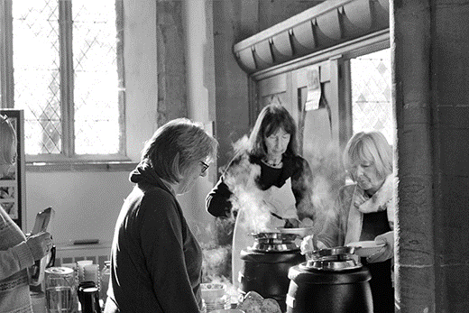
2019 FebMar Steve Inglis Story 1
Colour photos folder here
Grayscale photos folder here

Steve’s Wanderings

Our Ministry and Mission Resource Officer Steve Inglis has been out and about.
“It’s family. That is what it really feels like.” Several smiling faces nod in knowing agreement.
“I just never thought Jesus and technology could actually go together!” Another face beams with surprised excitement.
“It’s talking to them in a language they understand,” she says with warmth and understanding.
“These are just a few of the things I have heard from wonderful Lay Volunteers and Clergy involved in the broad spectrum of missional activity that I have encountered, and they are all taking place in a rural context.
“I’ve had the pleasure of getting out on the road, to glean from people’s experience, slowly building a picture of what is happening, picking up ideas, and assessing the need.
“From a multi-generational weekly drop-in featuring food, play, story-telling and music, through to a highly interactive digital exhibition that engages children and teachers in an exploration of the life of Jesus. These encounters have brought me into contact with people who are partnering with God and each other, pooling resources and skills in order to reach out to their local and surrounding community with the good news and hope of Jesus.”
“That’s cause for hope, don’t you think?”

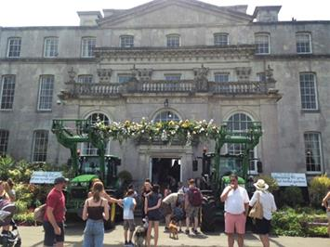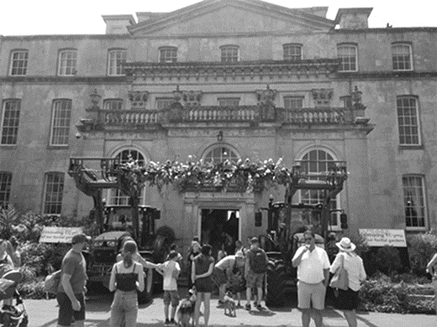
2019 FebMar Rural Day
Colour photos folder here
Grayscale photos folder here

First Rural Day

The Rural Hope team is delighted to be holding the first ever Rural Ministry and Mission Day on 14 September 2019. Sarah Keen, Rural Hope’s Programme Manager, explains more:
“We intend to make the Rural Day as enjoyable as possible. We do, however, have some clear objectives for what we hope it can achieve.
“The day will provide an unmissable opportunity to really strengthen ordained and lay collaboration in rural ministry and mission and, by the end of the day, we want people to leave with a real understanding of what underpins this initiative supporting rural ministry & mission. To be able to learn from others, here and in other dioceses, and to know how we can support you.
“There will be a chance to talk to a range of practitioners who are taking rural initiatives forward in the Diocese, and feel more confident about setting up missional initiatives in your own benefice or parish and know how to take the next steps towards this.
“We are delighted that Dr Mark Betson, National Rural Officer, has agreed to be our keynote speaker. Drawing on his own extensive experience and the latest research, he will be setting out his thoughts on what makes a successful rural church.
“This will be followed by an expert speaker panel with plenty of time for questions, chaired by Dr Jill Hopkinson, Rural Ministry Tutor at Sarum College. After lunch and a chance to visit the Market Place of rural-themed stalls, you will have the opportunity to pick your own afternoon’s activities.
“We will be offering a choice of four 45-minute workshops and alongside these, we are also running a set of interactive showcases which will offer small bitesizes of ideas for everyone.”
“While the day is open to all rural lay and ordained ministers and church officers, the size of the venue means we can only offer places for six people per benefice and these will be on a first come first served basis, so contact Clare Phillips on clare.phillips@salisbury.anglican.org as soon as possible!”

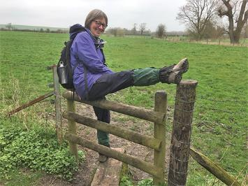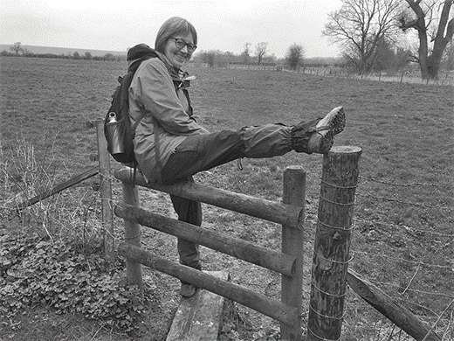
2019 FebMar Rhona Floate

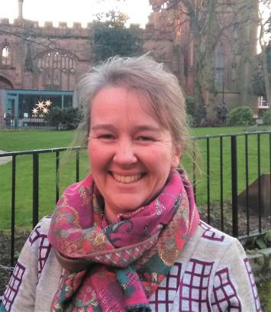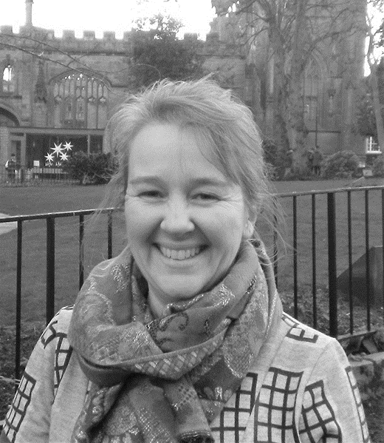
2019 FebMar Alice Farnhill
Colour photos folder here
Grayscale photos folder here

Two New Team Members

The Revd Rhona Floate joins as Rural Field Officer [RFO] for Wilts
“Rural mission was always at the heart of my call to ordained ministry. Training, development and support for others was always an energising part of my working life it’s amazing to be able to combine with keeping one foot firmly planted in parish life as a Team Vicar in the Whitton Benefice.
“My father was a village policeman, so we were a very visible part of community life and good training for rural ministry. My first career was running information services in the water industry and plant science research, both closely linked to the rural economy. We did everything from ‘muddy boots’ projects to cutting edge science.
“My hopes for the future as an RFO? To be a catalyst for visionary thinking, a sounding board for ideas, a springboard for action, a signpost to best practice, and an extra pair of hands helping rural church teams share their love of Christ with others.”
Alice Farnhill joins as RFO for Sherborne
“I’m moving back to Dorset from Coventry, where alongside bringing up two small daughters, for the past few years I’ve been Project Officer for the Community of the Cross of Nails, a global network of over 200 churches, charities and schools linked with Coventry Cathedral through its own reconciliation story.
“It’s been a humbling and deeply inspiring journey working with all these people. I have always felt Dorset to be home, however, with such fond memories. I will miss the pioneer ministry where we worship, but am sure that I am being sent out from there ready for this next exciting chapter.”

