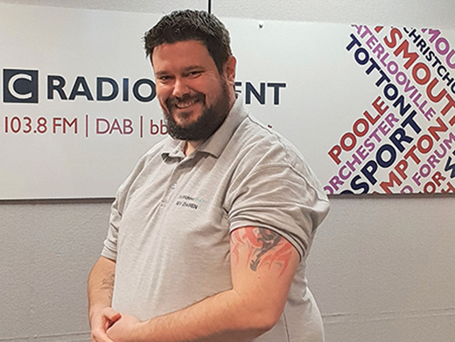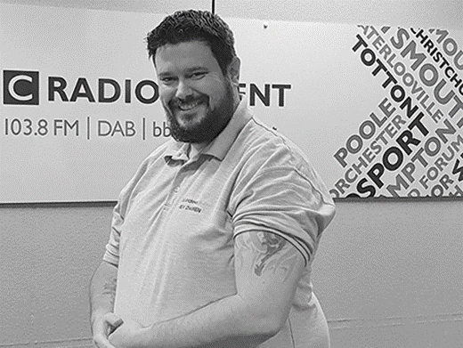

‘2019 AprMay Darren Dalton’
Colour photos folder here
Grayscale photos folder here

Encouraging and Equipping

Darren Dalton is the Curate in the Kinson and West Howe Team. While he came to faith 18 years ago, it took a long time for him to believe he was being called to ministry:
“I’m from a council estate, I’m not educated, I have tattoos, I didn’t think I was priest material - so I just didn’t trust what I was feeling.
“I lived opposite St Francis and one evening I felt this unending peace and God said to me “Spread my word”.
“Lorraine (Dobbins, the Team Vicar) got my passion for family and community and outreach and so encouraged me to become a Youth Worker, dealing with families on the local estate, setting up a crisis centre, dealing with social services. I didn’t believe God had another plan for me.
“Once I accepted God was calling me, once I trusted him, I saw that training for ministry could be practical rather than academic.
“I’m coming to the end of my first year of curacy and I have now got to grips with what priesthood is about – it’s about encouraging and equipping others to grow God’s church.
“My regret – not listening sooner, not trusting in God’s judgement for me – he doesn’t make mistakes.”
And about those tattoos.....
“In some ways my body is a stained glass window, telling the story of God’s amazing unconditional love for me, so while the people would look at me and say he will not accomplish anything -my faith and God told me I could!”
Read about Darren’s take on tattoos and faith at http://bit.ly/on-the-vine

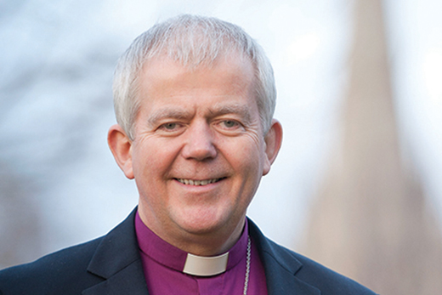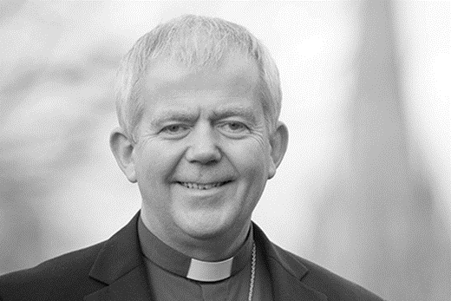

‘2019 AprMay Bishop Nicholas’
Colour photos folder here
Grayscale photos folder here

Monthly Letter
The Rt Revd Nicholas Holtam
Bishop of Salisbury

This is the third time we have been Praying Together through Lent. It is a simple formula: a short passage of scripture, this year from Luke’s Gospel, a reflection, prayer and suggested action. It doesn’t take long but it does root my day in God. It also connects me with a large number of people across the diocese praying together. I particularly like the variety of each day being written by different people, lay and ordained.
We produced 30,000 copies of Praying Together. It is a good way of renewing hope in the Diocese which stretches from Wiltshire’s Marlborough Downs to Dorset’s Jurassic coast. There is a Christian presence in every community with 574 places of worship and 196 church schools and academies. I have given copies away to ask people to pray with us.
Praying together has been good for us. The number taking part got me wondering about how we measure the life of the Church. We can count people and money. We are encouraged by our own growth and by the transformed lives of people who have grown through their encounter with God in Jesus Christ but how do we measure the quality of our prayer? What about the impact of the church on the society around? How well do we love justice, act mercifully and walk humbly with God?
In the end it’s not about us. What happened in the life, death and resurrection of Jesus changed the world. It’s not us or the Church we celebrate at Easter. The Church celebrates the resurrection of Jesus. Death is not the last word and there is new life and hope which changes the way we live here and now.
In Holy Week and Easter we find the still centre around which we and the world turns. In this turbulent world at Easter we glimpse the possibility of God’s kingdom on earth as it is in heaven. Having made the journey praying together, I hope you have a very happy and joyful Easter.
+Nicholas Sarum

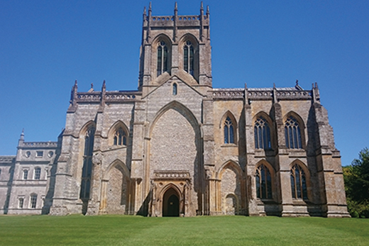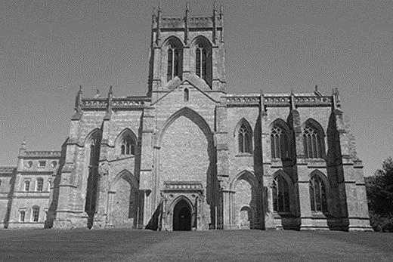

‘2019 AprMay Milton Abbey’
Colour photos folder here
Grayscale photos folder here

A “Heartbeat” of Prayer

Back in 964 AD a Benedictine Order of monks from Glastonbury came to the Abbey at Milton. They left six centuries later with the Dissolution of the Monasteries.
Benedictines are now back at the Abbey, but in a fresh expression of their heritage that befits the 21st century. Helier Exon is Custodian Trustee at the Abbey and a Companion himself:
“The idea of Benedictine Companions is both deeply historical and radically innovative. It seeks to develop the spiritual connection that visitors and friends have with the Abbey at Milton, and draw these people into its spiritual life and Benedictine heritage.
“Developing the concept of the Benedictine Oblates, and learning from the writings of Esther de Waal, the Companions are a dispersed group of people of all ages and backgrounds who will support each other in living out the Spirit of the rule of St Benedict in their daily lives and their communities.
“The focus is living according to a common rule and with a common life of prayer, centred around a daily office said at home and in the Abbey.
“We aim to not just be a community, but a “heartbeat” of prayer within the Abbey, our communities and the Diocese.
“We encourage and resource one another as Companions and we try to meet together once a month to celebrate the Eucharist and, in another week of the same month, to say the Office together, but that might be virtually - one of our number has moved to Manchester and he joins us by Skype for both the Office and the Eucharist.
“The first four members (including me) offered themselves to God as Companions of the Community with a personal promise laid on the altar and were accepted by Bishop Karen at our Foundation Eucharist towards the end of last year. But our aim was always to grow this group.
“We now have eight more enquirers, one of whom lives in New York.
At the end of the day our aim is to be a light touch community, incorporating both enquirer and experienced, for life or for a season.”
To find out more about becoming a companion, go to https://miltonabbey.org/milton-abbey-benedictine-companion

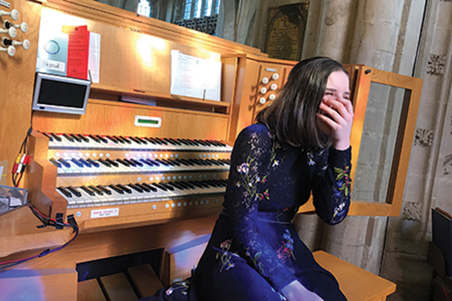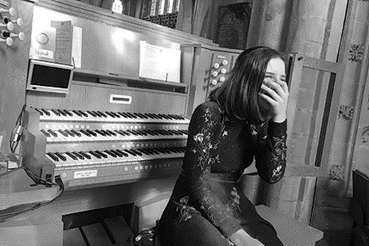

‘2019 AprMay Anna Hallett’
Colour photos folder here
Grayscale photos folder here

Inspiring Young Organists

Anna Hallett is 14 and an organist.
She has recently asked the question – who are the organists of the future?
And to answer the question she has published her own report, hoping to inspire other young organists to play.
“I started learning following a ‘Pipes and Pizza’ event held at Edington Priory in 2014, organised by ‘Pipe Up!’ a scheme supported by our Diocese.
“I am now lucky enough to be an RSCM Pipeline Scholar and last week I played my first complete service, back at Edington and I can’t wait to do it again!
“I decided to research “Who are the organists of the future?” following the publication of the Hubbard Report in January 2018, which stated just 4% of organists are under the age of 30.
“One of the concerning things a lot of the older organists raised was that there is no liturgical music training and the value of organists is not necessarily seen, nor the importance of the music which has been a tradition in a church for years.
“Initially I thought I might look at a project qualification through school, however the support I have received from the organ world has enabled it to become much more than that.
“With feedback from over 250 organists of all ages, many of whom provided additional supporting comments, several interviews conducted, further questions asked and much research carried out, it has become a project of passion (and too long for a school qualification!).”
Read Anna’s report here: https://pipeskeysandchords.com/inspiring-organists-of-the-future

