Loss and Sadness – Could link to All Souls’ Day November 2nd
INTRODUCTION
This year, instead of focusing on Remembrance Sunday, we have put together a resource you can adapt that is linked to sadness and loss. It is centred on the fact that Christians believe that God sees and shares our sadness and grief.
Spiritual development is as much about the ‘ows’ of life as the ‘wows’ of life and it can be helpful for children to have a conversation and some language to use about death, which is often not talked about much in our culture.
All Souls’ Day is a day in the Christian calendar where people pray for relatives and loved ones who have died. They are remembered in special services and sometimes candles are lit and names read out.

SOME NOTES AND RESOURCES FOR STAFF
- See here for some background on All Souls’ Day https://www.bbc.co.uk/religion/religions/christianity/holydays/allsaints_1.shtml#:~:text=All%20Souls%27%20Day%2C%202nd%20November%2C%20is%20a%20time,on%201st%20November%20by%20Anglicans%20and%20Roman%20Catholics.
- And here for background on Christian belief about life after death https://www.bbc.co.uk/bitesize/guides/zgqjgdm/revision/1

- NHS Video – talking to children about being bereaved https://www.youtube.com/watch?v=vUS89lFr0XA
- Useful resource for adults in relation to children’s loss https://www.nhs.uk/mental-health/children-and-young-adults/advice-for-parents/children-and-bereavement/
- Salisbury diocesan board of education resources for bereavement https://www.salisbury.anglican.org/parishes/cypaf/bereavement

THE POWERPOINT
There are 3 embedded videos in this story. We suggest you choose one (or one per key stage so that you could use this resource again in 2-3 years’ time and the children would experience a different story next time.)
- Water Bugs and Dragonflies - A story that explains death to children in a child friendly way and doesn't use the word death so you can choose to extend as it suits you and your children. The story follows water bugs appearing above water as a dragonfly and look below at their friends under the water. It could be used to explain the difference between our life in this earthly body and what comes next/went before. It is a book about change and leaving things behind. It could be used as a metaphor for earth and heaven.
- The Heart and The Bottle – This might go with ‘empty chair’ prayer space as the person in the story sees an empty chair and it makes them sad, so they put their heart away in a bottle and stop noticing things to wonder about and amaze them.
- The British Heart Foundation’s Small Creature Story- Small Creature misses ‘bird’ but is helped by other animals to overcome his fear, anger and sadness with some practical activities. These could be used by children in school who have experienced bereavement or loss.

PRAYER SPACE ACTIVITY OPTION 1.
This has been resourced for your school with a cross, blue cloth, templates for tears, a glass jar/vase and blue glass ‘tears’. You may want to create your own cross and some instructions. Each class could be given a time when they could do this activity.
See tears templates for children’s use. And blue glass beads for them to drop into the water themselves.
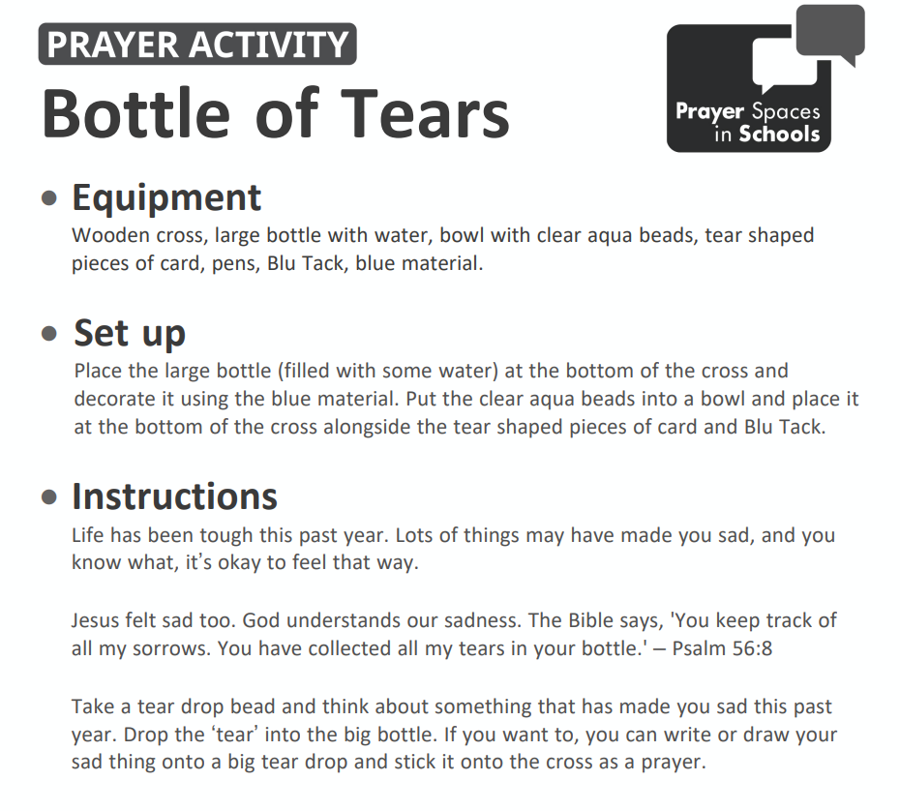

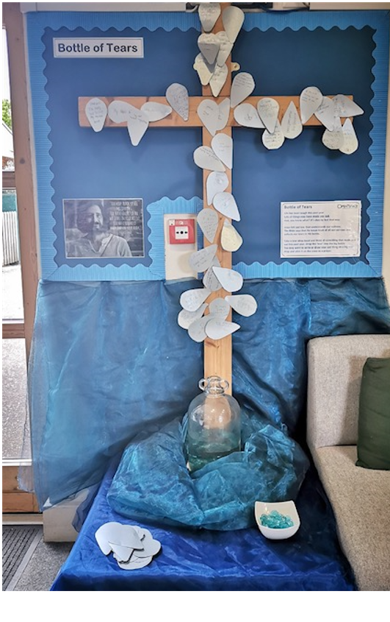
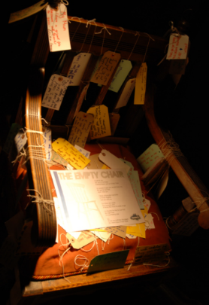
PRAYER SPACE ACTIVITY OPTION 2
Empty Chair – this could be set up by the school as an alternative activity. You could put a pet basket there too… as some children will have experienced loss of a pet.

When someone that we love leaves us or dies, they leave a gap in our lives. We miss them.
This activity offers a simple, safe place for pupils to consider and express a bit of how they feel about someone who they have loved and lost. It encourages pupils to reflect on the good memories, but it also allows for, and affirms, the sad ones too. It’s OK to not be OK.
This activity consists of an empty chair to represent the ‘missing person’, and invites pupils to write on luggage tags or post-it notes and attach them to the chair.