9. Making progress
Let’s begin this module with some reminders…
As a member of the governing body, we hold with colleagues the responsibility for carrying out our stated responsibilities;
As a Foundation Governor, alongside our Foundation appointed colleagues, we hold some additional responsibilities, as described in the appointment policy and referenced again at the end of the service of commissioning;
The Role of Foundation Governor in the Diocese of Salisbury
As a Foundation Governor, you share the responsibility ‘to preserve and develop the religious character and ethos of the school’ and to develop your spiritual leadership and that which is exercised by all those in leadership within your school community.
You are the vital link between the school and the parish and it is this ‘school parish partnership [that] is recognised as an important part of thriving Christian communities.’
In accordance with the expectations of the Salisbury Diocesan Board of Education, you will;
- fully support, cherish, preserve and develop the distinctive Anglican and Christian ethos of the school, ensuring that the school has a distinctive Anglican and Christian vision and values which lead to effective practice and outcomes
- preserve and strengthen the links between church, school and diocese
- take an active role in the school’s self-evaluations of progress against the ‘Statutory Inspection of Anglican and Methodist Schools’ (SIAMS) schedule
- ensure that collective worship and religious education at the school follow the appropriate guidelines and/or syllabus
- ensure that collective worship at the school is in accordance with the tenets and practices of the Church of England
- encourage, support and challenge the school towards aspirations that are transformational
- ensure that collective worship and religious education at the school are appropriately monitored
- ensure that the distinctive Anglican and Christian ethos of the school is encouraged and supported throughout its local community and is reflected in its policies and protocols, its curriculum and activities
- ensure that their own attitudes and behaviour in relation to the school reflect its distinctive Anglican and Christian ethos
- make sure that the School Improvement Plan includes strategy for the development of areas reflected in the school’s SIAMS self-evaluation document
- inform the SDBE when the head teacher post becomes vacant and, in partnership with the Chair of Governors, invite a representative of the Diocesan Director of Education to advise and attend throughout the appointment procedure
- to support and challenge the leadership within the school in their links with the wider parish(es) and community and to promote support for school activities and initiatives relating to its Christian distinctiveness and effectiveness

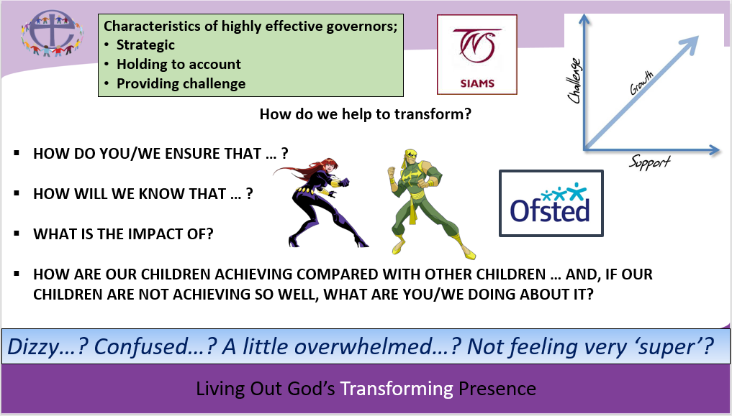
This is a huge task and a very big ask!

So, how do we know where to start?

How do we keep going and, hopefully, improve?

Remember our prayer…

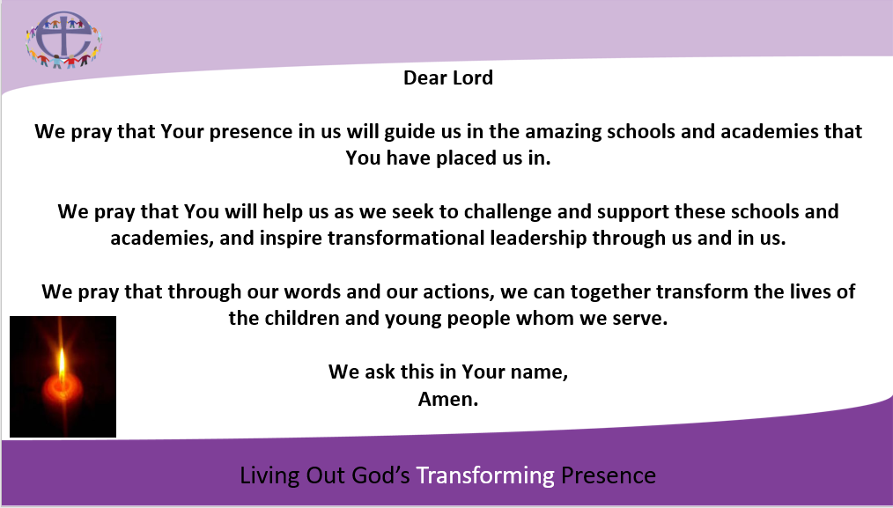

Let’s just focus on the first ‘mile’…;
Me
Impact
Learn
Effective

Me
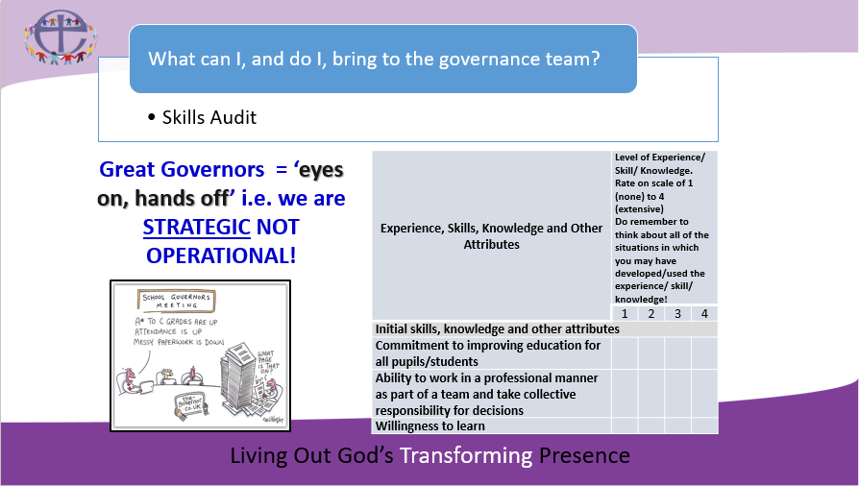

Impact

Learn
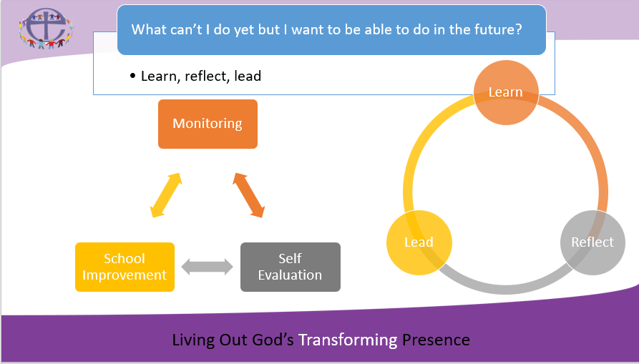

Effective
I will be effective when I am ‘Living Out God’s Transforming Presence’!
