8. Ofsted
Who is the current HMCI, and what does HMCI stand for? (Refer back to Module 2)

When was your school last inspected under Ofsted? What was the judgement? When is the next inspection due?

Extension questions:
What type of inspection was it (Section 5 or section 8)? What is the difference (see below) and what type of inspection does it mean your next inspection is most likely to be?

Has the current Ofsted self-evaluation form (SEF) for your school been shared and discussed with governors?

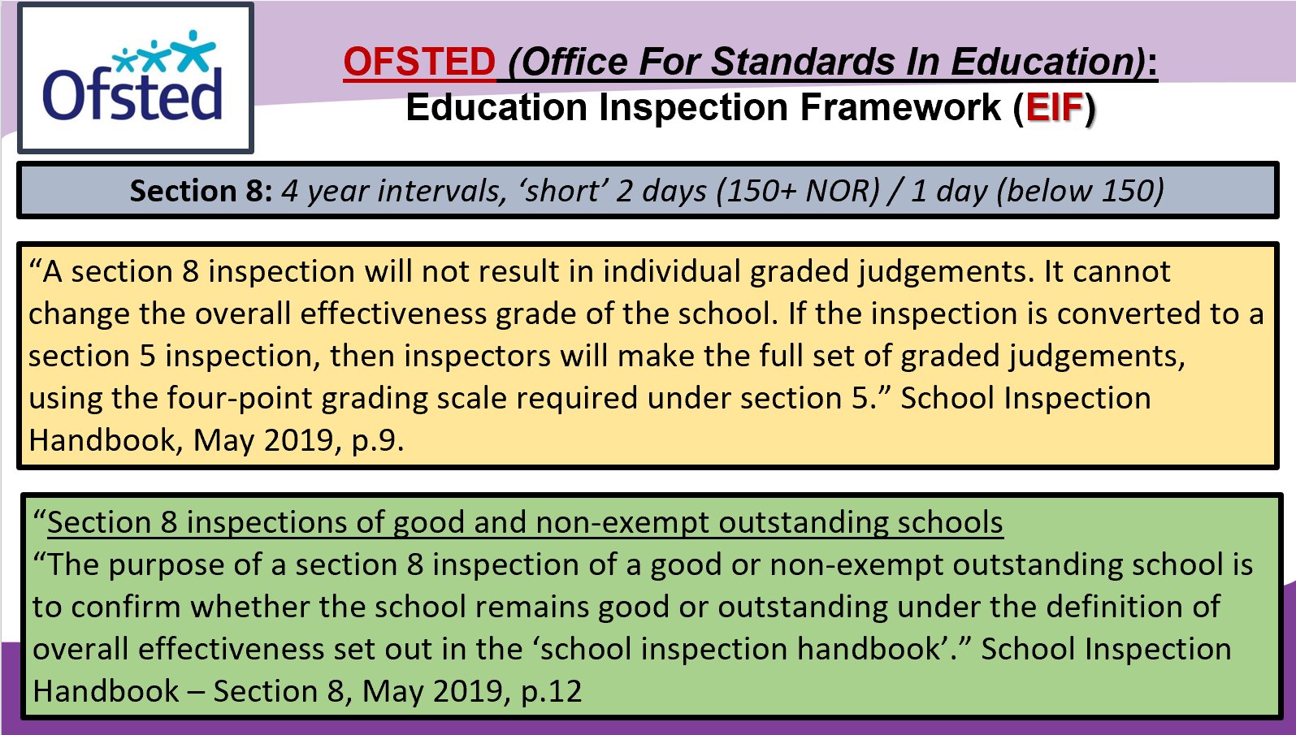

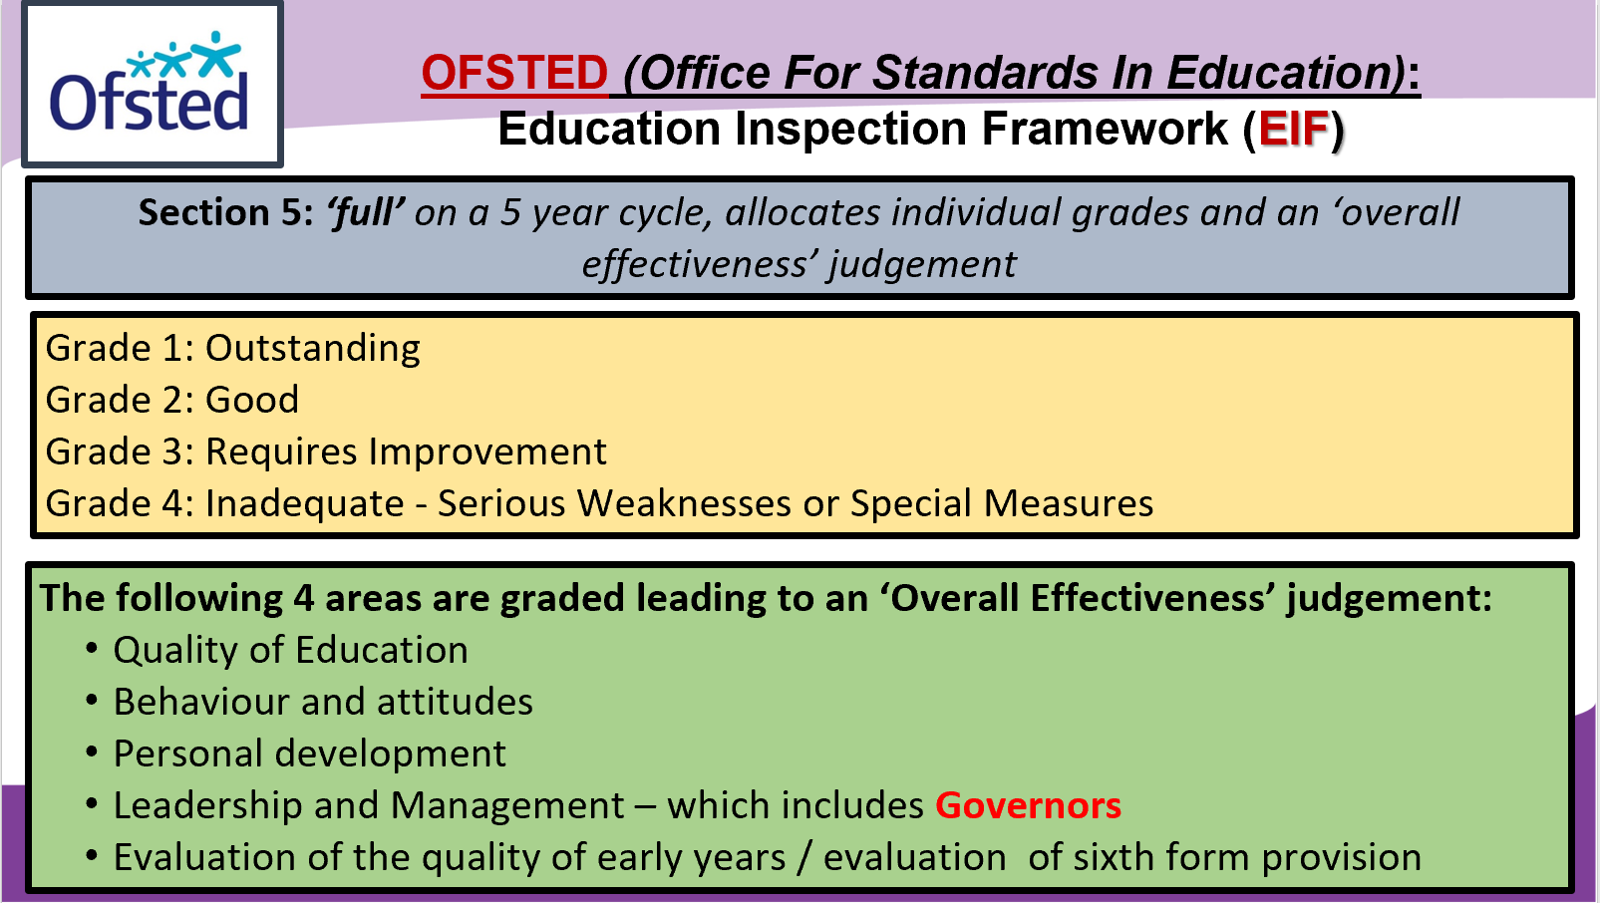
Evaluating the performance and progress of your school
The constant evaluation of educational performance that drives the school’s self-evaluation process is a vital aspect of the role undertaken by the governing board. This can involve a plethora of topics and terminology, and although not all will be relevant all the time, and in every context, understanding these can be the steepest learning curve.

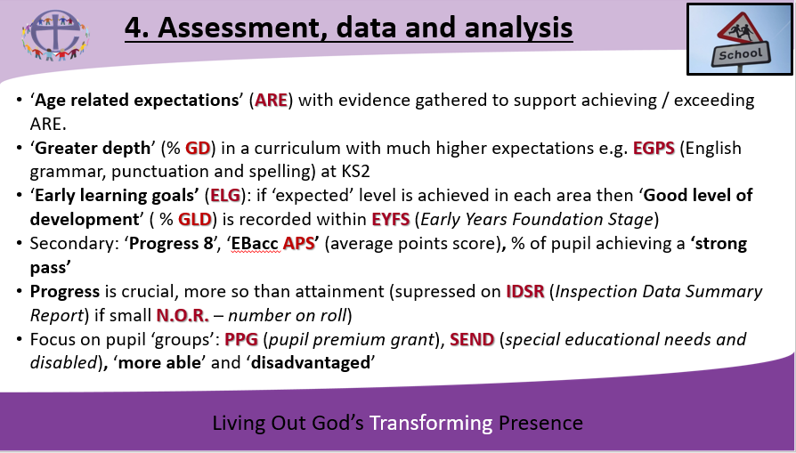
Topics and terminology: 2021-22 critical update
Use this section to include information about forthcoming changes within the education provision in your setting, and to record details of national developments over the coming months and years…
[Examples from 2020-21; Relationships, Sex and Health Education (RSHE), Reception Baseline Assessment]

