5. Ethos and Vision
‘Bringing the Vision Alive’

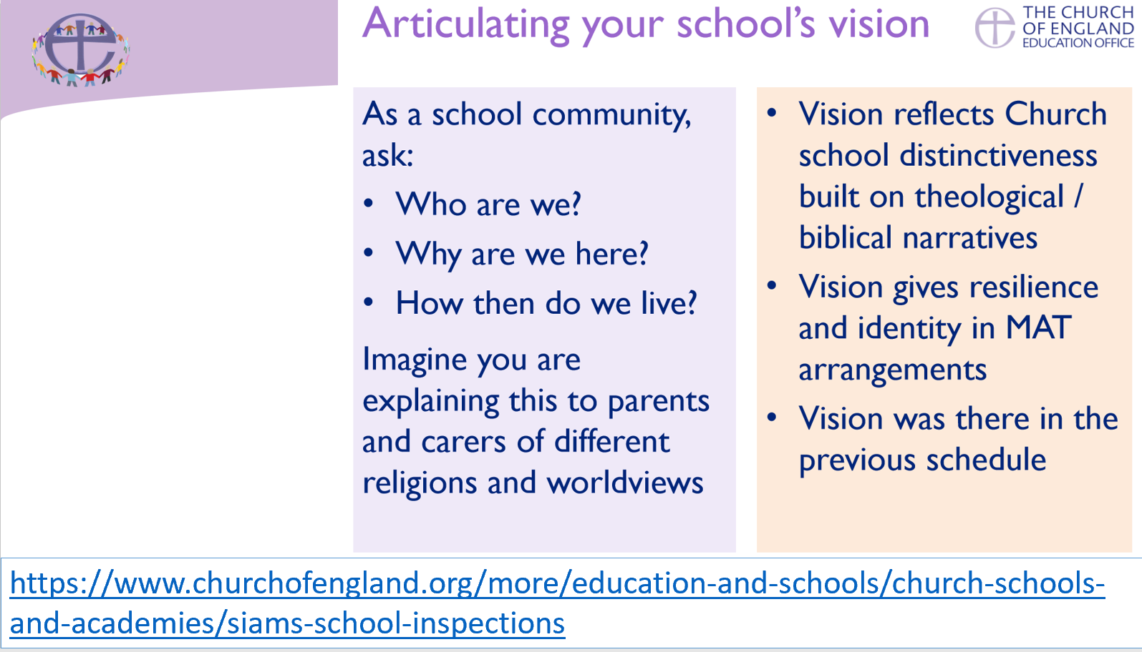

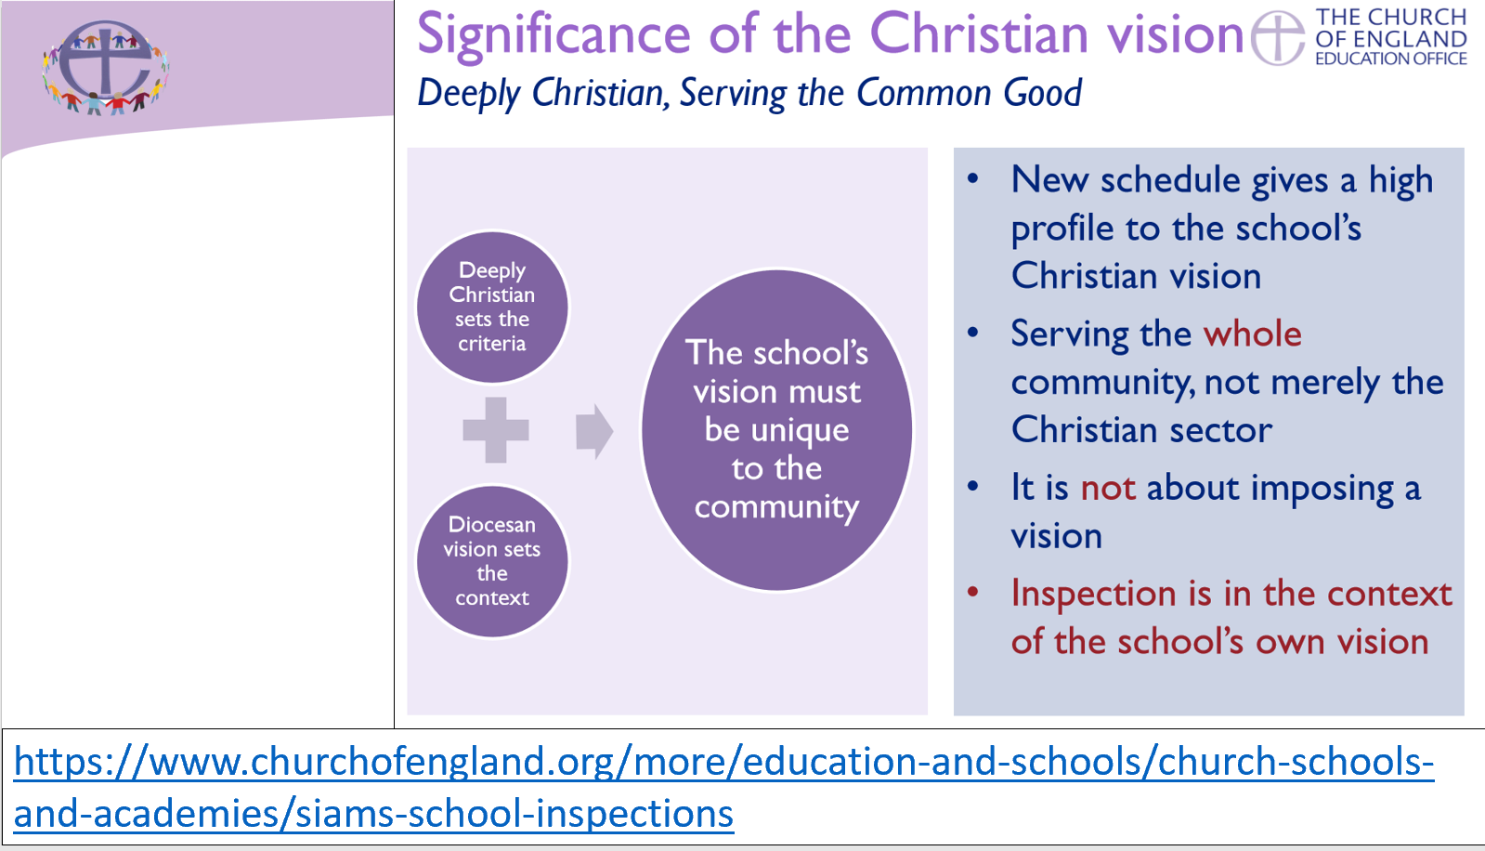
What do you think is meant by ‘ethos’ and ‘vision’ in a church school context?

Ethos Enhancing Outcomes

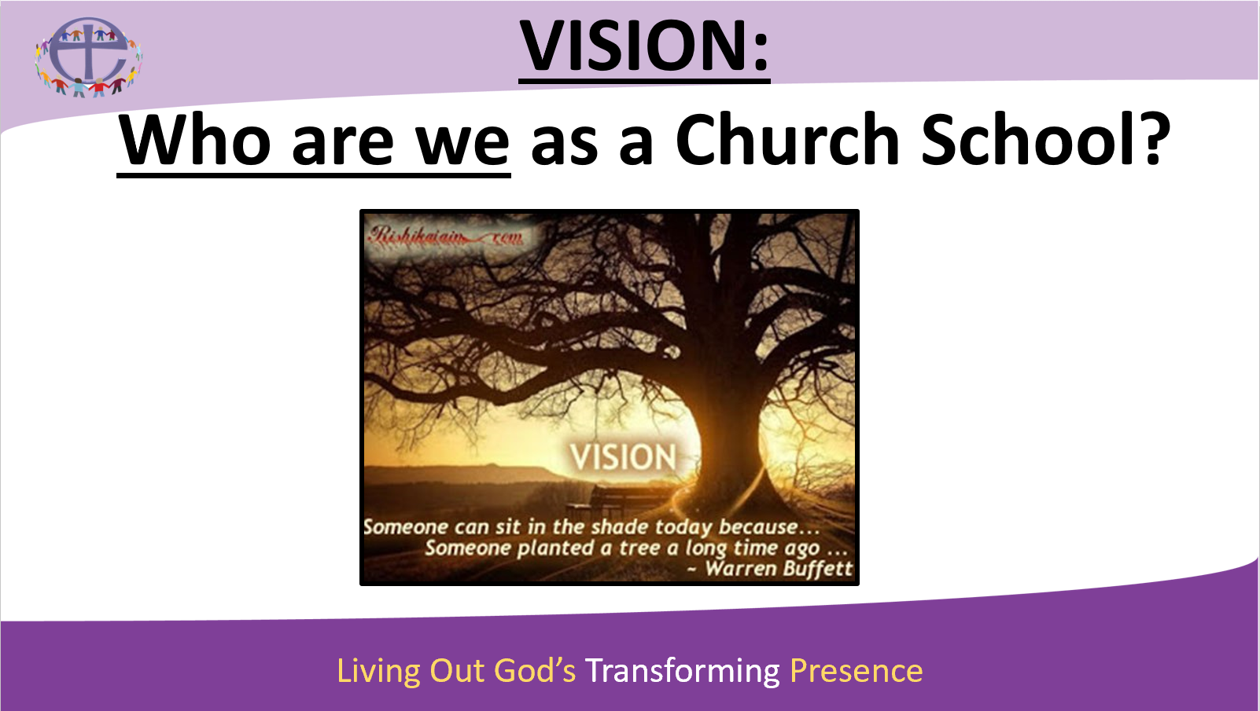

What is your school’s ‘distinctive Christian vision’?

Does your school have a vision vessel / vision image? What is it, and how was it produced?

Who decides / decided your vision?

Where would you find your vision within your school setting? Apart from physical examples on walls, pictures, etc., where else might you find it / see it?

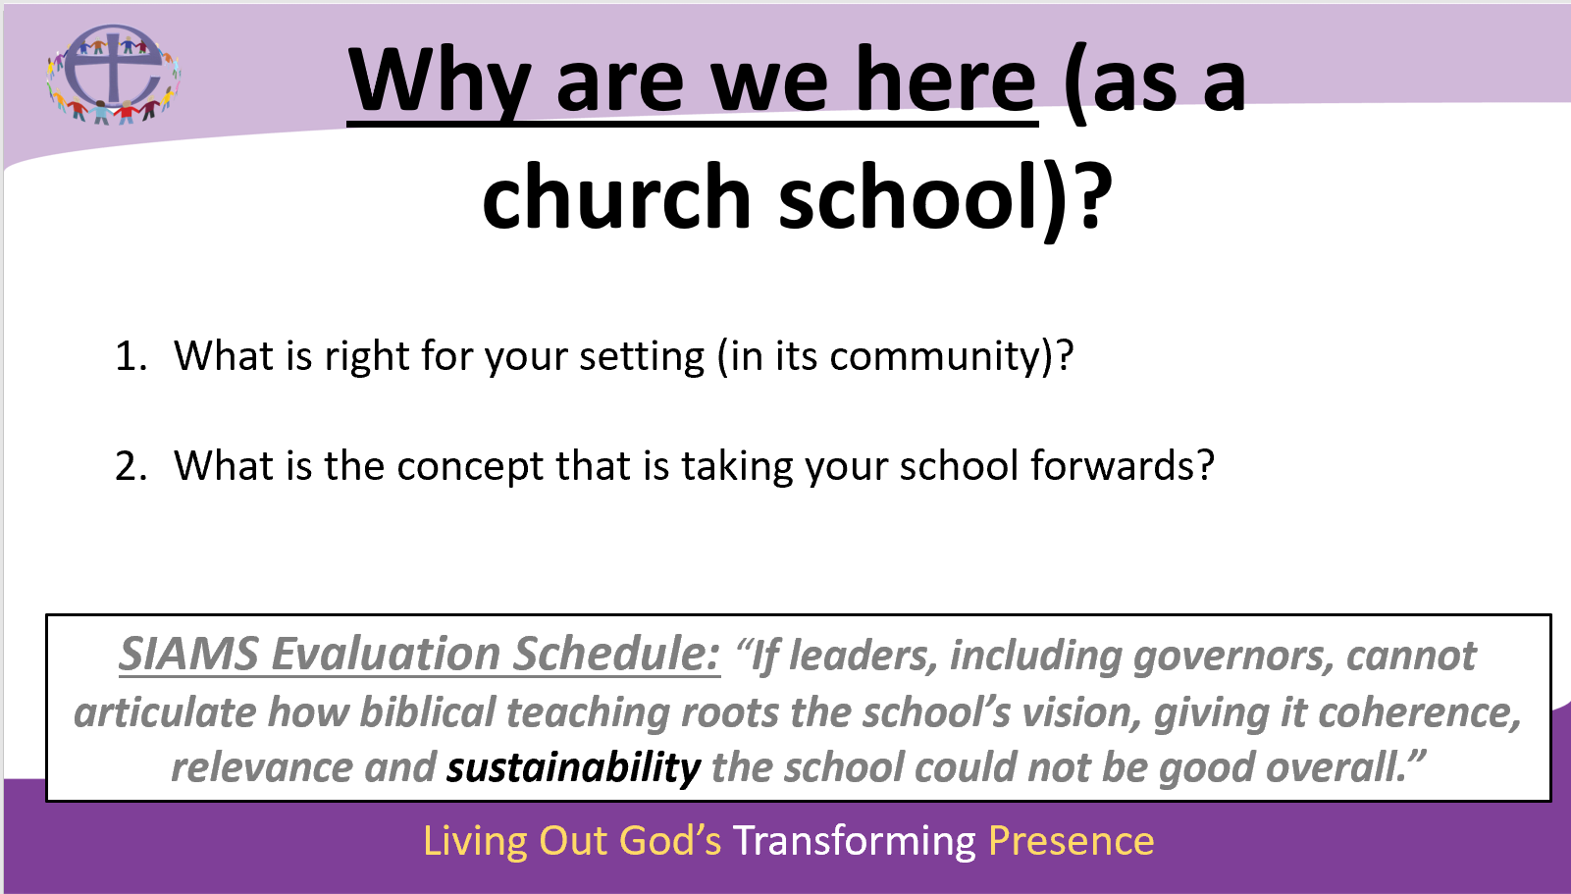

For further research –
- Do your staff, parents, governors, children know what the school’s vision is and where it can be seen?

- How often is the vision reviewed, and what is the process for this?

