2. Who’s who

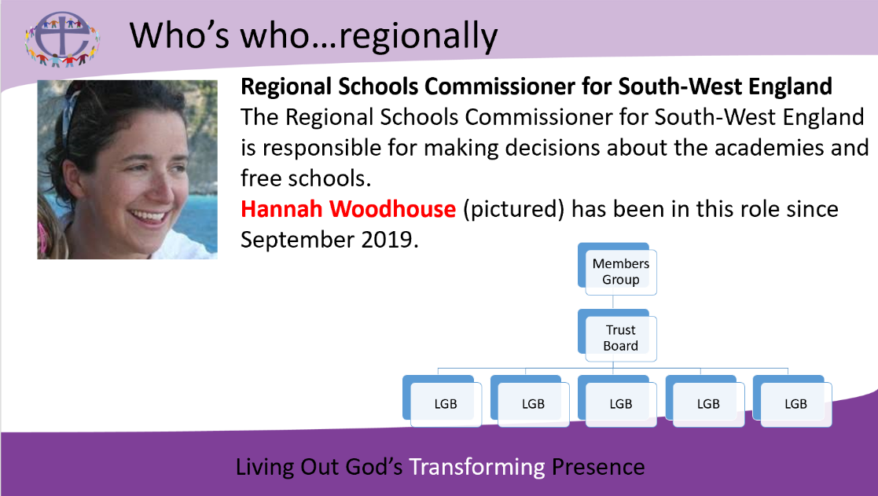

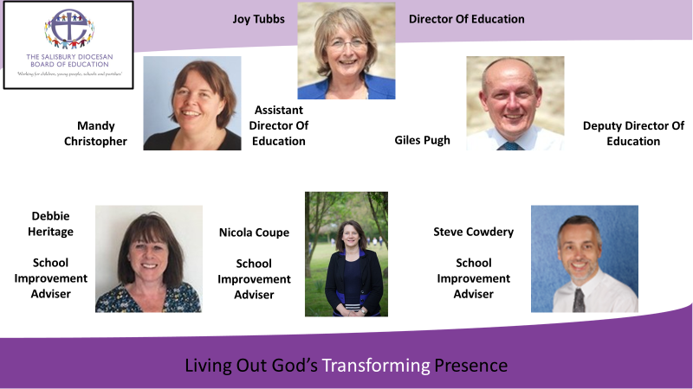

|  |  |
| --- | --- |
|  |  |

**For information on all SDBE staff, including the Schools Team click** [**here**](https://www.salisbury.anglican.org/schools/contact-us)