Week 36 Not Giving Up

 | RRS |  | I can express my emotions clearly and openly to others and in ways appropriate to situations

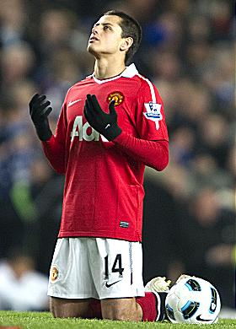
Reflection
Chico Hernandez of Manchester United and Mexico credits his faith for stopping him giving the game up altogether just 12 months before Manchester United bought him.
Hernandez, 22, said: “I started doing that when I was thinking of quitting. When I started playing a bit more, I started to do that only to say thank you for helping me.”
“I feel He helped me a lot and always he is there.”
“That’s why I like to say thank you for letting me be part of another game, for letting me play in another game.”
“I started thinking if this is what God wanted for me, I needed to work hard.”

Thinking
Who do you need to say thank you to for helping you not to give up?

I always thank my God for you because of his grace given you in Christ Jesus. For in him you have been enriched in every way.(1 Corinthians 1 v 4-5)

