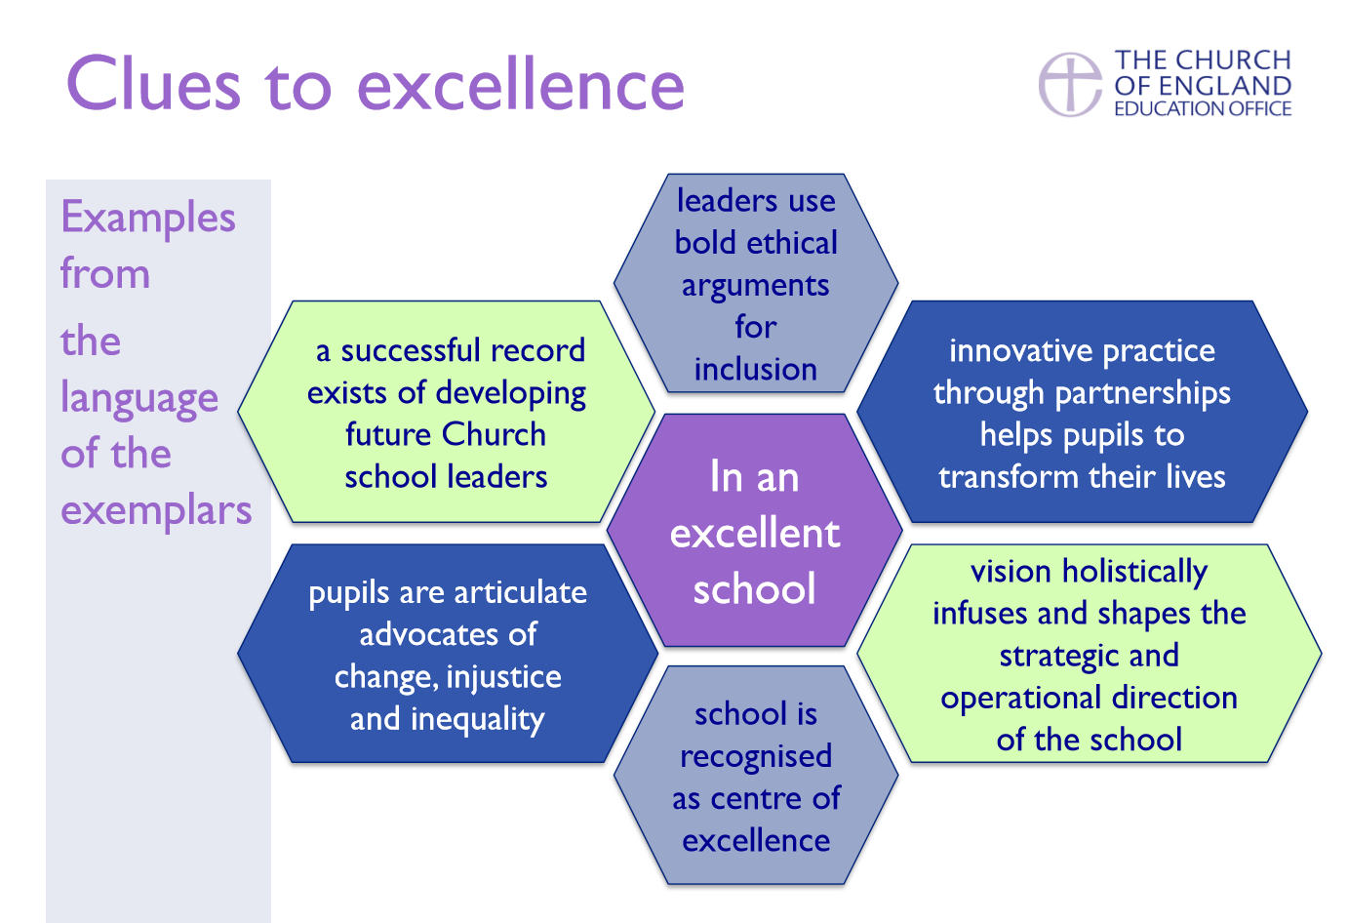
VISION & LEADERSHIP
- How well the school has developed and implemented an inclusive and distinctive Christian vision, monitoring its impact to ensure the school’s original foundation is maintained.
- How well the school lives out that Christian vision in relationships and partnerships with key stakeholders.
Examples of ‘Excellent’
- Leaders effectively demonstrate how the impact of the school’s vision holistically infuses and shapes the strategic and operational direction of the school. This leads to innovative and imaginative practice that, in the judgement of the inspector, helps pupils transform their lives. The school uses its involvement in any MAT, federation or school to school partnerships to introduce innovative practice that reflects the school’s vision.
- The school is innovative and ethical in adopting an admissions policy (in accordance with it Trust deed) that ensures that the school population both reflects its local community and promotes its Christian character by seeking to give opportunity to all and supporting inclusion and diversity.
- Leaders ensure that the relationship between the school, church and diocese is supportive and sustainable, enhancing the learning of both pupils and the congregation. It is a link that is widely acknowledged and valued by all members of the school community. The school may be used by the diocese as a centre of excellence.
- In an excellent Church school, effective induction and professional development is prioritised for all staff and governors. This has led to innovative practice working with the church and other schools locally, regionally and nationally.
- Governors have established systems for monitoring and evaluation that involve the whole school community and are, in the judgement of the inspector, exceptionally rigorous and effective. Governors have developed the school as a Church school through regular engagement with the local diocese and as a result often lead innovation locally. The school has a successful record of developing future Church school leaders.

Examples of ‘Good’

- Governors articulate the school’s vision with passion and practical illustration
- RE leaders & teachers have access to regular, high quality professional development
- It understands itself as a partner with local church and diocese.
- All staff members & governors have opportunities to develop their understanding of Church school education; leaders can demonstrate how this has led to improved practice
- Leaders have regular opps to develop their knowledge & understanding of strategic Church School leadership and this has measurable impact on pupil learning
- Leaders & governors ensure that this is an ongoing process in place that evaluates the effectiveness of the school as a Church school. This is based on evidence and analysis, includes most groups in the school community and informs school improvement.

- To what extent is the school’s vision and its associated values grounded in a clear theology firmly rooted in a Christian narrative?  - To what extent do leaders show awareness and understanding of current thinking in Church school education? | - To what extent does the school’s Christian vision shape school policies and Church school development plans? How is priority given to collective worship and to religious education (RE)? | - How well do leaders ensure that the school’s formal partnerships are supported, sustained and informed by the school’s Christian vision and associated values? This includes how well school leaders work with the local diocese/circuit and churches.
- Have the recommendations from the previous SIAMS inspection been addressed and brought about positive outcomes for pupils? | Could have the vision image here? Or put the 2 red bullet points?  Or pick a key quote that focuses on impact for each strand here? Or one image that captures something about school that is a key aspect of this strand? | - How well do leaders ensure that all staff members at all levels are supported in the development of their understanding of the school as a Church school? How well are future Church school leaders prepared and supported through professional development leading to improved practice?
- Next Steps to improvement |  | - How well do governors ensure that a robust and continuous self-evaluation process is in place that involves the school community in evaluating their effectiveness as a Church school?

WISDOM, KNOWLEDGE & SKILLS
- How well the school’s staff and leaders apply their Christian vision to ensure curriculum and extra–curricular opportunities meet the academic and spiritual needs of all learners.
Examples of ‘Excellent’
- Through reference to innovation, informed by the school’s Christian vision, leaders show how the curriculum is tailored to meet the needs of all pupils the school serves. They make bold ethical arguments for the inclusion and support of vulnerable pupils, including those with learning difficulties linked to the school’s vision that enable all to flourish.

- Aspects of the curriculum reflect a pedagogical approach that actively enables pupils to reflect and explore the spiritual and ethical dimensions of all subjects.

- Considering context and cohorts, academic progress is above average for all groups of pupils and there is little difference between the progress of those who are disadvantaged and those that are not.

- The school community applies its own understanding of spiritual development so that teachers have the confidence and ability to move beyond planned opportunities to make the most of questions raised by the curiosity of pupils and opportunities that occur spontaneously across the curriculum.

Examples of ‘Good’

- Leaders use ethical arguments to justify making bold curriculum decisions to ensure pupils experience an exciting and relevant curriculum that enables them to flourish
- Progress stats at least close to national average- including pupils with SEND and the most able. As a priority, the school is enabling its vulnerable pupils, including those with learning difficulties, to flourish academically.
- Clear & secure understanding of spiritual development, distinguishable from social, moral and cultural development and shared by the staff.
 |  | - a) How effective is the school at meeting the academic needs of all pupils through the curriculum? How effective is the school in identifying and supporting those who are more vulnerable and who may have additional learning and personal needs?
 | Could have the vision image here? Or put the 2 red bullet points?  Or pick a key quote that focuses on impact for each strand here? Or one image that captures something about school that is a key aspect of this strand? | - b) How well does the school support all pupils in their spiritual development, enabling all pupils to flourish?
Next Steps to improvement?

CHARACTER DEVELOPMENT, HOPE, ASPIRATION & COURAGEOUS ADVOCACY
- How well the school’s Christian vision supports the character and moral development of all pupils, giving them aspiration for themselves and hope for the communities of which they are a part.
- How well the school’s Christian vision inspires the whole school community to engage in social action and to be courageous advocates for change in their local, national and global communities.
Examples of ‘Excellent’
- Pupils explain how the school’s values give them confidence to listen, question, explore and challenge themselves in pursuit of their learning.

- Leaders use creativity and innovation to provide quality opportunities for pupils to explore situations of injustice and inequality so opening pupils’ horizons, giving them a concern for others. This is often a practical expression of the school’s partnership with the local church community. The school community has established mutually beneficial global partnership links to schools in different parts of the world that are highly valued by adults and pupils alike.

- Pupils are articulate advocates of change, challenging injustice and inequality. They have regular opportunities to engage in social action projects which pupils themselves have identified to address issues of disadvantage, deprivation and the exploitation of the natural world.

Examples of ‘Good’

- Pupils say how the school’s Christian vision and assoc. values help them to make positive choices about how they live and behave, and how they support them in their learning
- Leaders ensure opps to explore ‘big questions’ about life, thinking about disadvantage, deprivation, exploitation of the natural world….
- Leaders demonstrate how spending decisions (where possible), fundraising, charity partnerships and social action projects reflect the school’s Christian vision.
- Encourages pupils to think globally, exploring links between local diocese/world church and schools internationally.
- Pupils talk about ways to challenge injustice and inequality, engage in social action projects- going beyond sense of compassion to sense of justice

- a) To what extent does your school’s vision and its associated values develop aspiration in all pupils, giving them resilience to cope well when things are difficult and the perseverance to overcome barriers to their own learning and to make positive choices? | - b) Do leaders make sure all pupils have curriculum opportunities to look beyond themselves, ask ‘big questions’ and think globally about life and develop an understanding of disadvantage, deprivation and the exploitation of the natural world? How effectively has the school explored and engaged in diocesan and other global companion/world church links? | - c) How well does the school community connect its ethical and charitable activities to the school’s vision and associated values? Do leaders provide opportunities for all pupils to engage in social action and to understand how they can challenge injustice?
Could have the vision image here? Or put the 2 red bullet points?
Or pick a key quote that focuses on impact for each strand here? Or one image that captures something about school that is a key aspect of this strand?
Next Steps to improvement?

COMMUNITY & LIVING WELL TOGETHER
- How well the school’s Christian vision promotes social and cultural development through the practice of forgiveness and reconciliation that encourages good mental health and enables all to flourish and live well together.
Examples of ‘Excellent’
- The school is recognised by the wider community as a centre of reconciliation and support. It is a place where pupils are given and take second chances. Pupils will talk about forgiveness and reconciliation as a worthy way of living. Adults talk of support they have received from the church school community.

- Leaders ensure that policies for staff wellbeing reflect the school’s Christian vision and make sure that all staff are treated with dignity and respect. Staff and pupils report a culture of care and encouragement, a sense of hope. Almost all staff speak readily of tangible ways in which they have been supported by practical and compassionate care. They feel looked after and attribute this to the vision of the school.

Examples of ‘Good’

- Pupils are observed to behave well
- School behaviour policy and related policies reflect school’s Christian vision.
- Pupils have opportunity to seek forgiveness and reconciliation and this is reflected in school’s behaviour, exclusion and attendance policy & practice.
- Pupils are given the skills they need to disagree well and to live with contradictory convictions
- Effective systems in place for ident of issues around mental health and wellbeing
- Policies support pupils with mental health difficulties making use of expert advice as needed.
- Pupils & adults feel confident to express their views and concerns and say they are listened to and given opps to participate in school decisions
 |  | - To what extent does your school’s Christian vision and associated values underpin relationships at all levels in the school community, enabling pupils to disagree well and to practice forgiveness and reconciliation? Is this reflected in the school’s behaviour, exclusion and attendance policies?
 | Could have the vision image here? Or put the 2 red bullet points?  Or pick a key quote that focuses on impact for each strand here? Or one image that captures something about school that is a key aspect of this strand? | - How well do leaders ensure there is support for good mental health in children and adults and a sense of belonging that embraces and celebrates difference?
- Next Steps to improvement?

DIGNITY & RESPECT
- How well the school’s Christian vision creates an environment that embraces difference where all pupils, whatever their background or ability, can flourish because all are treated with dignity and respect
Examples of ‘Excellent’
- Leaders ensure that any barriers to inclusion that might limit the life chances of pupils are significantly reduced. Pupils talk of the school being a hospitable community where they are encouraged to fulfil their potential.

- Reflecting the school’s Christian vision, policies are successful in preventing rather than just reacting to incidents of prejudicial behaviour creating a culture where pupils whatever their background, disability, ethnicity, gender, identity, learning difficulty, nationality, religion, or sexual orientation are comfortable as the person God made them to be. Pupils take a lead in challenging prejudicial behaviour and language.

Examples of ‘Good’

- Culture where all members of school community, whatever background etc. are treated with dignity & respect as people created in the image of God.
- Pupils say that they feel safe to express their views without being made fun of in a culture of mutual respect
- Pupils show respect for difference and staff will challenge prejudicial behaviour etc
- Procedures and policies are in place and up to date, reviewed and evaluated regularly ref bullying
- School offers age appropriate and coherent relationships and sex education, reflecting school’s Xn vision and supports pupils to form healthy relationships

a) How well does your school’s Christian vision and associated values uphold dignity and value all God’s Children*, ensuring through its policy and practice the protection of all members of the school community? (* See ‘Valuing All God’s Children’) | - b) How well does the whole curriculum provide opportunities for all pupils to understand, respect and celebrate difference and diversity? | - c) Does the school have an approach to relationships and sex education (RSE) that ensures children are able to cherish themselves and others as unique and wonderfully made, and to form healthy relationships where they respect and offer dignity to others. (From 2020 onward)
Could have the vision image here? Or put the 2 red bullet points?
Or pick a key quote that focuses on impact for each strand here? Or one image that captures something about school that is a key aspect of this strand?
Next Steps to improvement?

THE IMPACT OF COLLECTIVE WORSHIP
- The ways in which collective worship is an expression of the school’s Christian vision.
Examples of ‘Excellent’
- The school community recognises and values worship as the heartbeat of the school. Pupils and adults talk with enthusiasm about worship and explain how it influences their lives, both in and out of school.

- School leaders work proactively with the local church community or diocese who provide innovative and appropriate support for collective worship. Pupils take a considerable lead in the development of worship within the school. Staff are well supported to lead engaging tutor group and classroom worship.

- Pupils articulate an informed and evaluative understanding of the value and use of prayer and reflection. There are varied and interactive prayer and reflection activities on offer to all pupils which they find helpful and supportive.

- Pupils are enabled to engage with the Eucharist in creative and innovative ways, and this ensures a range of age and context appropriate opportunities for pupils to explore the Eucharist in ways that respect the integrity of the pupils.

Examples of ‘Good’

- Worship allows everyone opportunity to engage, with freedom for those of other faiths and none to be present with integrity
- Prayer a natural and valued part of the culture of the school
- Pupils talk about value of prayer and reflection in formal and informal contexts, and how being still and reflective in their own lives can be helpful
- Worship is creative, has variety
- Most staff and pupils talk about how worship causes them to reflect on their behaviour, values and attitudes
- Worship enables people to develop appreciation of variety of elements and styles in wide range of traditions
- Aware of central importance of communion in Christian worship

- Offers the opportunity, without compulsion, to all pupils and adults to grow spiritually through experiences of prayer, stillness, worship and reflection. | - b) Enables all pupils and adults to appreciate that Christians worship in different ways, for example using music,  silence, story, prayer, reflection, the varied liturgical and other traditions of Anglican/Methodist worship, festivals and, where appropriate,  the Eucharist. | c) Helps pupils and adults to appreciate the relevance of faith in today’s world, to encounter the teachings of Jesus and the Bible and to develop their understanding of the Christian belief in the trinitarian nature of God and its language.
 | Could have the vision image here? Or put the 2 red bullet points?  Or pick a key quote that focuses on impact for each strand here? Or one image that captures something about school that is a key aspect of this strand? | - d) Enables pupils as well as adults to engage in the planning, leading and evaluation of collective worship in ways that lead to improving practice. Leaders of worship, including clergy, have access to regular training.
- Self Evaluation  Excellent, Good, Requires Improvement, Ineffective Next Steps to improvement? |  | - Encourages local church community partnerships to support the school effectively in developing its provision for collective worship.

THE EFFECTIVENESS OF RELIGIOUS EDUCATION
- How effective the school is in ensuring pupils flourish through the provision of high quality religious education reflecting the Church of England Statement of Entitlement.
- How effective the school is in ensuring that religious education expresses the school’s Christian vision.
Examples of ‘Excellent’
- Pupils are inspired by RE and recognise it as a challenging but safe space to explore their own and others’ religious, spiritual and philosophical convictions critically and responsibly.

- Pupils confidently give age appropriate theologically, philosophically and sociologically informed accounts of Christianity and other religious traditions. Pupils have significant opportunities to engage in dialogue with a range of religions and worldviews. They give age appropriate evaluative accounts of the continuing role of religion in contemporary British and global society.

- RE leaders in the school are recognised as actively involved in leading innovation within school/academy structures and at local, regional, or even national level.

- RE teaching and learning is consistently graded good with a high proportion that is better than good through regular school monitoring (verified at inspection). Based on the data available at the time of the inspection, considering context and recent cohorts, attainment and progress for all pupils is above or at least in line with other core/comparable subjects within the school, locally and nationally (national expectations at GCSE). This includes pupils with SEND and the most able. As a priority, the school is enabling its vulnerable pupils, including those with learning difficulties, to flourish academically in RE.

Examples of ‘Good’

- Planning for RE is effective reflecting a good balance between theology, philosophy and human science
- Pupils able to engage with religious text and theological ideas
- Age appropriate skills of enquiry, critical analysis and interpretation
- Pupils can give thoughtful account of Xity as a living and diverse faith with some reference to theological concepts
- Demonstrate an informed and respectful understanding of a range of religious and world views.
- RE lessons are a ‘safe space’ for pupils to discuss religious, spiritual and/or philosophical ideas
- Pupils can explain ways in which their thinking has been challenged.

- i. How well does RE help pupils to know about and understand Christianity as a living world faith through the exploration of core theological concepts using an approach that critically  engages with text?  - How well does RE help pupils consider the impact and connection that Christianity has on Britain’s cultural heritage and the lives of people worldwide? | - ii. How well does RE enable all pupils to develop knowledge and understanding of other major world religions and world views and their impact on society and culture? | - iii. How well does RE give pupils a safe space to critically reflect on their own religious, spiritual and/or philosophical convictions?
 | Could have the vision image here? Or put the 2 red bullet points?  Or pick a key quote that focuses on impact for each strand here? Or one image that captures something about school that is a key aspect of this strand? | - How effective is RE teaching and learning in the school?
- Self Evaluation  Excellent, Good, Requires Improvement, Ineffective  - Next Steps to improvement? |  | - Do teachers share effective practice locally and regionally and engage in professional development? Does RE have in place rigorous systems of assessment?

OVERALL SUMMARY (Aim for this to be 2 sides max. Could be printed on A3, so you don’t need a microscope to read it!
Strand One  Highest level impact statements; what are you most proud of?  What would someone drive 50 miles to come and see? | Strand Two | Strand Three | Strand Four
Strand Five | Strand Six | Strand Seven | Overall Self Evaluation  Ineffective, RI, Good, Excellent  Self Evaluation of Worship  Ineffective, RI, Good, Excellent  Self Evaluation of RE  Ineffective, RI, Good, Excellent

