Programme for Church School Flourishing
Champion For Church School Recruitment Workbook

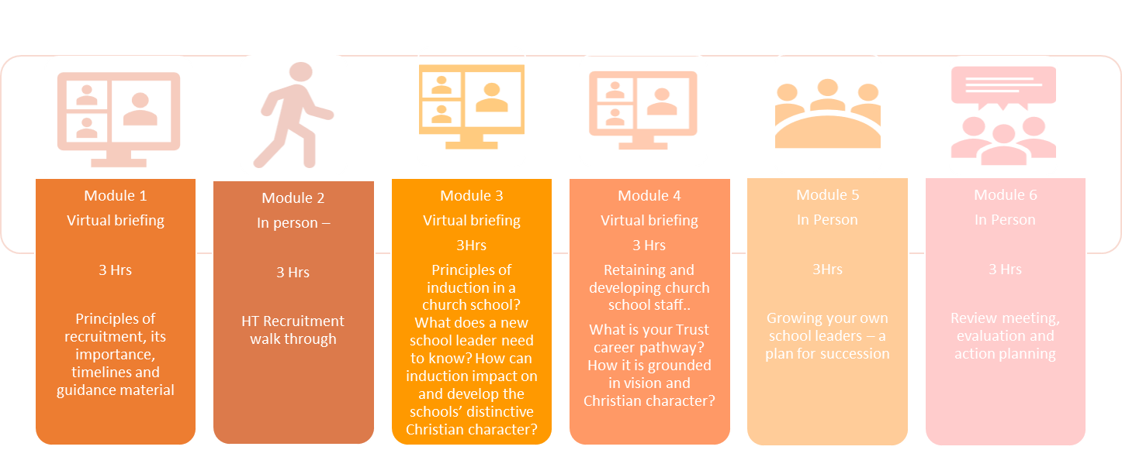
CCSR Module 1
Module A - Shadowing a preliminary meeting – 2hours
Module B – Shadowing a recruitment day/s - 10 hours

Intended outcomes:

- Confidence in holding the SDBE advisory role in recruitment;
- Recognising the role of recruitment processes in the flourishing of church schools.

Key questions to be answered:

- What is Church School Flourishing?
- What is the CCSR role?
- Outline the features of recruitment that flourish pupils and other adults in the school/trust
- How might a Trust reimagine their staffing resources?
- What is your understanding of ‘advocating for SDBE guidance’ when appointing a Headteacher?

Follow Up Task
A school is preparing to recruit and has the following vision and values:
‘Working together to build a firm foundation for learning and caring’

Rooted in Matthew 7 24 – 25 ‘Therefore everyone who hears these words of mine and puts them into practice is like a wise man who built his house on the rock.'

Love – Peace – Wisdom – Hope – Friendship – Honesty

Describe what would you hope to find in…
- A recruitment advert?
- In the CPD Strategy?
- The induction handbook?

Please use the pages below to answer these questions.

- What is Church School Flourishing?

- What is the CCSR role?

- Outline the features of recruitment that flourish pupils and other adults in the school/trust

- How might a Trust reimagine their staffing resources?

- What is your understanding of ‘advocating for SDBE guidance’ when appointing a Headteacher?

Follow Up Task;
A school is preparing to recruit and has the following vision and values:

‘Working together to build a firm foundation for learning and caring’

Rooted in Matthew 7 24 – 25 ‘Therefore everyone who hears these words of mine and puts them into practice is like a wise man who built his house on the rock.'

Love – Peace – Wisdom – Hope – Friendship - Honesty

In the box below, describe what would you hope to find in…
- A recruitment advert?
- In the CPD Strategy?
- The induction handbook?

Assessors’ comments:

Signed: |  | Date:

CCSR Module 2

Intended outcomes:

- Confidence and knowledge to advocate the SDBE advisory voice in HT recruitment;
- Knowledge of the SDBE guidance;
- Recognises role of recruitment processes in the flourishing of church schools and the spiritual flourishing of newly appointed leaders.

Key questions to be answered:

- At what stage of the pack do you celebrate your church school distinctiveness and deeply Christian vision and values?
- How can the interview process demonstrate hope, dignity and respect?
- What interview activities will you use to test the candidates as spiritual leaders?
- How might you nurture ambition and implement spiral of abundance with your new Headteacher?

Follow-up Task:

How can you thread the spiritual flourishing of a new Headteacher into the recruitment process?

Please use the pages below to answer these questions.

- At what stage of the pack do you celebrate your church school distinctiveness and deeply Christian vision and values?

- How can the interview process demonstrate hope, dignity and respect?

- What interview activities will you use to test the candidates as spiritual leaders?

- How might you nurture ambition and implement spiral of abundance with your new Headteacher?

Follow-up Task:

How can you thread the spiritual flourishing of a new Headteacher into the recruitment process? Fill in table below with some suggestions.
Advert | Interviews | Post Interviews

Assessors’ comments:

Signed: |  | Date:

CCSR Module 3

Intended outcomes:

- Confidence and knowledge to advise on induction and development strategies,
- Confidence to champion the spiritual flourishing of all staff

Key questions to be answered:

- How do your Trust staffing and HR policies reflect the Church of England vision for education?
- In what documents will you find threads of ‘spiritual flourishing for all’?
- How do your recruitment strategies nurture ambition?
- How are your new staff enabled to flourish working in a church school?
- Staff are the most expensive resource and the most significant activist for an employer, how do your employees champion your Trust?

Follow-up Task:

To identify the strengths, weaknesses and suggested alterations in a church school induction policy.

Please use the pages below to answer these questions.

- How do your Trust staffing and HR policies reflect the Church of England vision for education?

- In what documents will you find threads of ‘spiritual flourishing for all’?

- How do your recruitment strategies nurture ambition?

- How are your new staff enabled to flourish working in a church school?

- Staff are the most expensive resource and the most significant activist for an employer, how do your employees champion your Trust?

Follow-up Task:

This is taken from a church school induction policy. In the box below identify strengths, weaknesses and any suggested alterations.

This document outlines the purpose, nature and management of staff induction in St School Primary School.

Aims
The staff induction policy is designed to:
- Provide a flexible but systematic framework in which roles and responsibilities are
- clearly defined
- Familiarise staff with the values and aims of St School Primary School
- Integrate new staff into the team as quickly and smoothly as possible

The Headteacher or their delegate will assign a mentor for each new member of staff. All staff will be welcomed and receive basic induction on the first day of appointment, followed by formal induction training. The process will be tailored to meet the needs of individual members of staff. Induction begins before an appointment is made and continues over the following weeks. Induction will be part of the management process merging with the performance management scheme, development and training activities and personal review meetings. Induction is the starting point for personal review meetings and personal development plans.

Assessors’ comments:

Signed: |  | Date:

CCSR Module 4

Intended outcomes:

- Confidence and knowledge to advise on induction and development strategies,
- Confidence to champion the spiritual flourishing of all staff

Key questions to be answered:

- How does your Trust nurture an ambition for Headship?
- What is your succession plan?
- Is the harvest plentiful? How can this be changed?
- Is there a role for cross-trust collaboration?
- Are you aware of resources and materials to prepare for headship?

Follow-up Task:

In a succeession policy, one organisation states:

It's important to:
- make all staff aware, promote opportunities within the school, and encourage participation
- identify 'potential' and enable training and support
- set out individual plans for development and potential for next career steps
- view it as a success when a member of staff moves onto a leadership position at another school

Please use the pages below to answer these questions.

- How does your Trust nurture an ambition for Headship?

- What is your succession plan?

- Is the harvest plentiful? How can this be changed?

- Is there a role for cross-trust collaboration?

- Are you aware of resources and materials to prepare for headship?

Follow-up Task:
In a succeession policy, one organisation states:

It's important to:
- make all staff aware, promote opportunities within the school, and encourage participation
- identify 'potential' and enable training and support
- set out individual plans for development and potential for next career steps
- view it as a success when a member of staff moves onto a leadership position at another school

In the table below identify your current or hopeful parcties that meet these areas of succession planning.
Promote Opportunities | Talent Spotting | Training and Support | Celebrate Success

Assessors’ comments:

Signed: |  | Date:

LCSF Module 5 – Taking on the role

Intended outcomes:

- Planning and preparing for a pilot Church School Flourishing visit
- Carrying out the CSF visit
- Writing an evaluative statement
- Reviewing the visit
- Considering implications for Trust wide visits 22/23

Key questions to be answered:

- What was the focus of the CSF visit?
- What evidence did you explore, what tools did you use?
- What was the evaluative outcome of the visit? (Short answer – see Follow-up Task)
- What are your reflections on the visit? Did it meet the outline and approach you identified in your Module 3 reflections?
- What can you learn from this pilot visit that will shape your visit strategy in 2022/23?

Follow-up Task:

Please record the evaluative and supportive feedback you gave the school following your pilot visit.

Please use the pages below to answer these questions.

- What was the focus of the CSF visit?

- What evidence did you explore, what tools did you use?

- What was the evaluative outcome of the visit? (Short answer – see Follow-up Task)

- What are your reflections on the visit? Did it meet the outline and approach you identified in your Module 3 reflections?

- What can you learn from this pilot visit that will shape your visit strategy in 2022/23?

Follow-up Task:
Please record the evaluative and supportive feedback you gave the school following your pilot visit.

Assessors’ comments:

Signed: |  | Date:

Following the completion of each module’s content it would be helpful to capture initial feedback. To assist your ongoing professional development of the role and to help shape the future content of the CCSR training. Please score your confidence in each of the intended outcomes using the box provided; (1 being low and 5 being high).
Module 1 - Confidence in holding the SDBE advisory role in recruitment
Module 1 - Recognising the role of recruitment processes in the flourishing of church schools
Module 2 - Confidence and knowledge to advocate the SDBE advisory voice in HT recruitment
Module 2 - Knowledge of the SDBE guidance
Module 2 - Recognises role of recruitment processes in the flourishing of church schools and the spiritual flourishing of newly appointed leaders
Module 3 - Confidence and knowledge to advise on induction and development strategies
Module 3 - Confidence to champion the spiritual flourishing of all staff
Module 4 - Confidence and knowledge to advise on induction and development strategies
Module 4 - Confidence to champion the spiritual flourishing of all staff
Module 5 - Planning and preparing for a pilot Church School Flourishing visit
Module 5 - Carrying out the CSF visit
Module 5 - Writing an evaluative statement
Module 5 - Reviewing the visit
Module 5 - Considering implications for Trust wide visits 22/23

Assessors’ comments and final sign off:

Signed: |  | Date:

