CW PSA 1 resources
SIAMS Schedule from September 2021 with Excellence Hexagons
https://www.churchofengland.org/sites/default/files/2021-10/FINAL%20-%20SIAMS%20Evaluation%20Schedule%20%28Revised%20September%202021%29%20-%20UPDATED%20211019.pdf
CW evaluation questions
https://www.salisbury.anglican.org/resources-library/schools1/hub-lead-practitioners-hlps/school-worship/sdbe-hlp-nov-19-collective-worship-capturing-impact-for-school-improvement-and-evaluation
Resources
DBE resources webpage https://www.salisbury.anglican.org/schools/re-cw-sp
Prayer Spaces for Schools https://prayerspacesinschools.com/
This Season and towards Easter
Advent Prayer Spaces https://prayerspacesinschools.com/2021/11/22/advent-prayer-spaces/
CofE At the Heart of Christmas https://www.churchofengland.org/resources/advent-and-christmas-2021-resources-heart-christmas?mc_cid=426357bd10&mc_eid=5667eba7b9
Jesus and Santa - Same? Different? https://www.youtube.com/watch?v=NStpjQ477HA&t=122s
The other wise man pdf story for Epiphany http://www.conwaychristianchurch.com/uploads/2/0/9/7/20975724/001--january_6--epiphany--the_other_wise_man.pdf
40 Acts of Lent
https://40acts.org.uk/resources/
Diversity on the Screen – how might you use different pictures?
https://www.youtube.com/watch?v=RXTtiNyZtLM Make me a channel of your peace –
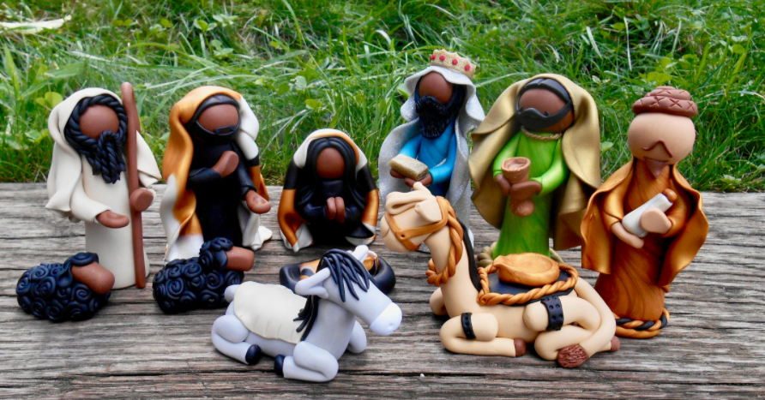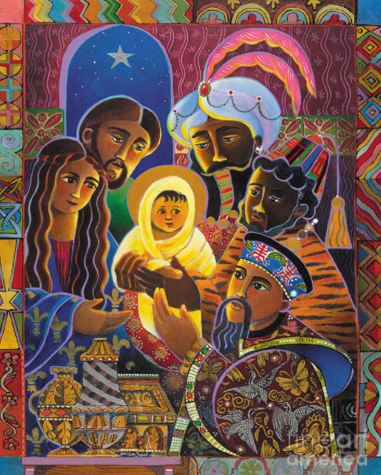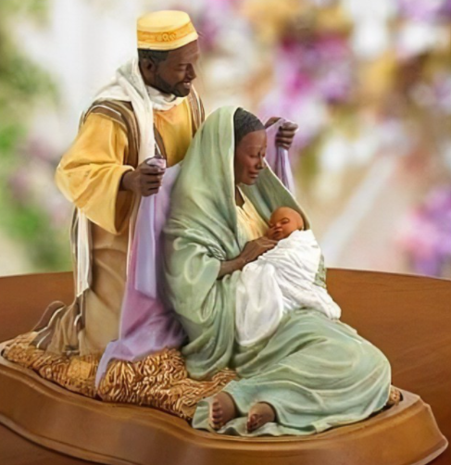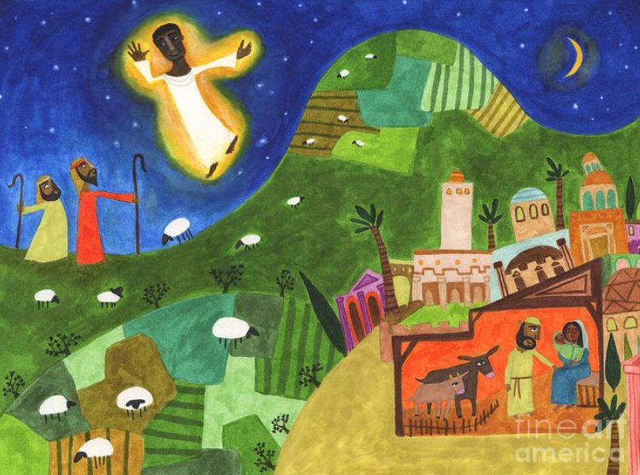
Resources to support CW being led by pupils
NATRE spirited arts project 2022 https://www.natre.org.uk/about-natre/projects/spirited-arts/spirited-arts-2022/ How could you use the gallery and questions from previous competitions to explore with children in CW?
CofE Faith At Home – Videos and PDFS https://www.churchofengland.org/our-faith/faith-home/i-am-school-leader
Picture News - https://www.picture-news.co.uk/
Bishops Cannings School
Newsletter for parents on services over the year https://bishopscannings.wilts.sch.uk/wilts/primary/bishopscannings/arenas/website/web/worship-21_22.pdf
BC School Prayer Space 2021 https://sway.office.com/cABh6F3C4L6AFcyQ?ref=email
BC Spirituality video https://www.youtube.com/watch?v=jComYivdGnI (from 10 to 17mins)

