BROAD CHALKE C. OF E. PRIMARY SCHOOL
Weekly Online Worship (WOW!) 22nd June 2020

This week we are starting a different sort of collective worship programme. Each week I will send out a newsletter so that everyone has the opportunity to take part in an assembly. We are calling this WOW (Weekly Online Worship!).

Parents can watch the video at home with their children. Teachers will be showing the videos in school.

These assemblies are produced by the Church of England specifically for these times, understanding that it is very difficult for teachers to produce a quality video of a collective worship which is engaging. We are very grateful to the The Church of England for helping schools in this way. Also the videos are less than 12 minutes long! The WOW name is our own idea though as is the WOW Newsletter idea and follow up ideas.

We are all having to find new ways to do things during this strange time – a time when so many things which we normally do or were looking forward to doing have been cancelled. But hope has not been cancelled!

So this week we are looking at HOPE. Sometimes it can be hard to have hope, especially in difficult or worrying times. However, Christians believe that Jesus teaches about hope as something that can grow, with encouragement and faith. Many of us are experiencing a wide range of emotions at the moment. Choosing hope can give us a different viewpoint. Hope can be what keeps us going. We all have a spirit which connects us to something bigger than ourselves. We don’t have to put the hope in ourselves, in our own ability to get through hard times, we can put the hope in something other than ourselves.
I always used to say in collective worship when something sad had happened in the world and children were scared – look for the helpers. Now we can look to the key workers, working together to get us through these times and to make this a better situation for all of us, hope in our families and for Christians, they can also put their hope in God. We can all put our hope and trust in others to help us out. The rainbows in windows were a lovely symbol of hope.
I hope that by watching this the ‘take away’ from it will be that it helps you to feel a little more positive and hopeful. There are always reasons to hope and to feel grateful. Thank you to all of you! Thank you to all the people who give us reasons to hope! I hope you enjoy the assembly.
With love from Mrs Brockway xxx
PLEASE CLICK ON THE LINK BELOW TO WATCH THE ASSEMBLY
https://www.youtube.com/watch?v=gTYPHw22eeo

Follow up Activities
If any children do follow up activities please do send them by email to your child’s class teacher to share with me and to add to Instagram or our website. Here are some ideas:
Write your own payer or poem about your hopes for the future.
Write your own prayer / poem to say thank you to the people who give you hope.
Write and colour the word hope and send a photo in to school of you holding the word hope. (These would look lovely on Instagram!)
Take a photo of your child with a worship candle
KEY QUOTE OF THE WEEK:
‘May your choices reflect your hopes not your fears’ (Nelson Mandela)
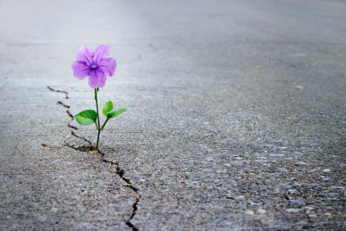
THINK:
What does this picture make you think of?
How might it be possible for this plant to be growing here?
What makes hope grow in difficult situations?

PRAY:
Dear God, we thank you for giving us hope when we feel worried, when we are having a hard time, when we don’t know what’s ahead of us and when we are sad. Thank you that even the smallest seed of hope can grow into a big, tall tree. Please help us when we find it hard to be hopeful, so we can offer hope to others. Amen

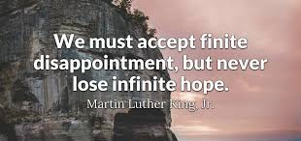

1. GIVE THANKS for something that was good today.
2. ASK FOR HELP with something where you have lost hope.
3. REFLECT on your day and think about the things that made you feel hopeful.
4. SAY SORRY for the times you gave up hope, or took away someone else’s hope.
5. DECIDE how you will keep hold of hope tomorrow.
6. Do a SIGNS OF HOPE walk: As you walk around your area, look for things that are growing. What do you think they will look like when they are fully grown? When we start looking for signs of hope, it can remind us of the reasons we have to be hopeful.

