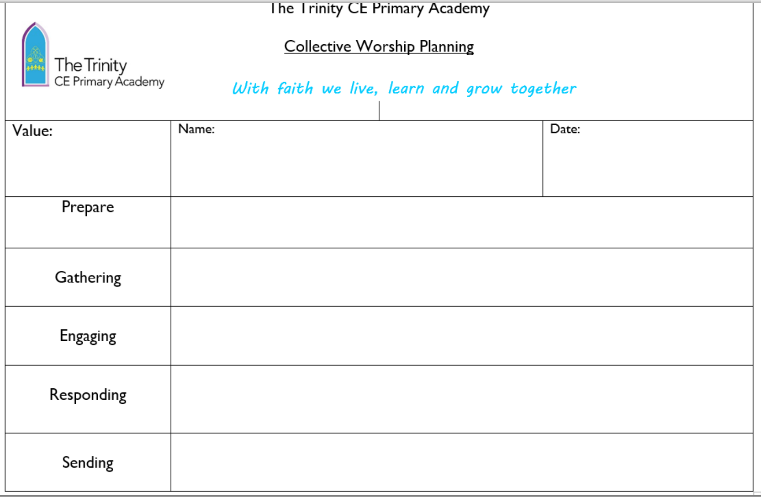
What was prepared?
How well did the video seem to show Gathering?
What strategies were used to engage the audience? Age range?
In what way were we/participants encouraged to respond?
What were we/they ‘sent away with’? What impact might this have had on their day/lives in or beyond school?
How has the school’s Christian vision been developed/reinforced through this worship?
How have pupils been given the opportunity to engage with religious text?

