Leader: | Date: | Time: | Group:
Message / Bible passage:
Gather | Engage | Respond | Send
Candle lit Bible verse / story Song Prayer and reflection time Children involved Sent out with a thought

Gathering
We gather together and greet each other. We all come to play a part in this community. We are preparing to meet God.
How is the room set up?
How is seating arranged?
Does everyone know what they should be doing? What will the greeting be like?

Engaging
We engage with the big things and the little things in life. We encounter Jesus and the stories of the Bible.
We are listening for God’s message for us.
How will you share God’s message?
How will you share your own experiences or contemporary events? What strategies will you use?

Responding
We respond to what we have heard and seen. We respond together as individuals.
We are given the opportunity to worship God.
Will you use singing or prayer or reflection time?
Will there be a practical response and how will this be encouraged? Do you give enough time to responding?

Sending
We are sent out to love and serve one another and to make a difference in the world. We are all dismissed with God’s blessing.
How will people leave worship – singing? silently?
Will there be special words of blessing or dismissal?

Date: 17.4.18 | Leader: Rebecca Swansbury | Group: Whole staff and clergy | Time: 3.30pm
Message / Bible passage: | Joshua 1: 5-9. Trust in God
Gather | Engage | Respond | Send
As children come in – play the video clip from Prince of Egypt as the Israelites leave Egypt. Get the children engaged in the story that comes before the Joshua passage.  Welcome to Worship.  ‘This is the day that the Lord has made… Let us be glad and rejoice in it.’  Ask a child to light the candle.  “I wonder why we light the candle?” | What does trust mean? (Think, pair share TPS)  Who do you trust? Do you trust me?  Ask for volunteers to be caught as they fall backwards into my arms.  Sing together: ‘God is with us Amen’ Ask children to come up and lead the actions.  Our Bible story today is from the Old Testament, which is before Jesus was born, and is about a man called Joshua. Joshua had been put in charge of the Israelites after Moses died. (Link back to video clip at the beginning of worship) He had to trust God with his life and the lives of all of the Israelites.  Act out the story together of Joshua and the Israelites leaving the desert to go across the Jordan river to cross into the promised land. Create the river in the middle of the children using blue cloth. Get a group of children to be the Israelites and the rest of the children can take part by acting out the expressions of the Israelites at different parts of the story. Then choose 12 children to go into ‘the river’ to collect the 12 stones for the altar.  I wonder how Joshua felt when he approached the river?  I wonder why Joshua got 12 stones out of the river? What does this tell you about Joshua? (TPS) | “Do not be afraid or discouraged, for I, the Lord your God, am with you wherever you go.”  I wonder how this promise helped Joshua and the Israelites.(TPS)  I wonder how this promise makes you feel?  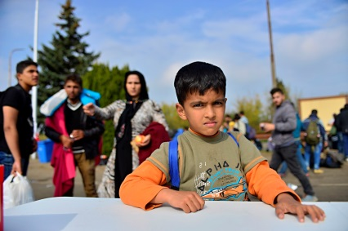  I wonder how this promise might support this refugee family?  Sit quietly and think about this story and verse and reflect on what it means to you and to others.  Let us say this prayer together:  In darkness and in light,  in trouble and in joy,  help us, heavenly Father,  to trust your love,  to serve your purpose,  and to praise your name;  through Jesus Christ our Lord.  Amen | I wonder what you need to trust God with this week?  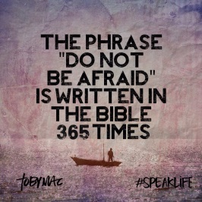  Remember it says “Do not be afraid is written 365 times in the Bible” so trust God and be brave!  ‘Go in peace to love and serve the Lord.  In the name of Christ’  Amen  Ask a child to come and extinguish the candle.
Candle lit Bible verse / story Song Prayer and reflection time Children involved Sent out with a thought

