 | Preparing the Letter  for your Giving Appeal | 
Your Giving Appeal or Thanksgiving Sunday letter will be shaped by the local factors such as current teaching on giving, views on proportionate giving and tithing and the ‘target population’ to whom the letter is addressed. However, whether it goes to those who are already regular givers through a planned giving scheme, the whole congregation, Electoral Roll members or the wider community, there are certain basic principles that apply to all. The following points are ‘ideal’ guidelines and the degree of detail will depend upon the resources available.
- Use no more than one side of A4 paper for the letter. Other information can be included in a leaflet and / or the Commitment or Promise Form, but the less there is to read, the better.
- Ensure that the document is easy to read. This means using ‘sans serif’ with a font such as ‘Arial’, a type size no smaller than 12 and only the left-hand margin justified (all as used on this page).
- Use a personal approach with a handwritten salutation and signature(s) and Christian or surnames. Include contact details such as a telephone number. A white envelope rather than a brown one (bills!) has a more personal feel to it.
- If you are writing to a number of different categories such as regular givers and ‘fringe’ members, it is preferable to ‘customise’ the different letters, although the main element will remain the same.
- Include some financial facts. This may be as little as projected income, expenditure and shortfall in the letter itself or in a separate financial leaflet. It is better to give weekly or monthly figures where the reader can see that any increase in giving can make a difference.
- Ensure that the letter, but more likely a leaflet or Commitment Form explains the different ways of giving eg Standing Orders, Gift Aid.
- Make sure you thank those who are already givers.
Possible structure: Thank you for past generosity (with total if appropriate)
What has been achieved over the year

Plans and challenges for the coming year
Financial highlights
Invitation to Financial / Time / Skills commitment
Deadline for returning promises
Signatures and names of church officers
Contact details
Once you have written it ……

- The ideal distribution is personal delivery and collection. Variations on collection can include (stamped) addressed envelopes, leaving in letterboxes in church etc, with personal collection for those who do not respond.
- After the responses have been received, send a thank you letter. It is important to reassure recipients that confidentiality is being maintained, so a letter including the amount that an individual gives should be signed by the Treasurer. A general ’thank you’ letter should normally be signed by the Incumbent etc.

There are examples of letters on the following pages. Pick and mix to get the right one for your church.

Letter introducing the theme of Annual Thanksgiving to Regular Givers

The Church of St John the Baptist, Fordley  Rector – The Revd Jonathan Hartley  The Rectory, Church Lane, Fordley, BN3 7HD 01723 546832 | 

Dear Helen and John

I am writing to thank you for your continuing commitment and financial support to St John’s Church through our Planned Giving Scheme, and to share with you our plans for ensuring a stable future for our church’s finances. (Note 1a)

Before the introduction of the present Gift Aid Scheme in 2000, St John’s and many other churches encouraged giving by covenant. This relied upon covenants being renewed every four years and was often accompanied by a Stewardship Campaign. It involved considerable work as the organisers ran yet another major campaign to make up the gap between income and expenditure that had grown over the four years.
Our last stewardship campaign took place in 2005. The response was very encouraging enabling us to meet the church’s day-to-day running costs and to move forward with confidence on our major project of improving access for the disabled.
The relative absence of financial worries has meant that we have been able to concentrate on the life of our church serving the wider community. Our involvement with St John’s School has increased and the Youth Club is now seen as contributing to life in the two villages. The weekly lunch for senior members is proving very popular and we have joined with the other churches to promote our Fair Trade initiative.
Considerable income is generated by fund raising. However, giving through our planned giving scheme lies at the heart of the financial security of St John’s. The PCC feels that we should not continue to rely on occasional campaigns to balance our budget. Most of us review our finances annually and it seems prudent to plan our giving to the church in a similar way. This would involve reviewing our giving in the context of our own and the church’s changing financial situation as part of an annual act of thanksgiving. This letter marks a change in emphasis from ‘fundraising’ to an annual pattern of review and thanksgiving which I very much hope you will support.
Please give careful and prayerful consideration to your own situation. I hope you will feel able to renew your commitment by completing the enclosed form and returning it in the confidential envelope to our Treasurer by 12th October. The easiest way to ‘get the regular habit’ is to give by standing order, but you might prefer to use the envelope scheme. Whatever you choose, you can increase the amount you give by £2.80 for every £10 given by using the Gift Aid Scheme. If you have any questions about this, please contact Tom Henderson, our Treasurer on 01735 291855. (Note 1b)
I do hope that you will be able to join in our first annual Thanksgiving Sunday at 10.30am on 19th October and add your thanksgiving for God’s generosity to you.
With all good wishes and prayers
Jonathan
Note 1: Use appropriate wording for different categories of person -
Alternative for Non-regulars givers (1a):
I am writing to you as a regular member of St John’s Church to share our plans for ensuring a stable financial future for our church.
Non-Regular (1b):
Please give this letter and Commitment Form your careful consideration. Our Planned Giving and Gift Aid Schemes are organised to ensure confidentiality between you and those directly involved in running them. I hope very much that you are able to make a commitment to regular giving to St John’s. If so, please complete the form and return it to the Treasurer by 12th October. I also invite you to join in our first annual Thanksgiving Sunday on 19th October. If you have any questions about this initiative, please contact me or Tom Henderson, our Treasurer on 01735 291855.

Annual Letter for existing Regular Givers
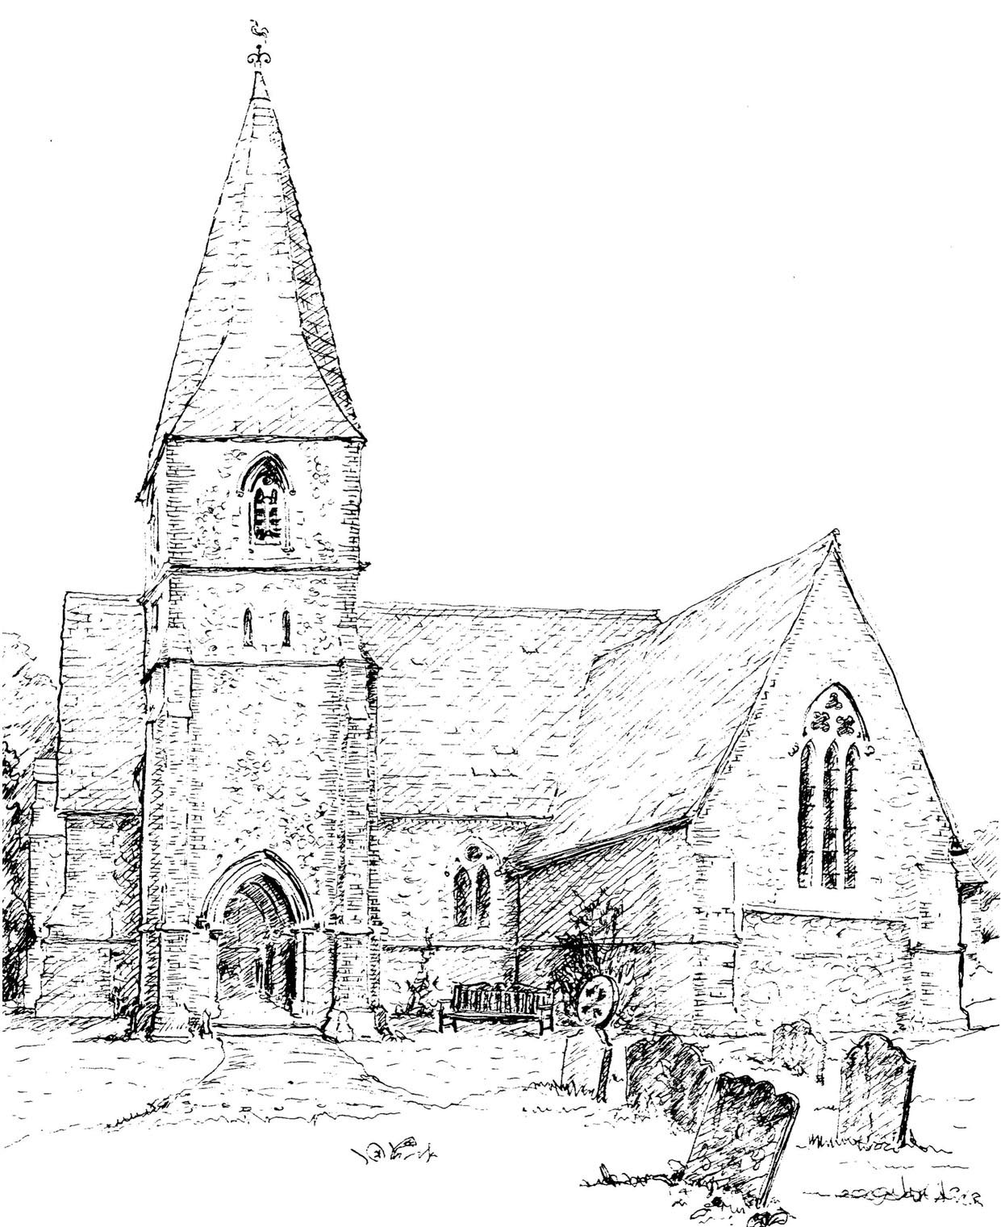 | St Matthew’s Church, Denton  Vicar – The Revd James Martin  The Vicarage, Church Lane, Denton, DT2 9NP  Tel: 01560 721876 Email: revjmartin@montrose.com

Dear Mr and Mrs Winstanley

Thank you for your continuing involvement in the life of St Matthew’s Church over the past year through your prayer, time, and financial contributions. Working together as a church we have: (Note 1a)
- joined with our Methodist friends in a partnership with Denton Community School
- run our first Alpha course
- started a weekly lunch for senior members
Details of our plans and church finances are in the enclosed ‘Plans and Needs’ leaflet, but we have news of two new projects that we would like to share with you:
- developing a young people’s music group to help lead our worship
- installing the long awaited new kitchen in the church hall
Alongside all these initiatives is the ongoing ministry to our own members and the wider community. These and all our other activities continue on a daily basis supported by the generosity of church members. This is why we are now asking everyone to review what support they can give during the coming year. The PCC manages the budget very carefully, but we still need to increase our giving by some £400 a month to keep pace with increased costs. We recognise that all our financial and time commitments change over time. Our annual renewal provides the opportunity to give thanks for God’s generosity to us and to commit afresh to supporting His work in Denton. (Note 2)
There is also a list of specific jobs where we need more help at the moment so that our plans can bear fruit. If you would like to find out more about these opportunities on a “no commitment” basis, please talk to the clergy or churchwardens.
At a time when the general economic situation might not look encouraging, it is perhaps particularly appropriate for us to review our financial priorities. By reflecting on how important our faith and church are to us we can determine the extent to which our giving can ensure that St Matthew’s continues to be a live worshipping community.
The enclosed Commitment Form is for your response. After completing it, please return it in the envelope provided to the Treasurer by Sunday 12th October. If you are unable to do so, one of our team will call to collect it from you in the following week. On Sunday 19th, our 10.00am service will include a special time of thanksgiving for God’s generosity to us and for our response in helping to meet this year’s challenges. (Note 1b)
With every good wish

Edward Henderson Margaret Timpson
Edward Henderson, Churchwarden Margaret Timpson, Churchwarden
01560 830154 01560 830122
Note 1: Use appropriate wording for different categories of person
Alternative for Non-regulars givers (1a):
Thank you for your support as a member of St Matthew’s Church over the past year. Working together as a congregation, we have:
Non-Regular(1b):
When reading the enclosed Commitment Form, please give some thought to how your giving can best benefit the church. A commitment to give through the Planned Giving Scheme ensures that the PCC can budget on the basis of a regular income. The Promise Form explains ways in which you can do this most effectively.
Please return your form in the envelope provided to the Treasurer by Sunday 12th October. If you are unable to do so, one of our team will call to collect it from you in the following week. On Sunday 19th, our 10.00am service will include a special time of thanksgiving for God’s generosity to us and for our response in helping to meet this year’s challenges.
Note 2: Alternative version to differentiate between restricted funds / capital projects and the day-to-day running / operational costs
We are fortunate to have reserves which the PCC has earmarked for the church hall improvements and it is our practice to allocate money annually to the Building Fund for future maintenance of the church building. However, we also need to ensure that our regular giving keeps pace with the ongoing costs of ministry to our own members and to the wider community. This is why we are now asking everyone to review what support they can give during the coming year while recognising that all our financial commitments change over time. This annual renewal provides the opportunity to give thanks for God’s generosity to us and to commit afresh to supporting His work in Denton.
Other wording for use as appropriate:
- As you know, we at St Matthew’s have committed ourselves to an annual thanksgiving and review of giving. This letter gives me the opportunity to thank you for your regular financial support through our Planned Giving Scheme, to mention some of our achievements and challenges, and to invite you to consider how you might continue with your support.

- The economy is very much in the news at present and affects us all in different ways. It will be no surprise to hear that our church is not immune from the effects of rising prices. We are used to the idea of our Sunday services being there for us in a well maintained building, but we might sometimes overlook ongoing activities that all contribute to building up our church family, welcoming visitors and reaching out to those in the surrounding community. But it all comes at a cost, however small.

- Whether it’s our unique building or the activities that take place inside and around it, there is a cost both in terms of the many hours given selflessly by members of our church community and in hard finance. If we are to be ambitious for the future, we need to be free of financial concerns and be able to plan with confidence.
Examples of ‘One-Off’ Giving Appeal Letters

The Church of St Thomas, Brimpton

Dear Dr and Mrs Thomas

Our parish church of St Thomas stands on the edge of our village and it is sometimes easy to forget it is there. But it is there and has been for over seven hundred years, serving our community as it still does today. It is the focal point for many village events; not only for Sunday services, but for those Christmas, Harvest and Carol Services when we gather together. It is also there to welcome our parishioners and visitors for some of the most important occasions in our lives - our baptisms, weddings, and funerals.

Because our church is there for us now, we tend to take it for granted and probably assume that it will always be so. Unfortunately we will only be able to maintain the building in its present condition, continue with our current services and the same level of support from the Revd John Hoskins, our Rector, if we are able to pay our share of the associated costs.

The monthly cost of maintaining the Church’s presence in Brimpton is £1,075 made up of:

Ongoing running costs, including insurance, heating, light, maintenance services, churchyard, and minor repairs which amount to some £275 a month.

Our contribution to the Diocese of Salisbury towards the cost of parish ministry (clergy pay, pensions, housing and training) amounting to £800 a month.

St Thomas’s is not a wealthy parish church. The Church of England ministry, which is available to the whole community, is funded mainly from the regular giving of the congregation, donations from visitors and the annual Fete. However, this still leaves us with a deficit of £210 a month.

We know that many of you support the church in a variety of ways already, for which we are immensely grateful. However, we need to face the reality that the church needs your help to get onto a secure financial footing. Ideally we need to do this through regular giving to assure the Parochial Church Council of a regular source of income when managing church finances.

We feel we must do all we can to preserve our church for future generations. Some in our wider community share this sentiment and contribute regularly to ensure that St Thomas’s continues to serve the whole village. We hope that you might wish to join them by giving a sum, however small, on a monthly basis – the easiest way is by Standing Order.

Details of how to do this are in the enclosed form. If you feel able to complete it, please return it in the stamped addressed envelope to our Treasurer, James Whiting (01268 819110). James will be happy to answer any questions that you might have about the church’s financial situation and how you can help. All correspondence and discussions will, of course remain confidential. Thank you for taking the time to read this letter.

Yours sincerely
Jennifer Thomas Andrew James
Churchwarden Churchwarden
01361 775802 01361 775852
 | Help to keep Denton’s Heritage

Dear Mrs Pennington
In Denton, we are fortunate to have a picturesque 12th Century Church with several outstanding features including two Norman arches and a Jacobean pulpit. All Saints’ Church has served our community for centuries and continues to welcome parishioners and their guests for important events at every stage of their lives.
Through this letter, the Parochial Church Council wish to alert you to the increasing financial problems that our Church is facing every year and how, as parishioners, you can help to retain the Church in its present state and ensure that it continues to serve our village.
Our Church’s major monthly costs are twofold. Firstly we have the day to day running costs of the church building, which include insurance, heating, light, maintenance services, churchyard, and minor repairs, amount to £450 a month. Secondly, as a parish, we are responsible for contributing annually to a share of the expenses of the Diocese primarily towards enabling us to have a Rector and Team. The main elements of this parish ministry are clergy pay, housing and training of the clergy and Readers, and cost £400 a month.

Against this monthly expenditure of £850, our income is £600 leaving a monthly deficit of £250.
Regular income to meet these expenses comes from many of us, by standing orders, weekly collections, fundraising and the tax refund from the Gift Aid Scheme. We appreciate that many of you give generously already and we are immensely grateful to all who contributed to the very rewarding church roof appeal two years ago. However, we are determined to ensure that All Saints continues to play a part in the life of our village and hope that you will join us in this.
We ask you therefore to review any contribution you already make to the Church, to see whether you feel you can increase your giving or, if you do not already do so, make a commitment to give on a regular basis.

Enclosed is a form for you to do this. We will call on you one evening next week to collect it. To ensure confidentiality, you might like to seal in the enclosed envelope. If we miss you, would you be kind enough to send your envelope to the Stewardship Secretary, Jeremy Brown, whose address is on the form. If you would like to discuss this further, he can be contacted on 01430 941250.

Thank you for making the time to read this letter,

Yours sincerely

Thomas Hetherington Margaret Wilson
Churchwarden Churchwarden
01430 967231 01430 977543
Thank You Letter
It is important that every response should be met with a ‘thank you’ letter. Some churches include the amount the individual(s) has made a commitment to give. However, it is important to reassure recipients that confidentiality is being maintained. A letter including details of the amount that an individual gives should be signed by the Treasurer. A general ’thank you’ letter should normally be signed by the Incumbent etc.
Two examples that could be expanded are below. Remember to continue with the personal approach using a handwritten salutation and signature.
From the Incumbent
Dear Dr and Mrs Handley
I am writing to thank you for your generous response to our Thanksgiving Sunday appeal. Your financial support for St Matthew’s is a real encouragement as we begin to put our plans into action.

Of course I am not aware of the confidential details of individual responses, but I and the PCC do know the general level of response and I am sure that you will also be encouraged by our progress so far. We have achieved the increase in giving of £500 a month that I mentioned in my letter to you. This enables us to go ahead with our plans for the young people’s music group and for installing the new kitchen in the church hall.

It is heartening to know that our shared enthusiasm for mission at St Matthew’s is bearing fruit. I am very grateful to you for your generosity and ask for your continuing prayers as we seek to serve God in our community in Denton.

With all good wishes and prayers
James

From the Treasurer

Dear Mrs Brown
Thank you for responding to the Thanksgiving Sunday appeal with your promise to give £50.00 a month by Standing Order. As you have already signed a Gift Aid Declaration, the total value to St John’s Church will be £64.00.

By giving through our Planned Giving Scheme, you and other members of the congregation help to ensure that the PCC has a regular income from which to meet our financial commitments during the year and to plan ahead with confidence.

I am very grateful to you for your generous support. Everyone’s financial circumstances change from time to time, so if you have any questions about your contribution at any stage, please do not hesitate to let me know. The details of your financial support are, of course, confidential to me as the PCC Treasurer.

Yours sincerely
Peter Wentworth

