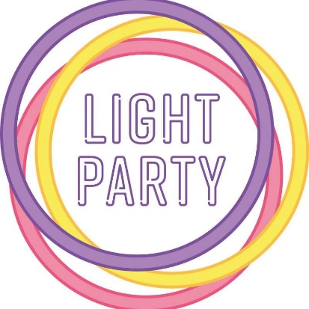
MELKSHAM
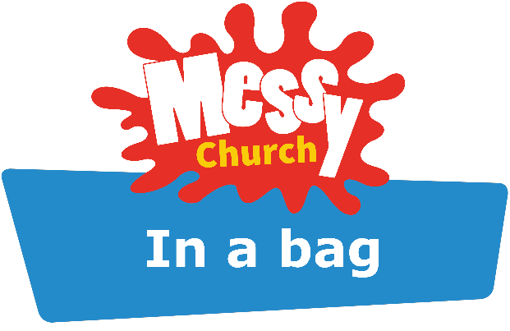

Saturday 31st October 2020

Welcome to our Melksham Messy Church Light Party, with a difference!

It was great to welcome you to collect your activity bag this evening & we
hope you enjoy our Messy Light Party celebration!

In your bag you will find:
- A Messy Science rainbow spinner activity.
- Everything you need to create a paper lantern (including an LED tealight).
- A light and bright rainbow activity.
- A pot of playdough for some messy creating!
- Exciting light themed colouring pages.
- Our Light Party Memory Verse.
- A glow stick.
- Some scrummy sweet treats!

Don’t forget to watch our online video at 6pm for an explanation of all the activities, worship, stories & more!
The link to our online video will be posted on our
Melksham Messy Church Facebook Group & can also be accessed via our Melksham Messy Church YouTube Channel.

Our last video of the day will be a Facebook Live at 7pm on our Melksham Messy Church Facebook Group. Come along for a Light Party catch up, to play a game, share jokes, prayers & more!

Hannah Tarring, Wiltshire Regional Coordinator for Messy Church
Children and Families Coordinator, Melksham Team Ministry

