NEW NCVS COURSE ON MENTAL HEALTH AWARENESS
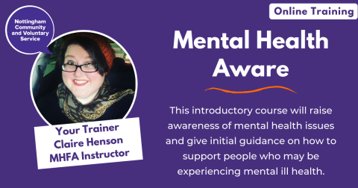
Become Mental Health Aware in our new introductory course. We've teamed up with Mental Health First Aid England (MHFA) instructor Claire Henson to deliver this important training opportunity for the voluntary and community sector.
This half-day, online course will raise awareness of mental health issues and provide you with guidance on how to support people who may be experiencing mental ill-health.
Claire, who is based in Nottingham, specialises in delivering adult mental health training to organisations, businesses, and community groups across the country.
The course, which will run online via Zoom, will provide an excellent starting point for anyone who is working in the field of mental health or for an organisation that wants to raise staff and volunteer awareness of mental health issues.
The course will cover:
- What mental health is and how to challenge stigma
- A basic knowledge of some common mental health issues
- An introduction to looking after your own mental health and maintaining wellbeing
- Confidence to support someone in distress or who may be experiencing a mental health issue
Upon completion of this course, each participant will receive a certificate of attendance to say that they are Mental Health Aware. A resource package will also be provided which will be mailed directly from Mental Health First Aid England to each registered participant.
Claire Henson said, "I’m really delighted to be delivering this course with NCVS to raise more awareness and understanding around mental health. This training course is a great starting point for anyone wanting to increase their knowledge around mental health and an understanding as to how they can also look after their own wellbeing."
We will be running this course throughout the year (2021), on the below dates. Please note, when you click on the link for the training date you are interested in, you will be taken to the registration page on our website:
- Monday 17 May 2021, 11am-3.30pm
- Monday 19 July 2021, 11am-3.30pm
- Tuesday 19 October 2021, 10.30am-3pm
The full course cost is £40 per participant (£25 course fee, plus £15 resource pack).
To view our Training and Development Programme in full, please visit our Training Courses web page.

